ISLAMABAD:
The government is set to incorporate Pakistan Mortgage Refinance Company Limited in partnership with domestic and multilateral banks with a paid-up capital of Rs6 billion in a bid to push the housing finance market in the country.
The company is expected to be set up in the next two weeks. Federal Finance Minister Ishaq Dar chaired a meeting on Monday to consider matters pertaining to the establishment of the mortgage refinance company before the Securities and Exchange Commission of Pakistan formally incorporates it.
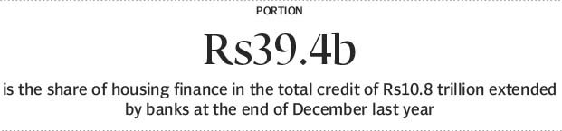
The company will have an authorised capital of Rs10 billion with Rs6 billion paid-up capital, according to a press release issued by the Ministry of Finance.
The government will inject equity of Rs1.2 billion and 2% of the amount or Rs24 million will be released immediately to meet initial expenditures.
Besides the government, contribution to the equity will come from the National Bank of Pakistan, Askari Bank, Habib Bank Limited, United Bank Limited, Bank Alfalah, House Building Finance Corporation, Bank Al Habib and Allied Bank Limited. The International Finance Corporation of the World Bank and the Asian Development Bank are also expected to provide funds.
It was decided that directorship will be offered to only those banks that will contribute significantly to the equity. Some banks were seeking to restrict their contribution to small amounts, though the government desired that they should pump more money into the company.
Some of the banks had already given their consent for equity injection while others were in the process of finalising plans, officials of the finance ministry said.
State Bank of Pakistan Deputy Governor Saeed Ahmad will be the first chairman until a new board is constituted and selects the chairman. The company’s head office will be in Karachi.
It is proposed to be established with the objective of promoting, developing and improving the housing finance market in order to increase accessibility and availability of affordable housing finance with greater participation by banks and financial institutions.
Refinancing facilities will be for long, medium and short-term to banks and financial institutions against their existing conventional and Islamic housing finance portfolios.
Commercial banks in Pakistan are reluctant to take big exposures in the housing sector that has become an obstacle in the way of addressing the issue of lack of housing facilities. Banks that are in the housing finance business are offering loans at very high interest rates, making them unaffordable for the people.
Against a total credit of Rs10.8 trillion extended by banks, house financing amounted to only Rs39.4 billion at the end of December last year, according to the State Bank of Pakistan’s statistics.
The finance minister said the new company must provide all forms of technical advice, consultancy support and assistance to banks and financial institutions in conventional and Islamic housing finance products along with developing and promoting international best practices for housing finance, said the finance ministry.
Exim Bank
Dar also chaired a meeting to review arrangements for establishing the Export Import (Exim) Bank, the plan for which the government had announced in the budget.
Finance Secretary Dr Waqar Masood said all spadework for the launch of the bank had been completed.
He said the bank would work as a development finance institution with an authorised capital of Rs10 billion. It is expected to be set up in the next two weeks.
The minister issued instructions for preparing a comprehensive business plan for his consideration before launching of the bank. The bank would promote export refinance and support small and medium-scale enterprises, he said.
Published in The Express Tribune, March 17th, 2015.
Like Business on Facebook, follow @TribuneBiz on Twitter to stay informed and join in the conversation.

