Pro-Poor Affordable Housing
Issues we know, answers we need

Zaigham M. Rizvi
Secretary General, Asia Pacific Union for Housing Finance (APUHF)

PRO-POOR HOUSING AND HOUSING FINANCE, A PRIMARY ISSUE
Housing is a basic need and fundamental right of every human being. Housing provides space and shelter for households to live in privacy, security and dignity. It also provides a point of reference on which one can get other services and utilities from city fathers/administrators. Access to housing is a key social determinant to ensure social status and well-being of the households. Providing of adequate housing to the citizens of a country is an essential component of Millennium Development Goals.
Housing is also a key driving force behind a country’s economy. In western world about 270 industries are linked to housing, and in Asia-Pacific region it is stated to be more than 40 industries that have direct linkage with housing and construction sector. It is a labor intensive industry providing ample employment to both skilled and unskilled workers. A slowdown in the housing markets can translate into slowdown in capital markets as well as labor markets, leading to an overall slowdown of the economy. A well-functioning and well governed housing market is crucial for economic prosperity of a country. It also has a critical role to play in a country’s GDP growth.
Providing Housing Finance is in fact giving economic empowerment to those who cannot afford it on their own. Thus Housing Finance Institutions and access to housing finance is the key driver to housing supply. It provides the vibrancy and push in the real estate segment in the economy. Housing finance is productive for lenders as well as to real estate developers, and also to final beneficiaries, the borrowers. How effective are the Housing Finance Institutions (HFIs) in accelerating growth of real estate sector and the economy is measured by Mortgage Debt to GDP ratio
Figure 1shows the size of the Housing Finance Industry (outstanding mortgages as a share of GDP) in some selected world economies.
Figure 1
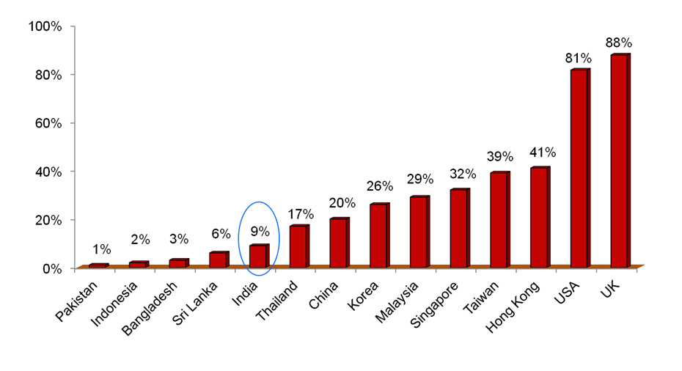
(Source: Paper presented by NHB at Affordable Housing Conference in Delhi, Jan 29-31, 2012)

For the purpose of review and analysis, the housing sector could be further subdivided into two subsectors, market housing and social housing, which are discussed in brief below.
Market Housing: Market Housing is the housing that is easily available in the real estate market for owning and disposing off easily without much effort, and without much concern for meeting the basic human need of having a shelter. These are a tremendous means for lifelong investments, particularly in third world developing countries. In this market segment the demand is generally met by the market forces, and no state intervention or support is needed to promote the supply. This is generally the demand originating from the high-end population, where affordability is not an issue, and the housing developers bring supplies purely on commercial considerations. This relates to upper-middle and high end of the population, and has a relatively much smaller share on overall housing shortage.
Social Housing: Social Housing is that segment where demand and the shortage backlog is substantial, and the market forces do not come forward to meet these unsatisfied demand as this market is not commercially attractive for the developers. A state intervention, by way of promoting land supply, fiscal giving incentives and subsidies may be needed to promote the supply. The Pro-Poor housing is at the bottom of this pyramid, which have the major share of the housing shortage, and where affordability remains to be the critical issue.

South Asia and Pacific Regional Scenario:
South Asia is the area where one out of four person of the planet lives. If we are to include China in this equation, then every second person on this planet is from this region! Unfortunately, most of the urban housing shortage in the region is in economically weaker sections of the society. Pro-Poor Low-Cost Housing supply and finance is the main issue of people in the Asia-Pacific region. Urban India alone is facing a housing shortage of about 27 million units, nearly all of which are in the economically weaker sections of the society. This remains the main challenge in nearly all major metropolitan cities of the region: from Kabul to Karachi, Mumbai, Dhaka, Manila and Jakarta. On Pro-Poor Housing, the fact remains that the “Issues we already know, Answers we need.” Time has come for Pro-Poor Housing to be taken to spotlight and to find viable and sustainable solutions.
Yet, in foreseeable future, the low income/low cost housing would remain an unaffordable basic need of the downtrodden and poorer segments, until government sponsored comprehensive programs are launched for pro-poor housing. The issue has assumed the alarming dimensions; and solutions have to roll down from political sloganism to the planners’ “drawing Boards”, for “on ground” execution. These pro-poor programs should also address the issue of availability of finance in wider horizon with easy access at affordable cost.
The housing shortage in the Asia-Pacific region is generally analyzed from the aspect of urban housing, since the people living in the rural areas, not facing any land scarcity, manage to find affordable housing solutions. In rural areas, the main challenge is to get access to finance through any rural housing microfinance system.
The factors contributing to urban housing and housing shortage are:
➢ Urbanization rates (driven by economic factors)
➢ Population growth rate
➢ Depletion of existing stock (very conservatively taken at 1% of the existing stock), and
➢ Changing size of persons per household (a cultural phenomenon)
Over the last five decades, Asia has seen some enormous urbanization and demographic changes. One of the most dramatic changes of all has been the migration of people from villages to cities. The percentage of people living in Asian cities and towns, as compared to total country populations, is increasing rapidly. In 1950, about 232 million people lived in urban areas, which represented about 17% of Asia’s total population. In 2005, Asia’s urban population had risen to 1.6 billion people, or about 40% of the region’s total population. There’s no doubt that as the Asian region continues to develop, the level of urbanization will increase. The United Nations estimates that urbanization in Asia between 2005 and 2010 will increase at the rate of about 2.5% each year. At this rate, about half of Asia’s total population will live in urban areas by the year 2025 i.e., every second Asian will be an Urban person. By the year 2030, it is expected that 54.5% of Asia’s population will be urbanized. This means that by 2030, one out of every two urban residents in the world will be in Asia.

Housing conditions in Urban Asia:
Presently, one out of every three people living in cities of the developing world lives in a slum. UN-HABITAT estimates reveal that in 2005, more than half of the world’s slum population resided in Asia, followed by sub-Saharan Africa, Latin America and the Caribbean. In Asia, slum prevalence varies from a high of 43 per cent in Southern Asia to a low of 24 per cent in Western Asia, while in Latin America and the Caribbean, 27 per cent of the urban population was classified as living in slum conditions in 2005. A slum household is defined as a group of individuals living under the same roof lacking one or more of the following conditions: access to improved water, access to improved sanitation facilities, sufficient living area (not more than three people sharing the same room), structural quality and durability of dwellings, and security of tenure. (Regional Project on Pro-Poor Housing Finance in Asia-Pacific: A Compendium of Select Countries. UNESCAP Study April 2010)
Most of the urban poor in Asia are workers employed in the ‘informal sector’. They are generally employed in small businesses, petty shops, hawking/vending goods, working as domestic servants and doing other chores in the neighborhoods, etc. The poor prefer to live close to their workplace, as they want to save on transportation and other costs. The suburban localities, which could be otherwise affordable by the EWS, may not have transport arrangements for commuting to the workplaces in the cities. Such remote localities in the suburbs may not be equipped with the residential infrastructure like water, electricity, sewerage, and basic health and education facilities. It has also been observed that the poor often use their house for their income generation activities (self-employment). Statistics show that the informal sector’s share in Asia’s overall GDP is as high as 31%.
In urban and suburban areas, the lack of residential and communication infrastructure is a major factor contributing to development of slums and illegal habitat. A majority of the poor lives in slum and squatter settlements because formal housing options are unavailable. The irregular nature of their income compels them to save on housing costs by occupying land close to their place of work/downtown. This habitat is generally illegal and overcrowded and inhabitants live with very basic and minimum residential infrastructure. Generally they do not possess any legal/mortgageable documents which cut them off from the formal credit from financial institutions. There have been some successful initiatives in countries like India, Pakistan, Sri-Lanka, Thailand, and Indonesia. The National Governments in all these countries have launched pro-poor housing and housing finance programs, and are directly involved in a number of initiatives which attempt in solving the housing shortage of the poor. There is a need to share such case studies and experiences between countries of the region and a need was being felt to set up a platform to facilitate this.

Regional Platform: Asia-Pacific Union for Housing Finance:
The participants of the Regional Policy Dialogue on Pro-poor Housing Finance, held at New Delhi, India on 30-31 January 2008 decided to establish a regional network on pro-poor housing finance. Meetings held within the framework of the NHB-ESCAP-UN-HABITAT project, including the meetings in Chiang Mai and Bangkok in 2009 further emphasized the need for such a network. Discussions on the nature and shape of the network were also discussed immediately following the SAHF meeting in New Delhi in 2010. Consequently a regional platform in the name of Asia-Pacific Union for Housing Finance- APUHF (www.apuhf.info ) was established with its Head Quarter at National Housing Bank, Delhi. The geographic scope of the network would include countries of Central Asia, South Asia, South East Asia, East Asia and the Pacific. The Mission of APUHF is “to develop pro-poor housing finance systems and mechanisms, so that affordable housing finance is available to all”.

Stakeholders of Low-Income/Low-Cost Housing and Housing Finance:
Access to adequate housing is a key issue in Asia and the Pacific. Over 500 million people or 45 percent of all urban residents of the region live in sub-standard housing, in slums and squatter settlements. UNESCAP had launched a regional project on Pro-Poor Housing Finance in Asia-Pacific Region. The project included preparing and publishing country reports on the state of pro-poor housing finance in the five countries of Asia Pacific viz. India, Thailand, Indonesia, Sri Lanka, and Mongolia which also briefly covers Pakistan and Bangladesh. The project prepared a comparative analysis of the best practices and the innovations in pro-poor housing finance.
The stakeholders of the housing sector in these countries include the Government which frames and formulates policies and at times also provides housing, the public sector institutions which act as ‘provider’ of houses as well as the ‘financer’ for houses, private sector construction companies/developers which act at the supply side of housing, financial institutions who enable the demand side as they provide housing loans to the individuals for the purchase/construction of houses, microfinance institutions/CBOs/NGOs which act as the demand aggregators, and multilateral institutions like the World Bank, IFC, Asian Development Bank, DFID which assist in shaping the housing finance system by their technical assistance programs. The key stakeholders, of course, are the individuals who fuel the demand side of housing.
The innovations in pro-poor housing finance in these countries include the Housing Microfinance Program of National Housing Bank in India, Ger area project sponsored by Japan Fund for Poverty Reduction (JFPR), The Women’s Bank program in Sri Lanka, Baan Mankong program in Thailand, Subsidized Home Mortgage program in Indonesia, and micro-housing finance program of Tameer Bank and Kashaf Foundation in Pakistan.
Snapshot of a few countries in the Region:
India:
In India, with a population exceeding 1.1 billion people facing massive urbanization and already existing urban housing shortage of 27 million units, nearly all in low-income category is faced with a much bigger challenge of affordable housing supply and finance. With Mortgage Debt to GDP ratio of 9%, India is progressing well into the area of housing supply and housing finance. According to ICRA Report FY11 on Housing, the scheduled commercial banks (SCBs) are playing an increasing role in financing the Real Estate sector with 69% market share (up from 31% in 2000-01, while HFCs have 31% of the overall market share in terms of value. Mortgages have grown from 1.5% of SCBs’ total advances to over 10% in 2002-12, and it is projected to grow to about 20% by 2020. Out of total outstanding housing loans of IRs 5.53 trillion, the share of SCBs is IRs 3.67 trillion as of March 2011 and of HFCs it was IRs 1.86 trillion. There are 55 HFCs operating in India, with HDFC playing the lead role, competing with top three players from SCBs. India faces an overall housing shortage of 74 million units, with urban shortage being estimated at 27 million units, and nearly all of that is in Economically Weaker Sections of the society. On housing supply, more so in Low-Cost Housing, today there are more than 25 large scale builders engaged in developing pro-poor affordable housing in different cities of India. The affordability is being propelled by innovations in low-cost construction technologies and construction materials, while the market is also seeing emergence of HFCs catering to financing requirements of low-income segment. (Source: Paper presented by NHB at Affordable Housing Conference in Delhi Jan 29-31, 2012). Figure 2 shows the growing role of housing finance in India’s GDP.

Figure 2
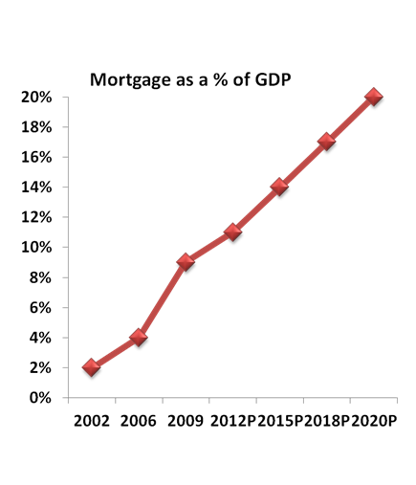
(Source: Paper presented by NHB India at Affordable Housing Conference in Delhi, Jan 29-31, 2012)

Pakistan:
Pakistan, with a population in excess of 170 million people, and faced with massive urbanization of 4-6% in major metropolis like Karachi, an existing urban housing shortage of 3 million units, with a poor access to formal finance at 14%, needs to come forward with a determined plan to meet the challenge of pro-poor affordable housing. Karachi alone, with a population of around 16-17 million persons, is already faced with a growing population of squatter settlements and illegal habitat. Outstanding Mortgage finance is declining since 2008, with PRs 60 billion end of 2011 down from 84 billion in 2008. One reason for this decline is the rising interest rates, with Weighted Average Interest Rate of 16% in 2011. The central bank of the country (State Bank of Pakistan-SBP) has taken many initiatives to promote housing finance through Banks/FIs. The country is also in the process of setting up a mortgage refinance institution. Some good initiatives have been taken by the developer industry in the area of low-cost housing, while much more is needed to be done to meet the backlog, in view of the already existing shortage, and new supply falling short of incremental demand.
(Paper presented by SBP Pakistan at Affordable Housing Conference in Delhi Jan 29-31, 2012)

Bangladesh:
Bangladesh has a population of 160 million plus, characterized by a very high population density of more than 1,227/Sq.KM persons, whereas in Dhaka it is more than 10,000 persons. It had a large area under water by way of rivers and lakes, and thus habitable land is very scarce leading to population density and urbanization challenges. The Urban population as % of total population is 27.6, with a population growth rate of 3%. However the major metropolitans like Dhaka and Chittagong have major population concentration as well concentration of major economic activities. Urbanization is very high in these two cities leading to issues of sub-standard illegal habitat and slums. The GDP/Capita is $692, with a GDP growth rate of 6.3%. Around 31.5% of population is poor, who require more personalized housing solutions as existing market terms are not always affordable to them. Housing backlog is estimated at 5 million, and annual supply is much short of incremental demand. Shortage is more acute in low-income segments. Challenge of affordability is not new to Bangladesh but the need for instituting a supportive institutional framework and increase the supply of affordable land and housing is still a daunting task.
(Based on the paper presented by BHBFC Bangladesh at Affordable Housing Conference Delhi Jan 29-31, 2012)

Thailand:
Thailand has a population of 68 million persons and a per capita income of $4,716. It has a very strong institutional framework for housing and housing finance, and claims to have nominal backlog in housing, with more than 80% of Thais having homes. The outstanding total mortgage debt is 2 trillion Thai Baht.
Three main government organizations implement government housing policies and programs primarily for middle-and-lower income citizens:
- NHA - National Housing Authority developing subsidized - low cost and affordable housing for low & moderate income people.
- CODI - Community Organizations Development Institute slum upgrading and provision of lending mechanism to the urban poor (e.g. microfinance and community based organization development).
- GH Bank - Government Housing Bank offering more affordable mortgage loans to low & middle income groups.
In Thailand, the Royal Gazette dated May 29, 2008 approved the National Housing Strategy and established the National Housing Policy Committee. One of the major responsibilities of the National Housing Policy Board is to oversee the formulation of long term national comprehensive housing policy rather than relying on individual Government policies.
The Thailand Government has two major programs with different approaches. The National Housing Authority (NHA) offers the Baan Eua-Arthorn (BEA) program and Community Organizations Development Institute (CODI) offers the Baan Mankong (BMK) Program. BEA is a new community housing program enabling lower income households to have homeownership in new communities with social and personal security. The BMK’s objective is to solve the settlement and tenure security problems for low-income communities countrywide. The concept of BMK is not to tackle each slum’s problem individually but to look at collective problems on a city-wide scale. Once these city-wide plans are finalized and upgrading projects are selected, the Community Organizations Development Institute (CODI) channels infrastructure subsidies and housing loans directly to the communities through legally established cooperatives or savings groups.
Figure 3
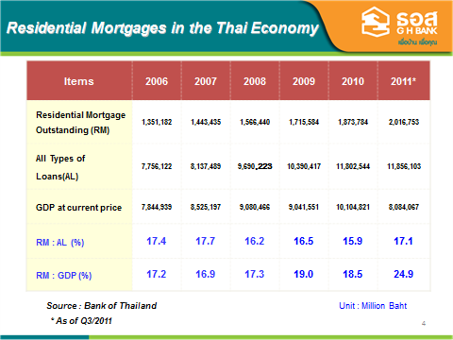
(Source: Paper presented by GHB Thailand, at Affordable Housing Conference in Delhi, Jan 29-31, 2012)

Indonesia:
Indonesia is the biggest archipelago country in South East Asia comprising of 17,504 islands.
Total population in 2010 showed 237.641.326 people, with population growth rate of 2.5%. It has a housing backlog of 8.6 million units. The yearly incremental need for housing is 0.8 million units, while annual supply is 0.2-0.3 million units adding to the already existing backlog.
Figure 4
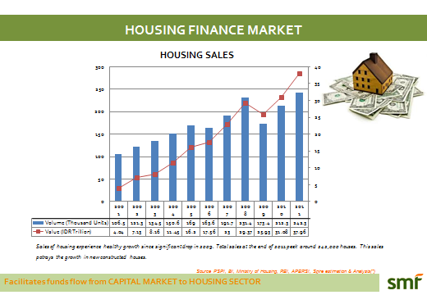
(Source: Paper presented by SMF Indonesia at Affordable Housing Conference in Delhi, Jan 29-31, 2012)

Figure 5
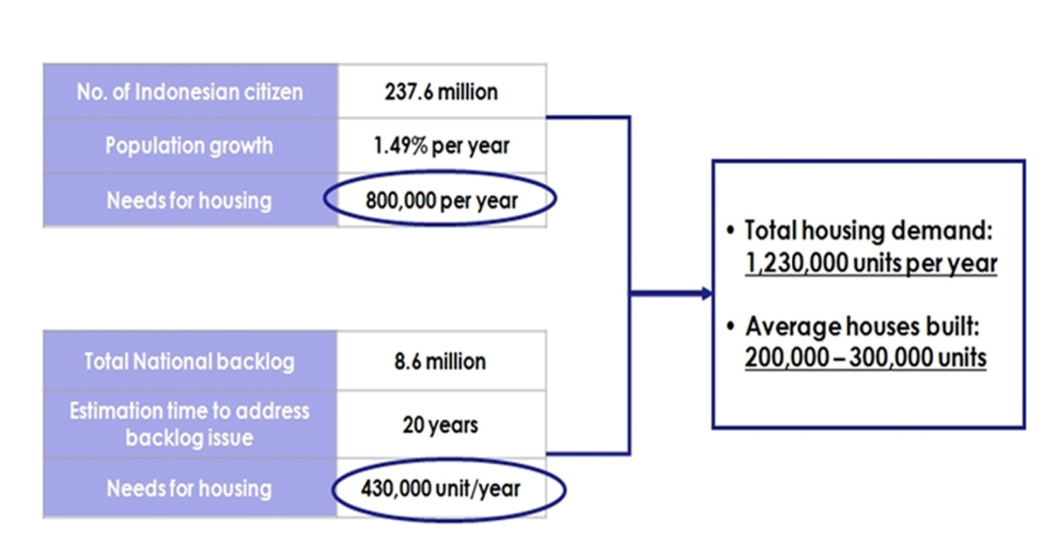
(Source: Paper presented by SMF Indonesia at Affordable Housing Conference in Delhi, Jan 29-31, 2012)

Figure 6
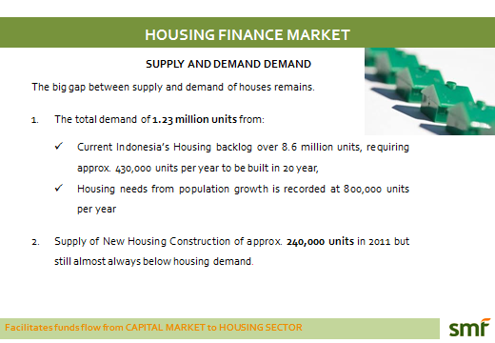
(Source: Paper presented by SMF Indonesia at Affordable Housing Conference in Delhi, Jan 29-31, 2012)

In Indonesia, Article 28H in the 1945 amendment of the constitution of Indonesia stipulates that housing is a basic right and therefore, every citizen has a right to live in a decent and healthy house with a good living environment. In the Long Term Development Plan (RPJP: 2005-2025) goals for housing and urban development can be summarized as cities without slums, where all human settlements are supported by sufficient infrastructure, civic facilities and a housing finance system that is sustainable, effective and accountable.
The Government has taken following steps to accelerate pace of providing housing to low-income households:
➢ National Movement for One Million Houses, with its objective to provide affordable housing and improving quality of living environment. This program was initiated by Government in 2003 to accelerate housing supply, specifically for low-income and poor households.
➢ Subsidized Home Mortgage (KPR), a housing assistance program carried out for low income communities. This program was initiated in 1976. In the beginning, under subsidized scheme known as subsidized home mortgage “KPR”, the subsidized mortgages were provided only through conventional banking institutions. To broaden the distribution of credit for low income households and to the faith based clients, the Ministry of Housing launched Sharia based Subsidized KPR Sharia (KPRS) schemes in 2005. This was done to spread the scope of availability of credit to wide spectrum of the society under Islamic principles.

Mongolia:
In Mongolia during mid-1997, the Government and the Asian Development Bank (ADB) started the development of a sound legal and policy framework for the housing sector. ADB provided Technical Assistance (TA) that helped in preparing the Housing Law, National Housing Strategy (NHS), Housing Privatization Law and the Condominium Law. In 2002, ADB and the Government of Mongolia continued this cooperation through the Housing Finance Sector Program (HFSP), which provided funds for lending to partner banks to offer mortgages to low and middle income households as well as TA to build knowledge and expertise in mortgage finance in commercial banks and among the government stakeholders. One of the major objectives of the Project was “to contribute to the long term objective of establishing a sustainable, market-based system for the delivery of housing finance to meet the borrowing needs of low- and middle-income households”. The HFSP has significantly contributed to establishing a sustainable, market-based housing finance system.

Figure 7
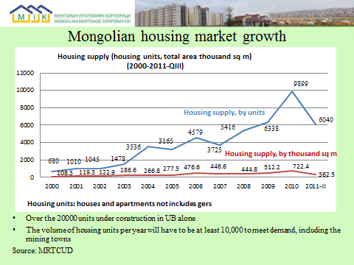
(Source: Paper presented by Mongolia Mortgage Corporation at Affordable Housing Conference in Delhi, Jan29-31, 2012)
Figure 8
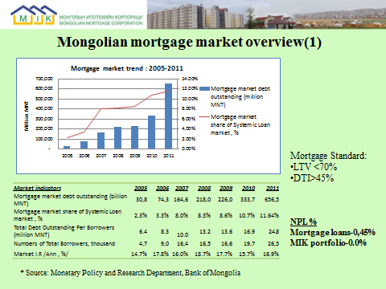
(Source: Paper presented by Mongolia Mortgage Corporation at Affordable Housing Conference in Delhi, Jan29-31, 2012)

Figure 9 shows a traditional Ger Unit, offering a major challenge to the planners to transform this habitat to formal/modern housing.
Figure 9
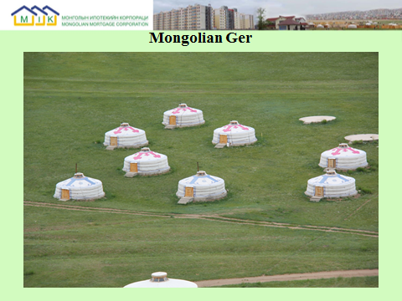
(Source: Paper presented by Mongolia Mortgage Corporation at Affordable Housing Conference in Delhi, Jan29-31, 2012)
Pro-Poor Housing: Issues and Possible Answers

i) Components of Affordable Pro-Poor Housing Supply and Finance are:
- Affordable Finance with Expanded Outreach
- Affordable Serviced Land
- Affordable Construction Cost (Role of Construction Technology and Construction Materials)
- Regulatory and fiscal support to create enabling environment for viable and sustainable market based solution for manufacturing scale supply of Low-Cost Housing
- Less dependence on direct funding support from the Government and opt for Cross-Subsidy and Smart Subsidy Models
- Affordable Finance with Expanded Outreach
- Affordable Serviced Land (through land banking and/or Private-Public Partnership Models
- Affordable Construction Cost (Role of Construction Technology and Construction Materials)
- Regulatory and Fiscal Support to Create Enabling Environment
- Government to provide external infrastructure support.
- Creation of specific regulatory regime for Low-Cost/Low-Income Housing

ii) Creation of Enabling Environment:
- Mortgage Guarantee Fund and Mortgage Subsidy Fund at State level
- Strengthening Loan Recovery and Foreclosure Laws
- Facilitate Bankable Titles
- Creation of Long Term Liquidity Facility Institutions
- Ensure Access to Finance (Conventional and faith-Based Finance)
- Set up specialized housing finance institutions for Low-Income and Micro Housing Finance.
- Develop Mortgage Guidelines

iii) Awareness of Issues and Sharing of Answers:
• Need for continuous dialogue and dissemination of experience and technology between local, regional and global institutions involved in low-cost housing construction and finance (platforms like Asia-Pacific Union for Housing Finance, International Union for Housing Finance, Affordable Housing Institute etc.)
• Set up local study centers for research on housing relayed issues (e.g., Monitor India)
iv) Risk Mitigation:
• Mortgage Insurance and Title Insurance Institutions
• Mortgage Guarantee Funds
• Alternative Form of Collaterals
• Mortgage Counseling and Consumer Education
• Share experiences on Risk Mitigation Models
• Credit Bureaus (generally having nil credit histories)

Issues we know -- Answers we need
Pro Poor and Affordable Housing Initiatives will lead us to answers
Asia- Pacific Union for Housing Finance
The Knowledge Sharing Platform
Website: www.apuhf.info

The paper is based on the proceedings and papers presented at Affordable Housing Conference, organized by National Housing Bank (NHB) India and Asia Pacific Union for Housing Finance (APUHF) on Jan. 29-31, 2012 at Delhi. The papers presented at the Conference are available at the Website www.apuhf.info . The paper illustrates the subject within the context of Asia-Pacific region Housing Finance

