Home » Featured, knowledge is strength

How to measure housing affordability in Singapore?
26 March 2010 No Comment
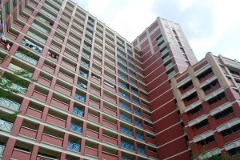
Yet another record breaking HDB flat from Bras Basah sold at $650,000 or a record smashing $736psf. This jaw dropping price was set by a Taiwance PR couple who purchased a HDB flat left with 70 year lease. On the other hand, the Government is stepping out strongly to maintain the stand that the public housing is still affordable, based on their own sets of parameter.
Let’s take a look at these 2 articles brilliantly dissecting the topic on housing affordability in Singapore:

The TRUTH about Housing affordability in Singapore….. By Diary of A Singaporean Mind
In a recent parliament speech, Minister Mah spoke again about HDB flats being ‘affordable’. To support his assertion he gave a few examples to illustrate what affordable means:
“In the case of new HDB flats in non-mature estates, the average mortgage payment for new flats in non-mature estates sold in 2009 was 22% of monthly household income, which translates to a DSR of 22%. This is 1-2% marginally higher than the level seen in the last decade, but well within the affordability benchmark of 30-35%. This also means that about 80% of Singaporean new flat buyers are able to service their housing loans entirely from CPF without any cash payment. In my opinion, this is a significant fact and a very real measure of affordability” - Minister Mah’s Speech in Parliament 5 March 2010[Link].
Do go through the other examples in his speech to fully understand what he means by affordability. He is basically saying if you can service your 30 yr mortgage loan today, things are okay…the HDB has done its job well and there are no real issues here. You noticed he used ‘average’ mortgage payment …hmm so what happens to the 500,000 families who are below average? What happens to the bottom 20-30% where income has fallen off steeply due to the income gap? Public housing is for everyone right? Not just the average and above average families. His choice of using the average to demonstrate affordability is just a small spin ….I’ll show you why this whole affordability argument from Minister Mah is bogus. Our public housing is the most expensive in the world and it causes Singaporean households to be deep in debt putting them at risk – 8% of HDB loans were in default in late 2008 even before the recession started[Link:HDB Mortgage Defaults Up 33,000 in October]. The need to service a debt over 3 decades make Singaporean households financially vulnerable – but there is something that make such loans even more dangerous……
How did people buy homes in the past anyway? My grandfather his home by leasing a piece of land from a landlord and he paid a house builder to build the attap house. I lived in it for 15 years – my grandpa was a baker, he had 6 children and never spent one day in debt. My father bought his HDB 4 room HDB flat in the early 80s. Those days HDB build 4 room flats the size of an $800K-$900K condo today. My dad paid of his housing debt in 7 years. His CPF was intact because they did not allow CPF to be used for housing in those days. Some time in the later half of the 1980s the CPF was liberalised for use in housing and this was what happened:
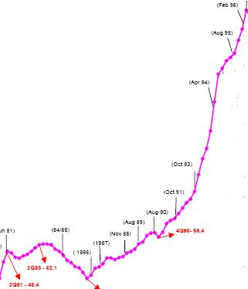
The surge in property prices was caused by the CPF liberalisation (according to this research paper[Link]. The housing loans to GNP ratio went up from 0.1 in 1980 to a whopping 0.49 in 1997 [Link]- a 500% jump! So CPF was emptied for purpose of buying homes and households became highly indebted – now housing becomes intertwined with retirement.
…Some of you may be asking what is wrong with debt anyway? You have a steady job, you make more than enough to cover your monthly instalments …so what is the big deal about borrowing $300K to buy a flat or $500K to buy a condo if you’re making $5-8K a month…30 yrs later you will be off the hook and along the way there is a good chance you can off-load to some other person for a profit of $100-200K if the timing is right. What is the problem…everyone else is doing it anyway….besides job loss, falling prices, illness, etc, there is something sinister I find most young people don’t take into account when they take up, say, a $500K loan – its seems so routine these days given the high cost of housing….let me tell you a story…
Late 1998 during the Asian crisis, prices for property fell and I was persuaded to buy one. After I selected my property and booked it, I went around to shop for a loan. I found a bank advertising an ‘unbelievably low rate of interest’. The offer was so good, the bank kept its doors opened on Saturday to deal with surge in loan applications. I went to the bank very early but found a long queue of people ahead of me. I waited for 5 hours before my turn. When the officer saw me, she said, “Mister, this type of good deal for housing loan you will probably never see again in your lifetime”. So what was this good deal? The bank was offering an interest rate of 5.25% for housing loans – the lowest in recent years. Many people today taking up housing loans forget that the 3-4% housing loan interest we see now is artificially low and not the norm if you look at interest rates in the past 3 decades. During the Asian crisis, housing loan interest rates went up to 8% i.e. if you have a housing loan of $500K you will be paying $40K a year or $3.3K a month on interest along without reduction in principal. One of my friend paid close to $200K in total instalments to service a $700K housing loan in 1996-1998 only to see the principal fall by $50K as interest ranged from 5.5-8% during that period.
Talking a 30 year loan is not a trivial thing – during the 30 years, many things can happen include the high likelihood of interest rates going up, job loss, illness, etc and Minister Mah is incorrect to say it is affordable and okay for people to take up these loans when we were already seeing a default rate of 8% in 2008 when the interest rate and job environment was relatively benign. Debt = risk and a public housing program that requires buyers to take up 30 yr mortgages to stretch their loan so they can afford the month instalments puts the ordinary people at risk while it maximises the govt revenue by putting heavy burdens on Singaporean households.

Evidence that housing prices in Singapore are unaffordable By Furry Brown Dog
Over the course of the past few months, I have encountered people (some of whom are friends) who for some reason either were unaware or in denial of the fact that housing prices are becoming increasingly unaffordable for Singaporeans. This is something which is well-known and documented to the extent I do not believe it is rational or reasonable for anyone to deny it should they be aware of the facts. In writing this post, it is my hope that I may be able to prove to these individuals that housing prices have been spiraling out of control and are rightly considered unaffordable. To make the case, I present three pieces of evidence to substantiate this claim.
1. Some time back, Eugene Yeo of the Temasek Review wrote this piece on the (un)affordability of HDB flats. Using the statistical measure of the Multiple of the Median, it was found that under the assumption of a median household (two working parents) annual income of $67,200 (see pg 5) (for 4-room or larger households and using $5600 as monthly income) annually in Singapore, the ratio of housing price to median income should not exceed $201,600 if we take 3.0 as the maximum allowable ratio as the 5th Annual Demographia International Housing Affordability Survey did:
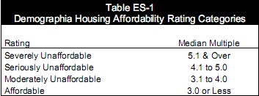
The cited example of the newly launched Punggol HDB flats whose cost ranged from $264,000 to $322,000 (4 room flat) and $344,000 to $409,000 (5-room) flat, clearly exceeds this affordability ratio:
Cost of HDB flat Median Multiple
$264,000 3.92
$322,000 4.79
$344,000 5.12
$409,000 6.09
As we can see from the above figures, all the flats lie in the “unaffordable” category according to the Demographia Housing Affordability Rating Categories with flats costing $344,000 lying in the “severely unaffordable” category.
Since the Demographia International Housing Affordability Survey study the affordability of private housing in first world developed countries, this means that public housing in Singapore costs more than private housing in these countries.
Furthermore, the annual household income used in the calculations is only a median which means that HDB flats are definitely unaffordable to half the number of households whose annual income are below the median figure of $67,200.
In fact the reality on the ground may even be worse. HDB’s own affordability statistics reveal an even uglier truth. Instead of using the median income of the typical 4-room or larger inhabitant, they quoted an even lower median income for applicants of $4100 and $5100 for 4- and 5- room inhabitants respectively. This is likely due to the fact that flat applicants are usually working people starting out early in their careers and hence have a lower income on average compared to the overall median. The result?
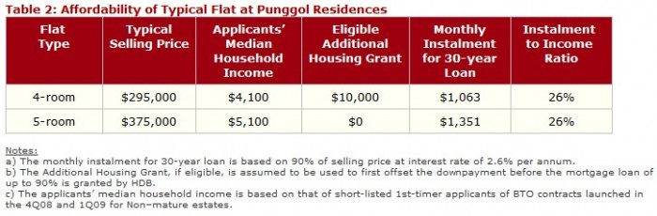Using the method of multiple of the mean this amounts to a ratio of 5.99 and 6.12 respectively, which is classed as “severely unaffordable” by the international study. Little wonder that so many complain of unaffordable housing in Singapore. Even if we look at other flats available on sale apart from the Punggol residences, how many 4-to-5 room flats cost at most $201,600?
2. Another possibility emerges out of this picture. Perhaps it is not that housing prices are unaffordable, but that average wages are way too low in Singapore. The method of median multiple does not exclude such possibility since it is a ratio and not an absolute measure. How credible is this hypothesis? Let us examine its plausibility. Swiss investment bank UBS releases an annual study titled Prices & Earnings examining the relative purchasing power of average salaries of employees in various cities around the world. The measure was obtained by using the average wages of the city inhabitant divided by the same basket of goods purchased in the various cities. The 2009 publication revealed that Singapore had slipped from a rank of 40 out of 71 cities to 50 out of 73 cities when the average domestic purchasing power parity (PPP) was measured:
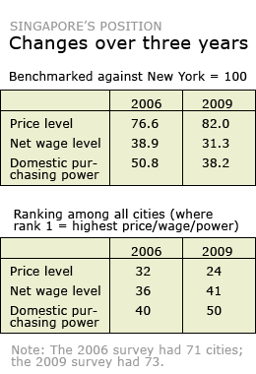Note: Temasek Review had written on this earlier as well. (They were in fact the first source, even quicker than the state-controlled mainstream media to break this) They expanded their article into a 3-article series discussing the rising costs of living and housing unaffordability as well as opine on the causes of these. The series may be found here, here and here. Definitely a must-read. Where does the average Singapore worker rank in the world relative to employees in other countries?
Singaporeans have a low purchasing power of only 39.9, comparable to Kuala Lumpur (39.5), Warsaw (34.0) and Bogota (33.7).
Other countries in the Asia-Pacific region which are ahead of us are Tokyo (82.2), Auckland (68.9), Taipei (58.9), Hong Kong (58.1) and Seoul (57.4).
In other words, though the cost of living is higher in Tokyo, the average Japanese has a domestic purchasing power more than twice that of an average Singaporean.
Though Malaysia is still a developing country and has a GDP (PPP) per capita of only $14,215, less than 3 times of ours, the ordinary Malaysian citizen has about the same domestic purchasing power as the Singaporean.
In particular these three paragraphs illustrate how far Singapore has come since the 1980s:
Over 85% of Singaporeans live in high-rise public housing built by the government. Though they are meant to be cheap and affordable to the masses, recent price hikes has priced ordinary Singapore workers out of the market.
In the 1980s, a new four room flat in Bishan cost about $60,000 while the median pay of a fresh graduate is about $1,500. A young couple paying a monthly mortgage of $1,000 will be able to repay the entire housing loan in 5 years time.
Today, a new four room flat under the Design, Built and Order scheme in Bishan cost around $600,000. The median pay of a graduate is only $2,500. How much will a couple need to pay a month in order to service a thirty year loan?
One last important point I would like to make before wrapping this up. The UBS study employed average rather than median income, which was used because this was more readily available. What are the drawbacks of such an approach? It is likely that Singapore’s ranking would have fallen even more if median income had been used as a metric due to its high Gini coefficient in comparison with the rest of the world. It ranks No. 2, second only to Hong Kong. This table from a paper by the Singapore Department of Statistics tells all (note the disparity between average and median income, a ratio of 1.4 for average-to-median):
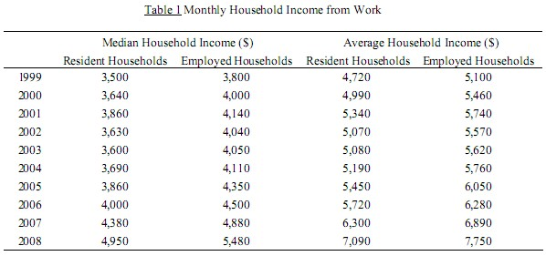
3. The third piece of evidence offered comes from a paper discussing the puzzle of why aggregate consumption has fallen so drastically low in Singapore, leaving Singapore without a built-in stabiliser of the economy. Professor Tilak Abeysinghe of NUS and Asst Prof Keen Meng Choy of NTU performed a regression analysis to determine the causes of falling domestic consumption in Singapore. The result? They concluded that rising housing prices in Singapore was a key factor in the rapid decline of the average propensity to consume (APC) in Singapore:
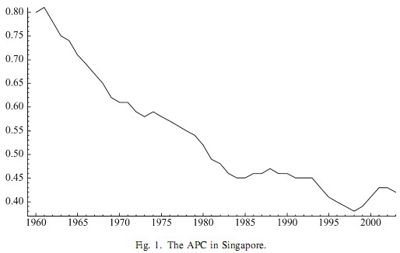
The following is quoted from their paper:
Even the most affordable public apartments in Singapore could cost 5–10 times the average annual household income while car prices stand as the highest in the world. House and car price in?ation in Singapore can in turn be traced to the limited land space,the rising aspirations of the population to upgrade to better housing, and the demand for cars outstripping the supply of quotas for car ownership.
The decline in consumption is chiefly due to the fact that real estate is a highly illiquid investment in Singapore and money locked away in property cannot hence be used for consumption or savings:
The insigni?cance of the housing wealth coef?cient reinforces the earlier regression ?ndings and vindicates our belief that housing assets in Singapore are perceived to be illiquid.
To quantify the effect several factors, the researchers isolated the variables corresponding to housing loans (liabilities), visitor (tourist) expenditure, household financial wealth and observed how each of them independently affected Singapore’s APC. Visitor expenditure was included for the following reason:
In principle, visitor expenditures should be irrelevant as private consumption is defined as expenditures by the resident population on the purchases of final goods and services. It is obtained by netting out the expenditures of tourists from the estimates of total consumption in the domestic market. However, the fact that the number of visitors who visit Singapore each year is nearly twice the size of the resident population means that any errors-in-variables problem created by visitor spending would be amplified.
The following results were obtained by the study:
Using these results, we are able to derive an ex-post explanation of the APC’s decline. The estimated long-run elasticities suggest that a 1% increase in the financial wealth ratio raises the APC by 0.16%, a similar increase in the loan ratio reduces it by 0.22%, while a 1% decrease in the visitor expenditure ratio reduces it by 0.19%. Perhaps not surprisingly, the price effect dominates the wealth effect, thereby explaining the secular fall in the APC.
…
The superimposed regression trend lines show that the ratio of household financial wealth to disposable income has an upward trend, but this increase in the wealth ratio has not been sufficient to stem the decline in Singapore’s APC, which has been driven by a sharply rising loan ratio and a declining visitor expenditure ratio.
In concluding remarks, the authors recommended that the government (HDB) take pro-active steps to ensure residential property remain affordable to Singaporeans:
The main result of our study is that rising loans and withdrawals from the CPF to finance house and car purchases have played a crucial role in the evolution of Singapore’s APC. It is observable that a fall in house prices is accompanied by a rise in APC with a lag of 4–5 years. This leads us to another important policy implication: to prevent further declines in the APC, the government should ensure that residential property and other household assets remain affordable to Singaporeans. At the least, it should do its best to prevent a recurrence of the bubble-like increases in residential property prices experienced in the early 1980s and 1990s. As our analysis demonstrates, these were the periods during which the APC lost much ground. More specifically, we recommend that any increase in property prices that exceeds the trend growth rate of disposable income should be mitigated by policy interventions.
To summarise, housing prices in Singapore have a significant effect on domestic consumption in Singapore due to the illiquid nature of real estate investments and their relative unaffordability. On a side note, this paper provides a perfect explanation as to why consumption makes up such a low proportion of GDP (40%, similar to China).
Now that the above three pieces of evidence have been presented and elaborated in detail, I believe it is worth taking a moment or so to reflect on the causes of rising housing prices. Seah Chiang Nee of The Star put part of the blame on the influx of rich foreigners holding permanent residency (PR) in Singapore:
The rejected Singaporeans who cannot wait any longer will have to turn to the dearer resale market, where they will face stiff competition from rich foreigners holding permanent residency (PR) status.
PRs made up 40% of buyers in the open market during the past five years, resulting in prices rising by 40%.
One local benefit, however, is that a newly married Singaporean couple is given a S$40,000 (RM97,121) grant to buy a HDB resale unit.
The squeeze is due to two factors: firstly, a PR population hike of 51% to 553,000 since 2004, and secondly, more citizens demanding central or mature areas.
Don’t take Mr Seah’s word for it if you don’t trust him. A Sept 24th, 2009 report by the Business Times show likewise:
Those who are financially stable upgrade to larger flats while those facing financial constraints have been downgrading. The government’s target population of 6.5 million is steadily increasing the pool of PRs; and they have to buy their HDB homes from the resale market as they do not qualify to buy new flats directly from HDB.
ERA’s resale transactions show that PR buyers make up some 40 per cent compared to 20 per cent three years ago. They typically buy 3- or 4-room flats and may upgrade to 5-room flats once they obtain their citizenships.
In addition, Temasek Review also pointed out that Singapore took active steps by promoting policies which widens wealth inequality and favours rich people at the expense of the poor. This is significant because Singapore is increasingly becoming a favoured destination for rich folks to stash their funds for investment, and this inflates asset prices such as real estate and land. When the government then sells HDB the land at a “discounted” rate (taking into account the market price offered by private developers and speculators such as these rich folks) of the market price auctioned among the interested parties, Singaporeans are told that they should be grateful to the government’s generous subsidy without which things would be so much more expensive:
The Government owns most of the island. From time to time it puts out parcels of land for sale and invites private developers to bid for them. (“Private” is used very loosely here as some of these real estate companies are GLCs).
The Government then sells land earmarked for HDB flats to the HDB at a lower price (say, 60 percent) of whatever amount the successful private bid comes to. In other words, the PAP claims, HDB land is subsidized (by up to 40 percent).
Deliciously diabolical, isn’t it? The Government, in the form of the HDB, “purchases” the land from itself, factors the amount into the price of flats, makes a tidy profit from Singaporeans and then claims that it subsidizes the flats!

***

