Is affordable housing really affordable?

HDB issued new data to show that new flats are within the budget of first-time home buyers in different income groups. Hear what people on the ground have to say.
Opposition parties have called for new flat prices to be further reduced, with some suggesting that they be pegged to the median incomes of Singaporeans or to the cost of building them.
Meanwhile, the HDB provided new data that supports National Development Minister Mah Bow Tan’s claim on Sunday that most first-time buyers of new flats will need to fork out little or no cash to pay for their new HDB flats.
His comments add to a debate on public housing that has become one of the hottest topics this General Election.
He cited the example of how a couple below the age of 30, who earn a combined $4,000 a month, need to work for only half a year to buy a new four-room HDB flat with no cash upfront and less than $50 in cash in monthly home loan payments.
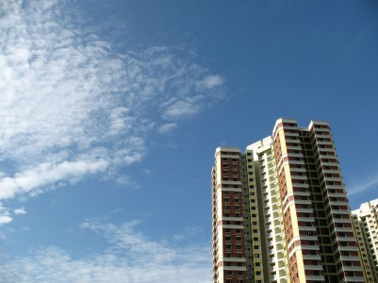
These numbers have since been questioned by some ST Forum letter writers and netizens online. Some have calculated that for such a couple to fork out so little cash after working for only six months, an HDB flat they buy has to be priced at $110,000, whereas the average price of a new four-room flat is around $270,000.
In its response to media queries yesterday, HDB said that Mr Mah’s calculations are correct because they include an Additional Housing Grant (AHG) of $10,000 which is given to a household that earns between $4,001 and $4,500 (See table). Key to the affordability of new flats is the Government’s Additional Housing Grant (AHG), which is given to most first-time buyers with a household income of less than $5,000 a month.
It produced more examples to show that because of the AHG, which can go up to $40,000 depending on the household income, couples buying two- or three-room flats and earning $1,500 and $2,300 a month respectively do not even need to wait a single month to be able to make the down payment for their new flats.
Mr Mah added in a video yesterday that he hopes ‘Singaporeans do not forget the fundamental principles that have brought us to where we are today, which is a home-owning society’.
The principles he mentioned referred to home ownership as compared to rental, homes as an asset and homes for the masses, he said, adding: ‘No other country has the same extent of home ownership that we have.’
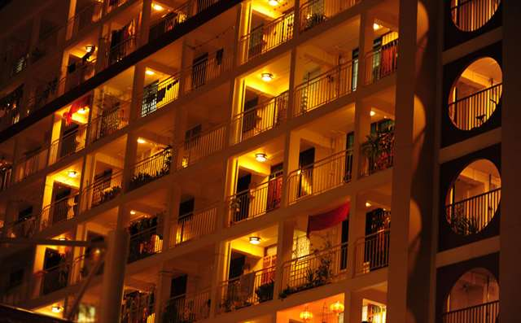
(Image courtesy of Singapore Tourism Board)
Hear what some members of public have to say:
The argument over the affordability of public housing will never be resolved until the HDB comes out with a concrete, measurable definition of exactly what it means by affordability.
Affordability boils down to dollars and cents. If it’s about numbers, a scientific and quantitative approach must be taken to resolve the problem or quell disagreements.
Let’s take a simplistic look at the concept.
A graduate earns an average of $3,000. A brand new four-room flat costs at least $300,000. This would mean an annual repayment of $10,000 for 30 years, excluding interest. This would translate to around $833 in monthly mortgage payments funded entirely through the Central Provident Fund. Can we assume affordability simply because he does not need to come up with cash for the mortgage? Have we considered his monthly expenditure? What is he left with after accounting for public transport expenses, education costs for his children and basic groceries?
Many people from our parents’ generation were not earning the fantastic salaries that many of us earn today. Yet, many of them have already paid off the cost of their first flat, even after including upgrading costs. How is this possible given the example above?
So, what is affordability? Being able to pay off a flat after 30 years with little left in the retirement account? Being able to pay it off after 20 years?
Let’s assess affordability properly and use a quantitative approach.
Chew Wai Yip
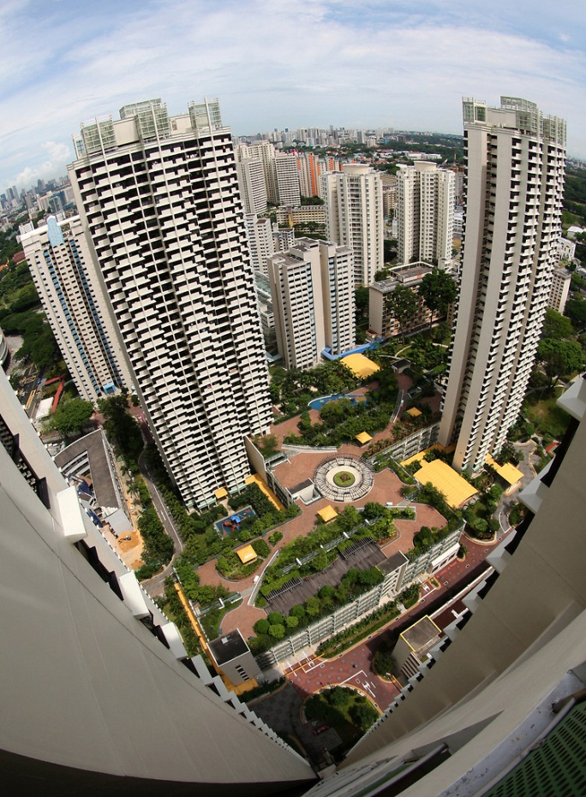
HDB Flats. Image courtesy of Singapore Tourism Board.
The housing debate between National Development Minister Mah Bow Tan and the Workers’ Party does not point to the key reason why HDB prices have surged.
This year’s first-quarter flash estimate for the Resale Price Index (RPI), which reflects prices of resale HDB flats, stands at 174.8. This means a resale HDB flat is approximately 70 per cent more expensive now than in the third quarter of 2006, following the last general election, when the RPI was 102.6.
However, the median income has not matched the increase, which resulted in the need for higher subsidies for first-time buyers as new HDB flat prices are pegged to surrounding HDB resale flat prices.
The Government is largely responsible for the price increase because it controls both the demand and supply of housing.
In terms of demand, the immigration policy resulted in a rapid growth of foreigners from 1.3 million in 2006 to 1.85 million last year. Singapore’s population was 5.08 million last year and 4.4 million in 2006.
Prices of private properties have shot up, given the 42 per cent increase in foreigners since the 2006 General Election, which is a significant factor in driving up resale HDB flat prices, based on price comparisons. In terms of supply, the Government decides on the number of new HDB flats being built, and also land made available for private housing.
Ensuring affordable housing for citizens must require an inter-governmental approach involving the National Development, Manpower and Home Affairs (immigration) ministries. Given their weekly Meet-the-People sessions, MPs should also have raised the concerns much earlier in 2008, when the RPI jumped from 104.9 in the first quarter of 2007 to 121.7 in the fourth quarter of that year.
Soon Sze Meng
Source: The Straits Times © Singapore Press Holdings Ltd. Reprinted with permission.

