Trash Can Be Turned into Renewable Energy. This Startup Raised $33M to Do It.

BY ALEX LAUER / JULY 29, 2019 3:27 PM

Sierra Energy’s FastOx system now counts Bill Gates, Jeff Bezos among its investors
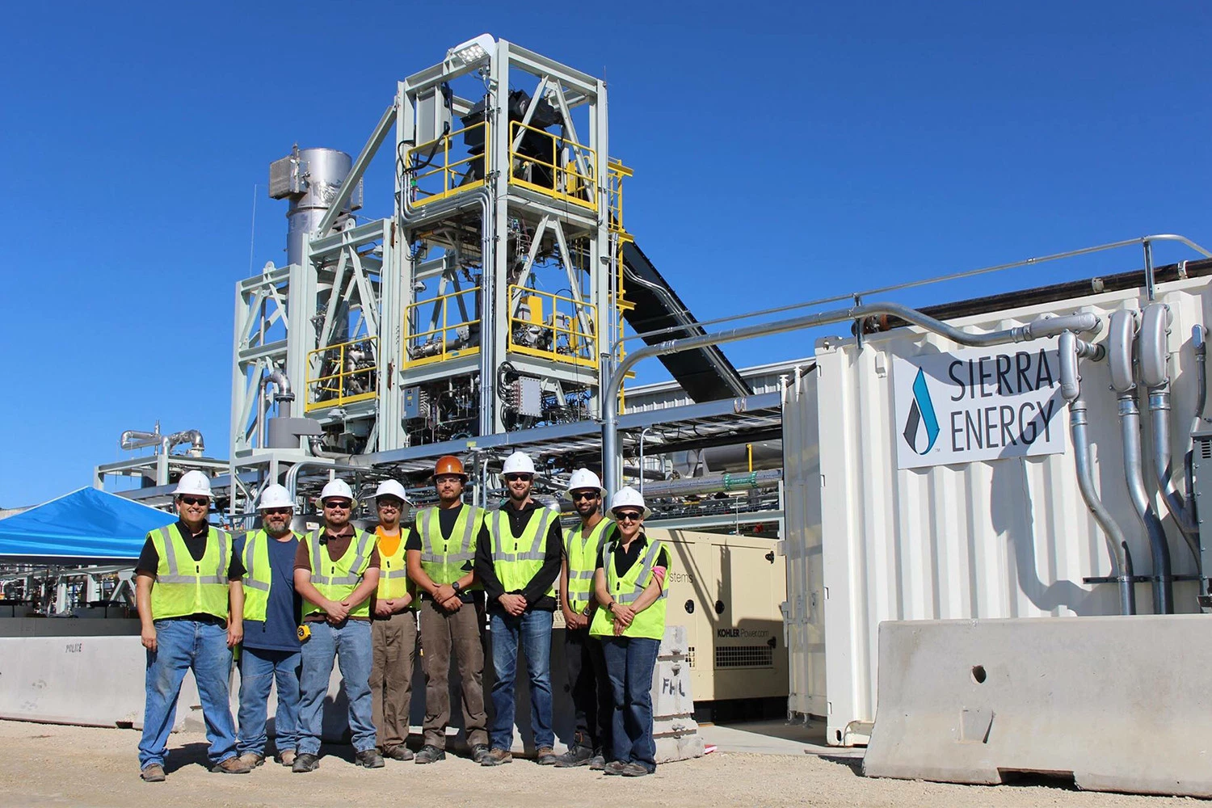

We all know trash pollution is a problem when it’s outside a landfill (see: The Great Pacific Garbage Patch). But as Carmichael Roberts reminds us, it’s just as big a problem inside: “Solid waste landfills are one of the largest producers of methane emissions in the U.S., which are far more potent than carbon dioxide as a greenhouse gas.”
What if we could not only make that garbage disappear, but we could turn it into clean, renewable energy? That’s the mission behind Sierra Energy, which announced today it had closed a $33 million investment round led by Roberts’s Breakthrough Energy Ventures, a fund whose investors include Bill Gates, Mark Zuckerberg, Jeff Bezos, Richard Branson and presidential candidate Tom Steyer, among other business leaders.

Sierra Energy’s almost unbelievable technology is called FastOx. Here’s how it works: Trash is brought into a blast furnace-based “gasifier,” it’s heated to 4,000°F using oxygen and steam, and then synthesis gas (hydrogen and carbon monoxide), non-leaching stone and molten metal is produced. As the press release notes, no harmful emissions are created, and all outputs are captured for reuse and sale.

In simple terms? Greenhouse gas-producing trash goes in, renewable energy and fuels come out, without the emissions of something like an incinerator, as Fast Company writes.

Two problems come to mind immediately: How expensive is this? And is it like current recycling initiatives, where materials have to be uncontaminated to be used? Fast Companyhas an answer for the first question:

Since landfills charge “tipping fees” to take trash, the new system could actually save money; a waste hauler that currently pays a landfill, for example, could decide to build its own system using the technology and then could both avoid paying fees and make money by selling electricity or products like fuel.

As for what kind of trash, Sierra Energy writes that FastOx can process “virtually any waste,” which includes “municipal solid waste, plastics, medical waste, e-waste, tires, batteries, railroad ties, and even hazardous wastes.” In other words, all those things you should be disposing of properly but end up throwing in the trash anyway.

As new Sierra Energy investor Bill Gates wrote back in 2018, we can’t combat climate change by only focusing on cutting fossil fuel use. We have to focus on other greenhouse gas sources, too. Sierra Energy’s FastOx looks like a promising way to accomplish the landfill part of that equation, and now they’ve got investment heavyweights backing them up.

***

