An Assessment of Sanitation situation in Mukuru Kwa Njenga Informal settlement.
The Case of Sisal area.

BY

Bevervy Ogao, Solomon Mwangi, Everlyne Mureithi, Monica Njeri and
Juma Obare Michael

September, 2017.
Author _ JUMA OBARE MICHAEL

ACKNOWLEDGEMENT
This report is a result of an assessment conducted in Sisal area, Mukuru Kwa Njenga. We wish to acknowledge and sincerely appreciate the co-operation from various stakeholders namely – KUMEA, Umande Trust, the leadership of the New Apostolic Church, The Local Administration (Chief), and Local households who positively made wonderful contribution for the success of this assessmement. We wish to appreciate the Enumerators (Youths of the New Apostolic Church) and The Team from Umande Trust led Beverly Ogao, Solomon Mwangi, Everlyne Mureithi, Monica Njeri and Juma Obare for their well co-coordinating during the field work. Moreover, our special gratitude goes to The Managing Director, Umande Trust, Madam Aidah Binale for her professional input and advice which was realy useful in ensuring that the assessment process realize its objectives. In addition, we want to extend appreciation to KUMEA and any other person for their input in ensuring that this basis is set. May the almighty God, guide us as we look forward to running projects that will improve sanitation standards and environmental hygiene in Mukuru Kwa Njenga.

ACRONYMS AND ABBREVIATIONS
GoK - Government of Kenya
KNBS - Kenya Nationa Bureau of Statistics
KUMEA - Kuimarisha Maisha East Africa
SDGs - Sustainable Development Goals
SPA - Special Planning Area
SPSS - Statistical Package for Social Scientists
VIP Latrine - Ventilated Improved Pit Latrine
WHO - World Health Organization

TABLES OF CONTENTS

ACKNOWLEDGEMENT ii
ACRONYMS AND ABBREVIATIONS iii
TABLES OF CONTENTS iv
LIST OF FIGURES iv
LIST OF TABLES v
EXECUTIVE SUMMARY vi
1.0 INTRODUCTION 1
1.1 Background Information 1
1.2 The Situational Context 1
1.3 Significance of the sanitation assessment 4
2.0 METHODOLOGY 6
3.0 DATA ANALYSIS AND DISCUSSION 8
3.0 Water 8
3.3 Health 16
3.0 SUMMARY OF FINDINGS, CONCLUSION AND RECOMMENDATIONS. 19
3.1 Summary of findings 19
3.2 Conclusion 19
3.4 Recommendations 19
REFERENCES 20
Appendix 21

LIST OF FIGURES
Figure 1: Infrastructures that resident fetch water 8
Figure 2: The availability of water in the area 9
Figure 3: The cohorts for prices of water 9
Figure 4: The cost water from different source of water 10
Figure 5: The different method of purifying water 11
Figure 6: The challenges encountered when accessing water 11
Figure 7: The various types of sanitation facilities used by the residents 12
Figure 8: The fees charged in the various toilet facilities 12
Figure 9: The comparison of charges in the different sanitation facilities 13
Figure 10: Conditions of the various sanitation facilities 14
Figure 11: Distances covered to the sanitation facility 14
Figure 12: Proportion of Bathrooms 15
Figure 13: The medical facilities used by individual in the area 16
Figure 14: Health Matters for the residents in the last six months 17

LIST OF TABLES
Table 1: The price bracket charged in various sanitation facilities 13
Table 2: Sanitation facilities and the level of their condition 13
Table 3: Some of the challenges experienced in the existing sanitation facilities 15
Table 4: Bathrooms types in the study area 15
Table 5: Disease cases experienced in the last six months 17
Table 6: Challenges in the health service delivery 18
Table 7: Proposed solution to challenges in the health sector 18

LIST OF PLATES
Plate 1: The location Extend of the study 1
Plate 2: The unsanitary and health hazards situation as result of poor drainage 2
Plate 3: The dereliction as a result of poor waste management strategy. 2
Plate 4 and Plate 5: Poor drainage and closeness of shanties creating a health hazard in the area. 3
Plate 6 and Plate 7: Fresh life sanitation model improving the hygiene of the residents. 3
Plate 8: One of the already abandoned pit latrine as result of poor condition and associated health risks factors. 4
Plate 9: The stretch in which the assessment was carried within sisal area. 6

EXECUTIVE SUMMARY
This assessment on the sanitation situation in Mukuru Kwa Njenga mainly targeted the households in Sisal area living within 60metres radius proximity to the proposed site. Mukuru is a Special Planning Area (SPA), hence not any other development other than the recommended one is allowed to take place. This is a clear revelation of how unique the idea of sanitation for all is important. This assessment aimed at looking levels and the existing infrastructures such as water supply, sanitation facilities, health and health status of the various households. This rapid assessment also looked into associated factors such as frequency, cost, distance covered, quality, the challenges and remedies to such issues. The bio-sanitation model to be develop in the Sisal area, is a multi-purpose unit and an environmental friendly initiative as the by –products will also be useful in development of other sectors especially urban agriculture.

1.0 INTRODUCTION

1.1 Background Information
World Health Organization (WHO) defines sanitation as the provision of facilities and services with the goal of attaining better and safe disposal of human urine and faeces. It is the most basic utility for human health, dignity and valuable living in a particular environment. Sanitation is also referred to as the hygienic way of ensuring there is no human contact with hazardous waste with goal of enhancing healthy living and environmental integrity, (GoK, 2016). Sanitation is associated to healthy surroundings services such as collection of garbage and waste water disposal to prevent water and sanitation related diseases (ibid).
The state of sanitation varies from country to country depending on their economic statues and population. Kenya, as one of the county in globe is not spared. Basic sanitation services are not accessible to the numerous populations in Kenya especially in informal/unplanned settlements. The poor and the low income are therefore unable to access decent and dignified sanitation services hence cases of water born diseases such as cholera, diarrhea, typhoid among others especially among children and poor environmental due waste water, poor drainage, uncollected garbage and many others (ibid).

1.2 The Situational Context
Plate 1: The location Extend of the study
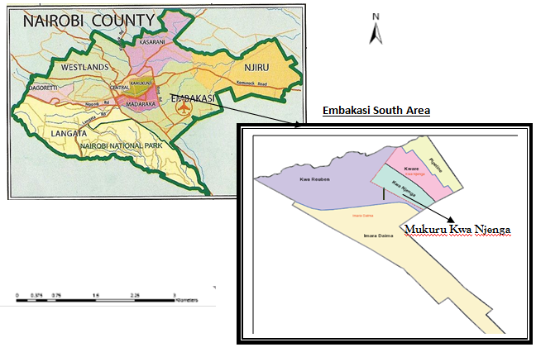 Source: Author, 2017
Mukuru kwa Njenga, is located in Embakasi South area, Nairobi County. This area is an informal settlement within the industrial area. Like in any other urban slum in the world, it is characterized by high population with low income, structures with old iron sheets, inadequate supply of water and sanitation services, poor drainage with no sewer connection. Municipal waste is menace with some of the access road have been turned in dumped sites.
Plate 2: The unsanitary and health hazards situation as result of poor drainage
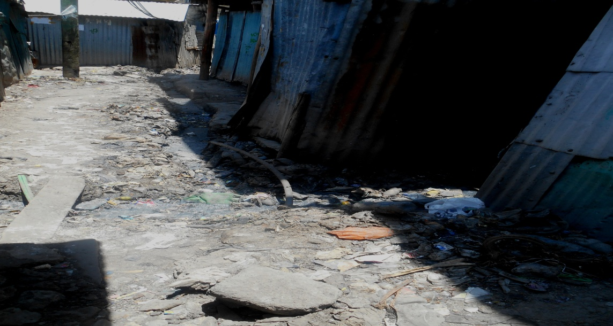Source: Field data, 2017
Plate 3: The dereliction as a result of poor waste management strategy.
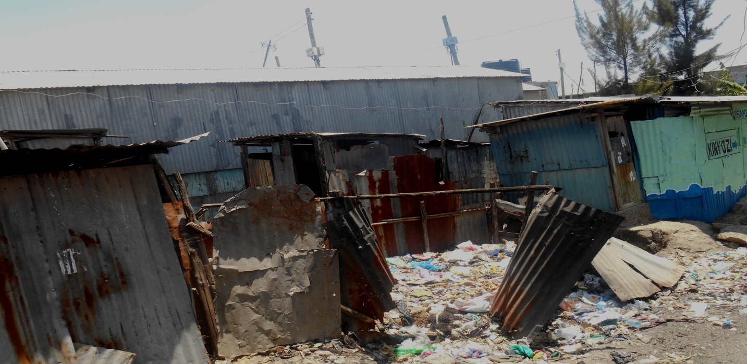
Source: Field data, 2017.
The shanties are very close to or connected to one another with only a path separating one shanty plot from another. Majority of the shanty plots lack a sanitation facility with some having an on plot bathroom in which the waste water is allowed to the open drainage systems a few metres from the plot itself. Due to lack of well designed drainage, the waste water remains stagnant forming breeding ground for mosquitoes a carrier for malaria infection.
Plate 4 and Plate 5: Poor drainage and closeness of shanties creating a health hazard in the area.
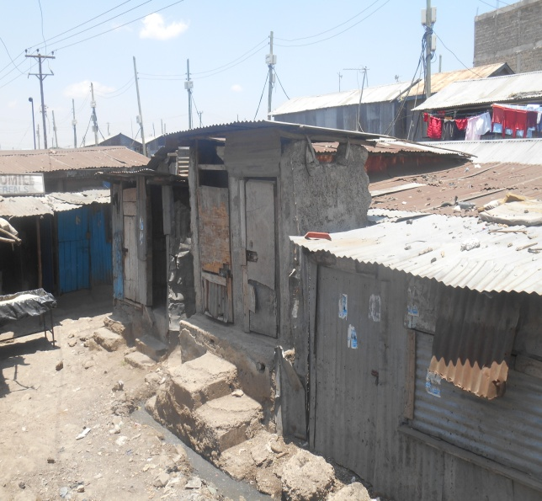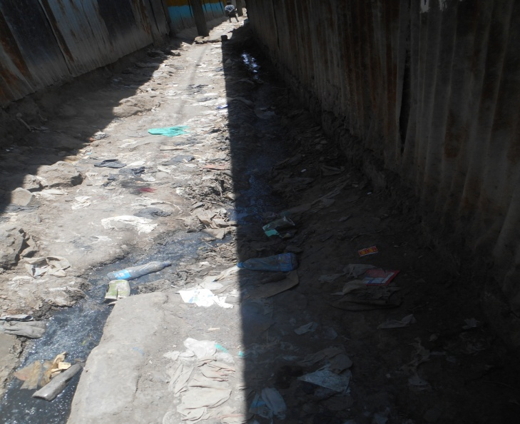
Source: Field data, 2017
The nearby sanitation facility in the area of focus is operated by the Catholic Church and has many users. Another sanitation model within the area is the fresh life adopted by some of the residents.
Plate 6 and Plate 7: Fresh life sanitation model improving the hygiene of the residents.
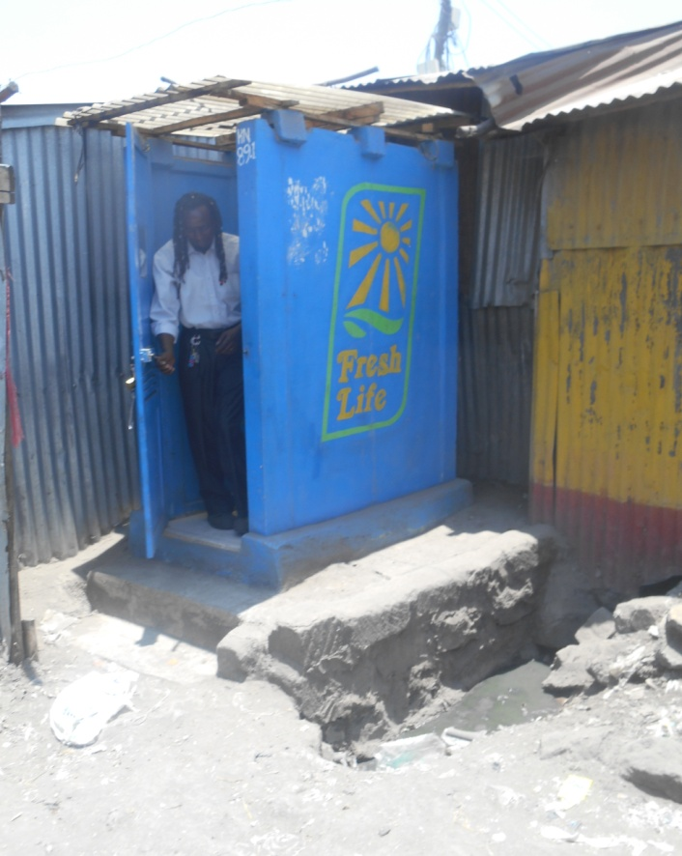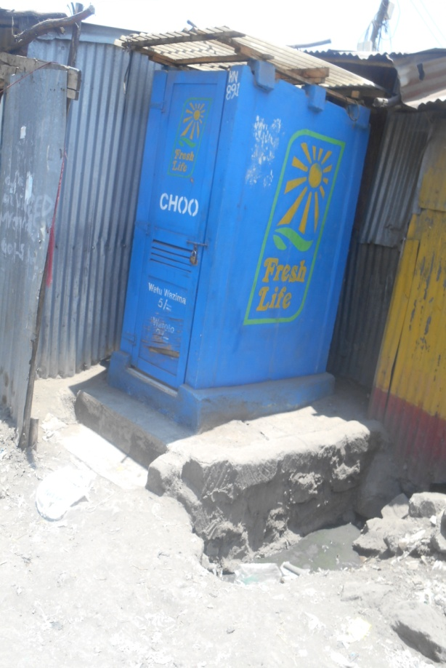
Source: Field data, 2017
In addition, some the sanitation facilities have shut down due lack of water and the decision of some the residents opting for cost effective sanitation model such as fresh life.
Plate 8: One of the already abandoned pit latrine as result of poor condition and associated health risks factors.
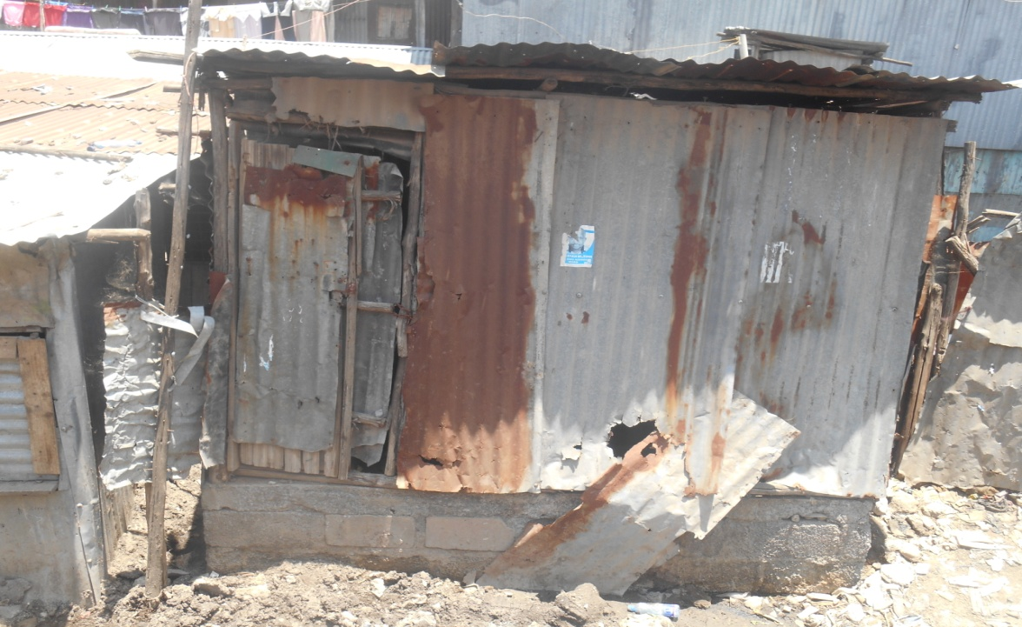
Source: Field data, 2017.
Lack of water in the area as result of infrequent supply; have led to cases of cholera in the area and other water borne related illness such as typhoid and diarrhea resulting into more expenditure on medical service and even some death cases. Children are most affected considering the dirty conditions they play. It is also of importance to note is that, food being sold by the road side is at a risk of contamination since most of them are located near open drainage that are poorly drained and of bad stench. The roadside sellers use firewood and other plastic products as fuel that is dirty and pollutes the surrounding worsening the existing condition. The kind of fuel they use also affects their respiratory systems due to smoke and heat contents. Despite the existence of some of the toilet facilities in the area, sanitation service provision is still not sufficient in the area. It is in this light that Umande Trust in partnership with KUMEA came to the aid of the New Apostolic Church in order to help realize the goal of improving sanitation condition in the area.

1.3 Significance of the sanitation assessment
The need for clean and healthy environment is not just a luxury but a basic right as stated in Article 42, of the constitution of Kenya. Our main focus here is clean water, sanitation, health and personal hygiene. This assessment is important finding the efforts that have been made by the county government since it came into operation. Interacting with people or local residence will give us a clear picture and deeper understanding about their plight. The information obtained from this study will be used in employing the alternative models that is meant in improving the sanitation conditions in the area that will be affordable, of dignity and environmental friendly and acceptable to all. Finally, the information derived from this study will be useful in implementation of a project which contribute in the achieving the goal of The Kenya Environmental Sanitation and Hygiene Policy (2016-2030), which call for universal access to improved sanitation, clean and healthy environment by 2030 and the vision of ensuring that all Kenyans have suitable access to highest attainable standards of sanitation, clean and healthy environment and also fulfilling the global Agenda that is, The Sustainable Development Goals (SDGs) on Health, Water and Sanitation goal 3 and 6 respectively.

2.0 METHODOLOGY

This study was designed and coordinated by a team from Umande Trust in collaboration with local stakeholder (The New Apostolic Church). The team was composed of five researchers employed a research design and methodology that successfully enabled efficient collection, analyzing, interpretation and presentation of both qualitative and quantitative data. Semi structured questionnaires were developed to assist in collecting the data from the households. Observation and direct interaction with the environment was important assessing the real situation on the ground. Digital cameras also played the most important role in capturing the real issues as they appear in the neighborhood through taking of photograph.
Plate 9: The stretch in which the assessment was carried within sisal area.
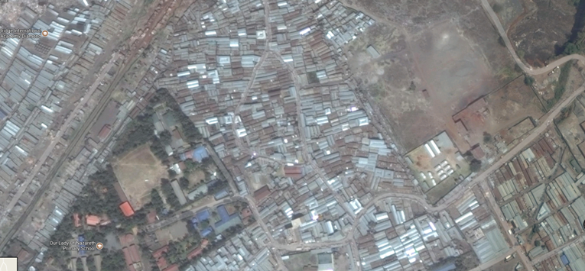
Source: Google Earth
During the field work, a total of 110 questionnaires were administered in the four transects of 60m radius that were developed from the project site. At least three Enumerators administered questionnaires in the plots within the transects. This included also simple random sampling where anybody in transect have an equal chance of being interviewed and purposive sampling method with the focus to obtain unique characteristics that will enable better decision making. The sample size was determined using the formula recommended by Nassiuma (2000) as follows. The population of Sisal area by 2012 was estimated to be averagely 6791 according to KNBS.

n= NC_{V}²
(C_{V}² + (N-1) e²)

Where
n= sample size
N= population; 9460
Cv= Coefficient of variation (take 0.5)
e= Tolerance of desired level of confidence, take 0.05% at 95% confidence level,

n = 6791 x 0.25
0.25 + (6790 x 0.0025)

=1697.75
16.225

The sample size 98/4= 24 at least questionnaires per transect.

The data collected were keyed in the Statistical Package for Social Scientists (SPSS) and then transferred to excel sheets for further analysis and presentations in bar graphs, tables and pie chats among many others.

3.0 DATA ANALYSIS AND DISCUSSION
This discussion mainly focused on water provision, sanitation and health associated impacts.

3.0 Water
This focuses on the sources, frequency of supply, the cost per 20 litre jerican, the distance to the source and associated challenges. From the study, it was noted that the local residents get water from three main sources that is tap (57%), water kiosks (29%) and borehole (14%) respectively as shown in the figure 1 below. Another source that was mentioned was donations/supply made by the Sonko Rescue team. The team operates as emergency to provide services to in times of disaster hence inefficient in supply of water to the residents even though they are for free.
Figure 1: Infrastructures that resident fetch water

Source: Field data, 2017
The frequency of water supply was much dependent on the source. For sources such as boreholes, the supply was on daily basis while sources such as tap and those in the water kiosks and vendors were majorly affected by issues such as water rationing. Figure 2, presents frequency of supply of water was below.

Figure 2: The availability of water in the area

Source: Field data, 2017
According to the field data, majority buy 20 litres of water at a range of 0-5 shillings (48%), 5-10 shillings (43%) and more than 10 shillings (9%) respectively. Figure 3, shows the brackets for water price rates.
Figure 3: The cohorts for prices of water

Source: Field data, 2017
Below is comparison between the sources of water and the cost per 20litre jerican. Most of the respondents prefer water from the tap even though the prices are high compared to water from other sources. Water from boreholes is preferred the least despite its usual availability.
Figure 4: The cost water from different source of water
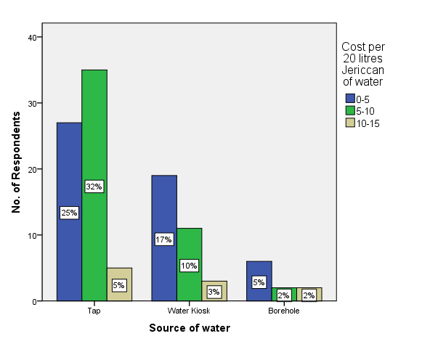
Source: Field data, 2017
The distance covered to in order to acquire/access the service was also an important factor considered when addressing issues about water supply in an informal settlement. The results from the analysis, reveals that 82% of the respondents access water in a distance less than 500 metres, 17% covers between 500 metres and one kilometer to acquire water and others 1% covers more than one kilometer to fetch water for domestic use. However, the distance covered by the respective respondents increase during water rationing period.
Water connections informal settlement especially pipe are passed through unsanitary conditions such as dumpsites and pipe leakages are common hence the need to treat water before use. Below are the responses related to the treatment of drinking water. Some of the respondents claimed that they only treat drinking water, when cases of outbreaks on related water borne diseases are announced by the Ministry of health.

Figure 5: The different method of purifying water

Source: Field data, 2017
The respondents also highlighted the challenges they face in effort to access water. The key challenges mentioned included, shortage of water, long ques at the water points, Dirty/polluted water and the high cost of water considering that the household uses an average of four-twenty litre jericans in a day. The figure below shows the proportion of the challenges.
Figure 6: The challenges encountered when accessing water

Source: Field data, 2017
In trying to provide solutions to the above challenges, the respondents suggested the following, provision of free and affordable clean water (30%), establishment of more water points (49%), adoption of alternative water supply services (7%), constant monitoring and repairing of leakages (7%) and sensitization of residents on the importance of water treatment (10%).
3.2 Sanitation
Access to a sanitation facility is very crucial for better human health and general environmental hygiene. Many of the plots in the area lack sanitation facilities and therefore the residents are forced to move outside the plot in order to access the services. Majority of the residents use pit latrines (77%), 21% use the pour flash systems and 2% use VIP latrines.
Figure 7: The various types of sanitation facilities used by the residents

Source: Field data
According to the respondents, plots that had sanitation facilities majorly had pit latrines, followed by pour flush and VIP latrines respectively. For those who seek for these facilities away from their residents, they have to pay a certain amount of fees. Most of the sanitation facilities are charged between less than five shillings and 5-10 shillings as below.
Figure 8: The fees charged in the various toilet facilities
Source: Field data, 2017.

The following are range of rates charged in various types of sanitation facilities.
Table 1: The price bracket charged in various sanitation facilities
 | Price Range
Sanitation facility | <5 | 5-10 | None
Pit Latrine | 36% | 11% | 53%
VIP latrine | - | 50% | 50%
Flush Systems | 55% | 41% | 4%
Source: Field data, 2017
Figure 9: The comparison of charges in the different sanitation facilities

Source: Field data, 2017
The respondents had the following feelings about the conditions of the various toilet facilities they use as shown in the table below and figure below.
Table 2: Sanitation facilities and the level of their condition
Type of the Facility | Condition of the facility
 | Poor | Average | Good | Total
VIP latrine | 100% | 0 | 0 | 100%
Pit Latrine | 26% | 64% | 10% | 100%
Flush Systems | 9% | 52% | 39% | 100%
Source: Field data, 2017
The poor conditions of the toilet facilities were attributed by the following reasons namely: Untidy conditions due lack or irregular cleaning, water shortage for cleaning, many users who do not care about the cleanliness and poor management since many facilities lack attendants, in that order.

Figure 10: Conditions of the various sanitation facilities

Source: Field data, 2017.
The respondents also cover different distances depending on the facility of their choice that they would like access. About 92% of the respondents cover a distance less than 500metres while only 8% had to cover a distance between 500-1000metres.
Figure 11: Distances covered to the sanitation facility

Source: Field data, 2017.
The respondents also expressed some of the challenges they face in an effort to access these toilet facilities. The table below shows some of the challenges the respondents highlighted as the main issues.

Table 3: Some of the challenges experienced in the existing sanitation facilities
Challenge | Proportion in Percentage
Some facilities are very dirty | 35%
Water shortage | 8%
Long distance | 4%
Insecurity | 6%
Blockage | 14%
Lack of exhaustion/filed up | 8%
Long ques | 8%
Overcrowding | 11%
Costly especially for household with many members | 6%
Source: Field data, 2017
Sanitation is only on complete in an area when bathrooms are also put into consideration. From field assessment, the following figure the shows the purposes different structures serve in the neighborhood.
Figure 12: Proportion of Bathrooms

Source: Field data, 2017
Table 4: Bathrooms types in the study area
Bathroom type | Percentages
Communal type | 15%
Bathroom and toilet in the same structure | 38%
Bathroom only | 39%
No Bathroom | 8%
Source: Field data, 2017

According to the residents who access these facilities, they spend an average of Ksh 10 for a bathroom. Due to current condition, we wanted to determine how much they will be willing pay for the bathroom and toilet services. On average, Ksh. 10 was the amount recommended for bathrooms and Ksh. 5 toilet services. However, some were willing to pay a higher fee especially if they are provided with hot water for bathing. In order to solve sanitation is menace on a larger scale, here are actions raised by the respondents. These include, ensuring that water is available for cleaning (36%), provision of caretakers for the facilities (10%), development of on plot toilet collected a water source (29%), site and service scheme where the residents can be provided with free toilet facility (15%), improvement of drainage and sewer systems (4%) and adoption of alternative sanitation model that best suit the neighborhood (6%).

3.3 Health
Efforts meant to uplift sanitation levels in area are directly proportional to improvements in Environmental health and hygiene. Here are the various types of health facilities the respondents in order receive medical services. Many of the respondents go the dispensaries as compared to other medical facilities while a smaller proportion consulted herbal doctors. Another proportion of respondents (1.2%) go the nearby pharmacy to acquire the same.
Figure 13: The medical facilities used by individual in the area

Source: Field data, 2017
Furthermore, about 45% of the respondents had of one member of their family taken to a medical facility in the last six months. The table below shows some of the sanitation and hygiene related to ailments that their family member suffered from.

Table 5: Disease cases experienced in the last six months
Disease | Percentage
Malaria | 34%
Diarrhoea | 15%
Common Cold | 9%
Stomach problem | 12%
Headache | 9%
Typhoid | 12%
Cholera | 3%
Vomiting | 6%
Source: Field data, 2017
Figure 14: Health Matters for the residents in the last six months

Source: Field data, 2017
Just as any other sector, health services is always constrained by a number of challenges. Here are some of the issues that various respondents highlighted as issues that need to be addressed.

Table 6: Challenges in the health service delivery
Challenges in accessing Health Service | Percentages
Expensive | 27%
Long Distance | 12%
Long ques | 14%
No attendants | 2%
Lack of Money | 15%
Restricted hours of Operation | 5%
Inadequate equipments in the facility | 25%
Source: Field data, 2017
The respondents also suggested the following remedies in order to enable acquire quality health services for all the users.
Table 7: Proposed solution to challenges in the health sector

Remedies to the challenges | Percentages
Establishment of better infrastructure | 9%
Employ adequate staff | 9%
Provision of cheap/free medical services | 29%
Equip at least one facility to operate 24 hours daily | 26%
Establish a facility to provide a number of medical services | 27%
Source: Field data, 2017.

3.0 SUMMARY OF FINDINGS, CONCLUSION AND RECOMMENDATIONS.

3.1 Summary of findings
Water, sanitation and health are interdependent factors and deficiency in one of the results in an equal proportion to the other ones. Water within Sisal area is infrequent in supply especially the piped water which is also stored in water kiosks. The one from the boreholes are readily available many people do not prefer since is very salty. Pit latrines are most dominant sanitation facility in the area but generally do not meet the need of the people needs. This is due to soil conditions in area as they cannot be dug to deeper depths hence require constant exhaustion services. It is worth noting that most plots have structures designed to act as bathroom with no proper outlets for waste water. The poor services witnessed at the various sanitation services are as result due to shortage of water, inadequate caretakers and large number of users. Health issues within the area are also a result of inadequate supply of water and poor ways of disposal of waste. There is a feeling that if these services can be provided for free or at cheap/low cost then water and sanitation challenges can be solved.

3.2 Conclusion
In summary, water and sanitation services are insufficient in the Sisal area as most of the relevant structures lack and if they exist, they are dilapidated. There exists efforts from various stakeholders working hard to provide water, sanitation and health related services. Holistic measures such as multi-stakeholder approach that create that will success owned and cherished by the whole community.

3.4 Recommendations
- There is need for stakeholders to come up with strategies that ensure that such neighborhoods have access to water, sanitation and health services is that affordable and readily available to the people.
- Adoption of environmentally friendly sanitation models such as the bio-sanitation concept to enhance clean and healthy environment disease free.
- Implementation of projects that meet the set standards, master plans for the area and state regulation. on development

REFERENCES

Kenya Environmental Sanitation and Hygiene Policy (2016-2030).
Kenya National Bureau of Statistics; the population census of survey of 2012.
The Constitution of Kenya 2010, Gok; Government Printers.
The National Vision 2030. (2008). GoK; Government Printers.
United Nations (2015). The Global Agenda; the sustainable development goals.

Appendix
Umande Trust, based in Kenya, is a rights-based agency striving to significantly improve access to water and sanitation for all. It is working in partnership with an organization called Kumea to construct a bio-centre in Mukuru kwa Njenga.
This questionnaire aims to conduct a rapid assessment on sanitation situation in the area.
We would like to inform you that the information you will provide will only be shared with the concerned actors hence ensuring confidentiality. The information will be used for the purpose of the assessing sanitation condition within the neighborhood. You have been chosen from a random basis.
- Personal Data
  - Name:

  - Age:
- Below 18 years.
- 18-30years
- 31-45years
- 46-60years
- 61-Above
  - Gender:
- Male
- Female
  - Household size
………………………………
Gender
Male | Female
  - For how long have you stayed in Mukuru kwa Njenga? Reason?

- Water
  - What is your source of water?
- Tap.
- Water kiosk.
- Borehole.
- Rain.
- Others…………….
  - What is the frequency of supply?

  - How much does a jerican cost?
- 0-5 Ksh
- 5-10 Ksh
- 10-15 KSh
- 15 and above.
  - How many jericans of water does your household use in a day?

  - What distance do you cover to access water?
- 0-500m
- 500m-1km
- Others.
  - How long on average do you spend on the line at the water point?

  - How do you treat your drinking water?

  - What challenges do you face while accessing water?

  - What do you think are the solutions to the above challenges?

- Sanitation and health.
  - Does your place of residence have toilet facilities?
- Yes.
- No.
If no, where do you access this facility?

  - What type of toilet facility do you use?
- Pit latrine.
- VIP latrine.
- Flush system.
- Others……………..
  - How much do you pay to access toilet facility?
- 0-5 Ksh
- 5-10 Ksh.
- 10-15 Ksh.
- 15 and above.
  - What is the condition of the facility?
- Poor
- Average
- Good
If poor, why?

  - How far is the facility from you?
- 0-500m
- 500m-1km
- Others.
  - What challenge do you face while accessing toilet facilities?

  - What do you think are the solutions to the above challenges?

  - What type of bathroom exists in your neighborhood?
- Communal type.
- Bathroom and toilet in the same structure.
- Bathroom only.
- No bathroom.
- Others………..
  - How much do you pay to access bathroom services?
- 0-5 Ksh.
- 5-10 Ksh.
- 10-15 Ksh
- 15-20 Ksh
- 20 and above.
  - How much would you be willing to pay for:
- Bathroom –
- Toilet –

- Health.
- Where do you access health services?
- Private clinic.
- Dispensary.
- Herbal doctor.
- NGO funded hospital.
- Other……………..
- Has any member of your family visited the hospital/ dispensary in the last 6 months?
- Yes.
- No.
If yes, which disease was he or she suffering from?

- What challenge do you face while accessing medical services?

- What do you think are the solutions to the above challenges?

