AN EVALUATION OF SLUM UPGRADING SCHEMES IN NAIROBI COUNTY:
THE CASE OF KIBERA SLUMS.

BY

JUMA OBARE MICHAEL
N36/2594/2011.

RESEARCH PROJECT
(EPM 492)

A Research Project Report Submitted in Partial Fulfillment for the Requirements For the
Degree of Bachelor of Environmental Planning and Management in the School of
Environmental Studies of Kenyatta University.

AUGUST 2015.

DECLARATION
This Report is my original work and has not been presented for degree award in any institution.

Signature: ……………………………… Date…………………………………
JUMA OBARE MICHAEL

APPROVAL
This Research Project Report has been submitted for examination with my approval as the University Supervisor.

Signature ………….........................Date………………………………
MR. WILSON NYAORO.

DEDICATION
This Report is dedicated to the residents of Kibera Slum who honoured this study through their participation and sincere contribution.

ACKNOWLEDGEMENT
This Research was conducted in Kibera slum, Lang’ata Sub-County, Nairobi County in February 2015. This Report is as a result of the generous contribution and assistance of various organizations, institutions and individuals within and out of Kenyatta University. First and foremost, I thank the Almighty God for giving me energy, strength,protection and good health to conduct this study. My sincere gratitude goes to Kenyatta University administration through the Department of Environmental Planning and Management, for giving me this opportunity to carry out this research. Special appreciation to my supervisor, Mr. Wilson Nyaoro, for his professional advice, guidance and frequent assessment and encouragement that played a beneficial role in the improvement and perfection of this report. Additionally, my heartfulappreciations go to my cousin Fredrick Odhiambo, who assisted me by all means especially during the pre-field and field work in the various villages of Kibera. Special thanks go to the following the following organizations and institutions: The Umande Trust, the Human Needs Project (HNP) and the Department of Slum Upgrading for their professional input and hospitality during the field study. Finally, I wish to acknowledge any other person or institution whose action contributed to the development of this report but their names and designation has not been stated in this report. May the Almighty God whose action surpasses human understanding be with us forever.

ABSTRACT
Slums had been perceived as areas prone to a lot of challenges especially overcrowding, poverty, poor sanitation, crime, violence, HIV/AIDS pandemic, marginalization, and segregation among others among others. Due to such stereotypical convention and misinformation, slums had been neglect and not considered as part of the city despite the major contribution it offers, especially in the early days. A number of theories have been developed about slums without due consideration of the underlying factors to such neighborhoods’. At least three factors have been put forward in trying to understand why such settlements crop up. These include: colonial system of planning, system of governance and rapid population growth even though such may not be applicable in other countries. Discovering that such conditions were no longer improving, various governments came up with various strategies in try to contain it, namely: demolition and clearance, relocation to public housing, site and service and the later the slum upgrading initiative. The World Bank and UN-HABITAT also developed of Cities alliance for Cities without slum to encourage states to improve their slums. The Kenyan Government have deployed a lot of resources in Kibera slum to developed and uplift the living standards of the residents. The findings of the study showed that the beneficiaries of the programme as transformative and deprivation. Some residents feel that the programme has disrupted their day to day activities hence living them without anything to cling on. The benefits include: easy accessibility, security, improve health services, lighting and clean environmental conditions for sustainable living. The study adopted descriptive research design which composed: pre-field work, field work, literature review, data collection and interpretation as a study approach. The broad objective of the study was an evaluation of slum upgrading scheme in Nairobi County. The data analysis was done using Statistical Package for Social Scientists (SPSS) version 20 and Microsoft Excel. The presentation was done by use of graphs, charts and tables. The final result was the preparation of an integrated plan for sustainable development of Kibera.

TABLE OF CONTENTS
Contents
DECLARATION i
APPROVAL i
DEDICATION ii
ACKNOWLEDGEMENT iii
ABSTRACT iv
TABLES OF CONTENT v
LIST OF FIGURES vii
LIST OF TABLES vii
LIST OF PLATES viii
ACRONYMS AND ABBREVIATIONS ix
1.0 INTRODUCTION 1
1.1 Background to the problem 1
1.2 The problem statement 3
1.3 Research questions 3
1.4 Research objectives 4
1.5 Research premises 4
1.6 Justification of the study 4
1.7 Significance of the study 5
1.8 Scope of the study 5
1.9 Operational terms 6
CHAPTER TWO 7
2.0 LITERATURE REVIEW 7
2.1 Historical development of slums 7
2.2 Policy and legal framework for slum upgrading schemes 8
2.3 Infrastructural elements and facilities that needs upgrading 10
2.4 The role of stakeholders in slum upgrading schemes 11
2.5 Problems constraining the development of slum upgrading schemes 14
2.6 Gaps within the Literature 15
2.7 Theoretical framework 17
2.7.1 John Turner’s Theory 17
2.7.2 Community Action Plan Model 18
2.7.3 The Culture of Poverty Theory 19
2.7.4 The Theories of the Culture of Poverty and Marginality. 20
2.8 Conceptual framework 21
3.0 AREA OF STUDY 23
3.1 Location and extent 23
3.3 Drainage 25
3.4 Climate 25
3.5 Population distribution and profile 27
3.6 Socio-economic characteristics 29
3.7 Education 29
3.8 Labour force 30
3.9 Health 30
3.10 Land and Land use 31
3.11 Infrastructure and Access 31
CHAPTER FOUR 33
4.0 RESEARCH DESIGN AND METHODOLOGY 33
4.1 INTRODUCTION 33
4.2 RESEARCH DESIGN 33
4.3 Nature and Sources of Data 33
4.3.1 Nature of Data 33
4.3.2 Sources of Data 34
4.4 Methods and instruments of Data Collection 35
4.5 Target Population 36
4.6 Sampling Techniques and Procedures 36
4.7 Methods of Data Analysis 37
4.8 Limitations of the Study 37
CHAPTER FIVE 39
5.0 DATA ANALYSIS AND DISCUSSION 39
5.1 Policy and Legal framework for Slum Upgrading Schemes in Kenya. 39
5.1.1 Policy Framework 39
5.1.2 Legal Framework 42
5.2 Infrastructural elements and facilities that needs upgrading in Kibera 44
5.3 The role of stakeholders in Kibera slum upgrading schemes 53
5.3.1 The National Government 54
5.3.2Non-Governmental Organizations 55
5.3.3 Media 60
5.3.4 Community Based Organizations (CBO’s) 60
5.4 Problems constraining the development of Kibera slum upgrading schemes. 61
CHAPTER SIX 64
6.0 SUMMARY OF THE FINDINGS, CONCLUSION AND RECOMMENDATIONS. 64
6.1 Summary of the findings 64
6.2 Conclusion 65
6.3 Recommendations 65
6.3.1 Short term Recommendations 65
6.3.2 Long term Recommendations 66
6.4 Areas for further studies 67
PLANNING MATRIX FOR INTEGRATED PLAN FOR SUSTAINABLE DEVELOPMENT OF KIBERA SLUM UPGRADING SCHEME 68
REFERENCES 82
APPENDICES 88

LIST OF FIGURES
Figure 1: The role of various Stakeholders in Slum Upgrading Scheme. 12
Figure 2: A Conceptual Framework 22
Figure 3: Map of villages in Kibera Informal settlement. 23
Figure 4: Location and Extent of Kibera. 24
Figure 5:The Rainfall and Temperature in Nairobi City. 26
Figure 6: Projected population of Kibera. 27
Figure 7: Population pyramid for Age Structure. 28
Figure 8: Changes in Population within a Decade 29
Figure 9: Size of Households. 48
Figure 11: Problems faced by residents of Kibera. 49
Figure 12: Infrastructural elements that need Upgrading. 50
Figure 13: Occupation of the Respondents. 51
Figure 14: Some of the Stakeholders involved in Kibera Slum Upgrading. 53
Figure 15(a) and (b): Perception of Respondents about the ongoing Slum Upgrading. 63

LIST OF TABLES
Table 1: The projected Population of Kibera, 27
Table 2: Objectives and Nature of Data 34
Table 3: Some of the problems faced by residents of Kibera slums. 45
Table 4: Household Composition. 47
Table 5: Infrastructural elements that need upgrading. 49
Table 6: Occupation of respondents. 51
Table 7: Comments on the ongoing slum upgrading and its effectiveness. 63

LIST OF PLATES
Plate 1(a) & (b): Unsanitary conditions where there is illegal Water pipes connections 45
Plate 2(a) & (b): The state of foot bridges connecting the Villages of Kibera 46
Plate 3(a) & (b): The Menace of Solid water in some villages of Kibera 46
Plate 4(a) & (b): The Conditions of Shanties in Kibera. 48
Plate 5: Houses under construction by the Railway Corporation in Kianda, 52
Plate 6(a) & (b): Installation of Street lighting and sanitation facility. 52
Plate 7(a) & (b): Electricity installation and Access roads construction in Laini Saba village 53
Plate 8(a) & (b): Community library in Kianda, managed by the Global Alliance for Africa. 56
Plate 9(a), (b) & (c): Bio-centre, community library and toilets constructed The Umande Trust. 58
Plate 10(a) & (b): Safi E-cooker and the tapping of Bio-gas and the cooking stoves installed by Umande Trust 59

ACRONYMS AND ABBREVIATIONS
CFCA Christian Foundation for Children and Aging
CBOs Community Based Organizations
FBOs Faith Based Organisations
FGD Focused Group Discussion
HIV/AIDs Human Immuno Virus/Acquired Immune Deficiency Syndrome
HNP Human Needs Project
ILUSP Intergraded Land and Urban Sector Programme
KENSUP Kenya Slum Upgrading Programme
KISIP Kenya Informal Settlement Improvement Project
KNBS Kenya National Bureau of Statistics
MDGs MilleniumDevelopemnt Goals
NCIDP Nairobi County Integrated Development Plan
NEMA National Environment Management Authority
NGOs Non-Governmental Organisations
NYS National Youth Service
PIU Programme Implementation Unit
SEC Settlement Executive Committee
SIDA Swedish International Development Agency
UN United Nations
UNCHS United Nations Commission for Human Settlements
UNDP United Nations Development Progamme
UN-HABITAT United Nations Human Settlements Programme
USA United States of America

CHAPTER ONE

1.0 INTRODUCTION

1.1 Background to the problem
“Slums” are identified by distinctive terms peculiar to given regions and countries, since what is considered as slum, invariably depends on local and regional perception of the housing standards and social conditions, hence the varied definitions by different scholars and organizations, (UN-HABITAT, 2012). According to Geoffrey Payne (1997), a ‘slum’ is a heavily populated area characterized by sub-standard housing and squalor. It is applied to numerous settlement types in an area featured by social and economic isolation, irregular land ownership, and low standards of sanitary and environmental conditions. This also includes the vast informal settlements which are quick manifestation of urban poverty including squatter settlements and sub-division of land. The quality of such dwellings ranges from simplest shacks to permanent structures while access to water, electricity, sanitation and other basic services and infrastructure tends to be limited.
The Merriam website dictionary defines a ‘slum’ as a densely populated area marked by crowding, dirty–run housing, poverty and social disorganization.
In the MDGs general context, a ‘slum’ is defined as a wide range of low-income settlements and poor human living conditions; the inadequate housing conditions are manifestation of poverty. According to UN-HABITAT report (2003), ‘slum’ is a contiguous settlement where inhabitants are characterized as having many inadequate housing and services. The report further developed a household level definition in order to be able to use the existing levels of surveys and census. “ Slum household” therefore is a group of individuals living under the same roof who lack either of the following: durable housing, sufficient living space, for instance not more than three people in a room, easy access to safe drinking water and sanitation, security of tenure that prevent forced evictions among others, (ibid).
Slums and informal settlements are associated with numerous challenges. According to the Government of Uganda (2008) such issues include: sub-standard housing that are inadequate, insecure land tenure due uncoordinated administration, uncollected solid waste dumping, drainage challenge since most are located in hazardous areas such as flood plains, proximity to dumpsites and industrial plants and lack of sanitation in most parts. In another case by the Government of Kenya (2013), slum dwellers undergo many fundamental issues namely: socio-political and economic exclusion, marginalization, deprivation, malnutrition and health, employment/underemployment, insecurity and resource allocation among others.
UN-HABITAT reports estimate that the worldwide number of slum dwellers stood at 830 million and this is projected to be 900 million by 2020. According to earlier reports 2009 the figures were 817 and 889 respectively with majority of the world slum dwellers found in Africa. In Kenya, the proportion of the urban population had been rising steadily. In 1999 the number of slums had increased to 34.5%, affirming that one out of every three Kenyans currently lives in urban areas (Government of Kenya, 1999). This proportion is expected to rise to 50% by the year 2015, with much impacts experienced in Nairobi, (ibid).
To reverse this trend, several initiatives have been adopted ranging from the global to local levels. In Mumbai India, between 1950s and 60s, the government of the state, developed a slum demolition policy and clearance of land occupied by the urban poor, (Environment and urbanization, 2005). Similarly, in Sao Paulo, Brazil, between 1964 and 1985, the state government developed a relocation policy of squatter settlement in a large public housing estate, (O’Meara, 2010). On the other hand, a series of international conferences have held in the push to improve such conditions. In 1987, the United Nations General Assembly, made a resolution about international year of shelter for the homeless. In 1996, the UN-HABITAT, held an 11th conference in Instabul, to revaluate the worsening living conditions. In 1999, the UN-HABITAT and World Bank formed a new organization called Cities without slums to pursue the governments on the need to upgrade their informal settlement and integrate them in their development plans, (World Bank & UN-HABITAT, 1999). In 2000, the United Nations adopted the Millennium Development Goals which became MDG Seven target eleven to champion the progress, (UN, 2000).
Moreover, Kenya with other stakeholders had also developed initiatives since colonial period. In 1895 and 1970, the demolition and evictions approaches were adopted, (Syagga, 2011). In the 1970s and 1990s, with the help of the World Bank, the government initiated site and service schemes in various towns namely: Nairobi, Mombasa, Kisumu, Eldoret, Nakuru, Thika, and Nyeri, (Government of Kenya, 2013). In order to be in line with the MDGs, of the year 2000, the government with the assistance of UN-HABITAT, initiated main two projects namely: The Kenya Slum Upgrading Project (KENSUP) in 2004 and later Kenya Informal Slum Improvement Programme (KISIP) in June, 2011, (Muragruri, 2012). The core functions of these initiatives include: improving livelihoods of the people in relation to housing, empowerment, development of physical and social infrastructure, targeting to improve the livelihoods of at least 1.6 million household (5.3 million slum dwellers) by the year 2020, (ibid).

1.2 The problem statement
Despite the initiatives put in place by the Government of Kenya, Private sector, International Agencies among other stakeholders, slums, and informal settlements still remain a major issue. This is mainly spearheaded by rapid urbanization hence development and growth informal settlements and Nairobi is not speared. The annual informal growth rate in Kenya at 5% and it is the highest in the World and it is likely to double in the next 30 years, (UNDP, 2007). Nairobi city is one of the largest hubs of trade in Africa and business in East Africa. The city’s population has been progressively growing over years from11, 500 inhabitants in the year1906 to 3.1 million people in 2009, (KNBS, 2010). More than half of the city’s population lives in slums and informal settlements occupying less than 1% of Nairobi area and less than 5% of the residential area, (Mutillah,2003).
The unprecedented rate of urbanization can be linked to massive migration movements as well as natural growth, challenge in planning contribute to more environmental constrains with varied impacts. Low quality housing, lack of basic infrastructure such as: sanitation, drainage, access to energy and clean water supply among others not only results in conflicts and insecurity but also a greater threat to human health hazards and at times death, (Beatley, 2000). Stakeholders, especially International Agencies, warns that if drastic measures are not put in place, then such cases will be more prevalent in the future. This research project is therefore entitled to carry out an evaluation of slum upgrading schemes in Nairobi: The case of Kibera slums.

1.3 Research questions
- Are the existing policy and legal framework adequate for effective slum upgrading programmes in Kenya?
- What are the infrastructural elements and facilities that need upgrading in Kibera slums?
- Who are the stakeholders involved in the Kibera slum upgrading schemes?
4. What problems do constrain the Kibera slum upgrading schemes??

1.4 Research objectives
The broad objective of this research project is to evaluate slum upgrading schemes in Nairobi, the case of Kibera.
The specific objectives include:
- To analyze policy and legal framework for slum upgrading schemes in Kenya.
- To determine the infrastructural elements and facilities that needs upgrading in Kibera slums.
- To examine the role of stakeholders in the Kibera slum upgrading scheme.
- To examine problems constraining the development of Kibera slum upgrading scheme.
- To prepare an integrated plan for sustainable development of Kibera slum upgrading scheme.

1.5 Research premises
- The existing policy and legal structures are characterized by several weaknesses and gaps and are therefore not effective in promoting slum upgrading in Kibera slum.
- There exist various stakeholders with key roles to play in order to make Kibera slum upgrading schemes a success.
- Infrastructural elements and facilities in Kibera slums are dilapidated and therefore need upgrading.

1.6 Justification of the study
Kibera is one of the largest slums in Africa occupying approximately 2.5 square kilometres and located 5 kilometres from Nairobi city centre, (Umande Trust, 2010). According to the 2009 Kenya Population and Housing Census reports Kibera's population as 178,284 (KNBS, 2013), contrary to previous estimates of one or two million people. Since its formation, the slum had been growing progressively; majority move from the rural and it provides cheaper ground for them as they search for employment hence, the need for proper interventions.
Just like any slum in the World, Kibera faces various challenges namely: housing since many are sub-standard and dilapidated, insecurity of tenure, high crime rate due to unemployment, lack of sanitation and the ones offered by the private bodies are unaffordable to majority of the residents since they are poor, (UN-HABITAT, 2003). Moreover, there is much overcrowding, no access roads within the settlements and security lights, in adequate social services such health, education and even recreational facilities to fully cater for high population in the area.
The previous interventions that had been initiated to improve the situation on the ground did not achieve much, since the growth of the slum increased and the living conditions even worsened. This study therefore, evaluates the factors that might have contributed to effectiveness or ineffectiveness and the transformation evidenced since the initiation of the upgrading schemes. This study also comes at the critical moment when majority of several stakeholders have expressed interest in improving the situation in Kibera. These include housing developments, improvement of existing and construction of new access roads, establishment of temporary health facilities, street lighting, and participatory collection of garbage among others. It is also important in determining the reactions of slum dwellers towards such development and how best the schemes should be carried out to avoid conflicts or any form of opposition from the local people.

1.7 Significance of the study
Slums are integral part of the urban landscape as they have historically been the only affordable housing solution available to the urban poor who contribute much to the city’s economy. Over years, the slums had been considered as nuisance compared to today’s general consensus that slum are unique eco-systems which have changed over the years to adopt the needs of the residents, (Edelman, 2013). The slum dwellers contribute greatly to the development of the city’s economy through provision of cheap labour. It therefore calls for the need to improve their living conditions to enhance their participation in national building, (ibid). This should be effectively carried out by involving the inhabitants from the initiation of the project to post project activities for the successful achievements. The findings from this study will be valuable in guiding the policy and legal framework in facilitation of slum upgrading schemes, activities and role of the stakeholders and outlining possible remedies to challenges that do constrain slum upgrading schemes. In addition, the study will contribute to the body of knowledge about slum upgrading initiatives since there is little information available and also supplement research work in future.

1.8 Scope of the study
The area of focus for this study was Kibera slum located in Lang’ata Sub-County, Nairobi County. This study was carried in the Kibera villages where the slum upgrading schemes were on going. It focused on the policy and legal framework, the infrastructural elements that needs upgrading, the stakeholders and their functions as well as the factors that do constrain the slum upgrading schemes in Kenya. The outcome of the study was an integrated plan for sustainable development for the effective and efficient co-ordination of the slum upgrading schemes to ensure such immense incidences are curtailed.

1.9 Operational terms
Slum: A settlement where inhabitants are characterized lack or inadequate access to basic services, for instance, housing, water supply, sanitation, insecure tenure among others. Many governments do not recorgonize the slums as integral part of the city.
Upgrading: Uplifting levels or standards living or environmental conditions in a particular neighbourhood. Such may include: infrastructure, empowerment both social and economic and public awareness.
Slum Upgrading: This is an initiative meant to transform a settlement especially living standards and environmental condition. It is an interdisciplinary processes hence the call for many stakeholders for the success of the initiative.
Stakeholder: A person, group, organization or institution with interest in a particular programme, schemes or project.

CHAPTER TWO

2.0 LITERATURE REVIEW

2.1 Historical development of slums
Many researchers have attempted to figure out what could be the main cause of slums or informal settlements. Both local and global factors such as: colonial systems of planning, systems of governance, rapid population growth among other explanations have been developed, (UN- Habitat, 2003), though they are not satisfactory. There is no doubt therefore that history is of great importance for governments in trying to consolidate their human population. It is also important to note that the approach is good but cannot be confirmed statistically and comprehensively on the relationship between urban governance and the driving factors. Historically, three contingent factors are found to have a significant influence on contemporary slum incidence: rapid urban growth, colonial legacies of governance and political fractionalization, (ibid).
First and foremost, rapid urban growth historically in less developed countries posted a greater challenge to local and national government in trying to consolidate the human settlement. Take the case of the following countries within a period of 30 years (1960-1990. The population of Accra, Ghana grew from 393,000 inhabitants in 1960 to 1.2 million in 1990; Jakarta, Indonesia grew from 2.68 million inhabitants to 7.65 million over the same 30-year period; and Porte Alegre, Brazil grew from 880,000 to 2.93 million over the same period. Persistent demographic pressure on infrastructure, services, and urban land is clearly a factor to be considered. However, this is an insufficient explanation of slum growth in itself since in other states such have been witnessed without formation of informal settlements. Secondly, colonial legacies employed by the European played a major contribution. Acemoglu, Johnson, and Robinson, (2001), suggested that the extent of European colonial settlement had a direct impact on the kinds of institutions that were established in colonial territories and handed it down to post-colonial governments. Where colonial settler mortality was high due to unfavourable disease environments, fewer colonizers settled; more extractive institutional regimes were introduced, and these persisted after independence resulting in poor economic outcomes. Recent study by Banerjee and Iyer (2005) revealed that, variations in colonial land revenue institutions across regions accounts for contemporary disparities in agricultural productivity, as well as investments in agriculture, health and education across theseregions. The study highlights the path-dependent nature of colonial institutions and their effects on contemporary outcomes. The lasting effects of colonial town planning, investment, and the design and enforcement of institutions had been noted by urban researchers, (Okpala 1987; Awotona 1988). For instance, the case of Kenya, 1926, the Nairobi bi-zonal plan divided it into racial districts mainly Westlands for the whites, Parklands for the Asians and Eastlands for Africans. This also created disparity in development. The 1948 master plan further worsened the situation. It aimed at restricting indigenous Kenyans from accessing some of the urban resources. This forced the natives to develop some sub-standard houses and facilities that are not adequate.
In addition, political fractionalization is also a contributory factor. Its empirical evidence is along ethnic and regional lines that had inhibited effective governance. Easterly and Levine (1997), states that ethnic diversity can impede agreement about the provision of public goods and create positive incentives for growth-reducing policies. There is also some evidence that political fractionalization has a geographic component. Herbst (2000) argues that the practical difficulty of controlling large territories with low population densities using a small administrative apparatus is one of the reasons colonial powers often relied on indirect rule, and this challenge has also been a constraint to post-independence state consolidation in Africa. This therefore promotes uncontrolled and unplanned due lack of adequate coordination.

2.2 Policy and legal framework for slum upgrading schemes
According to UN-Habitat, (2003), a slum household is a group of individuals living under the same roof who lack the following: durable housing, sufficient living space, for instance not more than three people in a room, easy access to safe drinking water and sanitation, security of tenure that prevent forced evictions among others. This report further indicates that it will increase to 2 billion people in the next 30 years if no concrete actions are put on board. Such settlements are known by many different names and are characterized by a variety of tenure arrangements. All these attributes and the overriding challenges require proper policy and legal platforms by governments and international organizations to address. In attempt to eradicate slums in Mumbai, India in the 1950s and 1960s, the state of Maharashtra and the Municipal Corporation of the greater Mumbai developed slums demolition policy and cleared any land that urban poor encroached. This strategy apparently did not achieve much since people would rebuild their huts in the same location or shift to another unoccupied land nearby whenever the harassment by the local authorizes would be too much, (Environment and Urbanization, 2005). In the 1990s, a variety of reasons relating to both equality and practical considerations about slums began to be viewed as a housing solution. Policy and legal framework were developed to provide civil amenities in slums and the need for resettlement incase of demolition, (ibid).
Similarly, in Sao Paulo, Brazil, between 1964 and 1985, the military government had a policy of relocating squatter settlements into large public housing estates on the very edge of the city but those who could not find housing would emerge into new housing settlement creating low income communities on the outskirts of the town, (O’Meara, 2010). In 1980s, the administration adopted new legal framework known as “special zoning legislation” to promote social housing and redevelopment projects. This had three objectives namely: legislation of land tenure without fulfillment of conventional planning standards, enforcing compulsory development on undeveloped land and requiring property owners to produce a proportion for social housing, (ibid).
Slums are characterized by lack or inadequate infrastructure such as access roads, electric connections and social facilities. In 1979, the government of Uganda adopted the National Human Settlement policy that aimed to improve on access to infrastructure and social amenities and plots in urban areas. The emphasis of this policy was in the provision to low income people and the amelioration of housing conditions in slums. The implementation was done in two projects namely: The upgrading of Namumwongo low cost housing in Kampala and Masese Women Self-help housing in Jinja, (Government of Uganda, 2008). In addition, to ensure that it is in line with the UN General Assembly resolution (1987), on the international year of shelter for homeless, the government of Uganda also initiates the National Shelter Strategy in 1992. This was a programme for improvement of housing conditions to ensure adequate shelter for all by 2020, (ibid).
Another attribute of slums is insecure land tenure which is a global feature. This exposes the residents to incidences of forced evictions and investments in such places are therefore difficult. In 1980, Bombay, India, the World Bank funded urban development project aimed to grant a thirty year renewable land leases to slum residents. It therefore provided them with the security of tenure in an attempt to subsidize slum shelter improvement from the sale of land and grant loans repayable over the next 20 years, (Zhou, 2011).
In 1999, the UN Habitat and the World Bank formed a new organization known as Cities Alliance with the aim to pressure the governments on the need to upgrade their informal settlements and integrate upgrading strategies in their development plans. In 2000, the World Bank came up with urban policy and subsequent shift to more directly embracing the urban poor and upgrading informal settlement. This was known as cities without slums. The utility to cities aesthetics was championed by the urban competitiveness agenda, (Marrie, 2011). The two ideologies emerged to form a solitary idea known as Cities Alliance for cities without slums. It therefore aimed at transforming the livelihoods of 590 slum dwellers by 2020, (ibid). The idea was adapted by the UN general assembly the year 2000 MDGs which became MDG seven target eleven hence the spread of the vision in many states development polices, (UN, 2000). Under the MDG seven target the United Nations launched a project that aims to improve the lives of more than 100 million by the year 2020, (ibid).

2.3 Infrastructural elements and facilities that needs upgrading
According to Adebayo and Iweka (2014), infrastructure is understood to mean the physical and social framework of facilities through which goods and services are made available to the neighbourhood dwellers by the government, at highly subsidized cost or at zero cost. The infrastructures are the ones the government has a duty to provide in order to enhance a sustainable well being of urban inhabitants. Infrastructure can be further classified into two namely: social infrastructure and technical infrastructure (economic infrastructure). Social infrastructure is associated to education, health, social services while economic infrastructure produces services to facilitate economic production or serve as in inputs to production for example: electricity, roads, ports, telecommunication, railways, water, sanitation and sewerage, ( Malthaeus, 1997). In Nigeria, this function is regarded as the core responsibility for the Federal, State or Local government. This is highly skewed in favour of technical infrastructure, (Adebayo and Iweka, 2014).
Gradual upgrading of both the environment and infrastructure in urban slum areas is seen as a measure to promote economic recovery that will benefit about 72% of the urban population majority living in Africa, (ibid). Water supply is a major issue in many informal settlements or slums. Cases of inadequacies are experienced due to the distance covered to fetch it, the cost and quality. In Lagos, the federal government in collaboration World Bank initiated an upgrading programme to provide water to ensure that the slum dwellers have access to safe, quality water and affordable in terms of cost. Water facilities were installed near houses of the residents and places to their proximity, (ibids).
Rapid population growth and influx of more people in urban areas due to rural to urban migration have posed shortage of houses, which resulted in development of sub-standard housing. In abid to bridge the gap, the UN-Habitat in collaboration with various stakeholders have initiated many housing programmes in various towns in several countries such as Lagos – Nigeria, Mumbai- india, some towns in Indonesia, other parts of Africa including Kenya. This has really transformed several living conditions environments.
UN-Habitat (2012), “Streets as a tool for Urban Transformation in slums,” considers accessibility as a greater issue to address in improvement of slums. Slums are associated by lack of access roads, streets and public lighting, overcrowding and insecurity. This has hindered accessibility of some parts of the area in case of emergencies. Effective slum improvement should therefore focus on development of existing access roads and streets and establishment of new ones. Streets are therefore, element for quality life as they play a key role in linking up neighbourhoods, businesses and other economic activities situated adjacent to each other or sharing common public space,(ibid). In enhancing security and safety, public lighting and mixed use along, the streets bring more usage and interactions among the residents intensifying public safety. Moreover, street naming and numbering of houses establishes physical address and location enabling residents to gain address and postal codes hence gaining citizenship rights, (ibid). According to Shehayed (2008), such improvements have been successful in Al-Dakrour in Cairo, Egypt, Bissau in Guinea Bissau, Lusaka, Zambia and other countries in Eastern Asia and Latin America.

2.4 The role of stakeholders in slum upgrading schemes
Scaling up slum improvement is essentialinorder to commensurate with the growing slum population. Elimination of the slum conditions over the next thirty years will require a sustained effort on a global scale. This is challenging in consideration that it will require substantial financial resources that the central and local governments may be lacking. Participatory or involvement of other actors is therefore crucial for such development vision to be realized, (World Bank, 2005). It is therefore a multidisciplinary cutting across technical and financial among other sectors in the environment. The actors in such activities include: The national governments, international organizations, local governments, the local residents, private investors, NGO’s, the media, civil societies and international developers, (Painter, 2006). The inclusive role of the the actors is to enhance an enabling environment for slum upgrading process through provision of secure tenure, utilization of community or local labour to develop small infrastructure works, revising building codes and enabling access to financing resources, (UN HABITAT, 2003).
First and foremost, National governments are charged with the responsibility for policy, land tenure issues, legal framework, coordination, resource supply, global communication, monitoring and evaluation. Overally, the national governments play the facilitating role during the whole process, (ibid). Slum dwellers are the main focus in the improvement of slums. They understand the problems of their neighbourhoods and relative priority for improvement depending on the challenges they face most. In ensuring effective articulation of their call in the top-down process, the residents organize themselves into CBO’s to champion their interests. The NGO’s and local governments therefore uses such groups in the planning for infrastructure, projects and improvements to social, educational, health and livelihood service delivery,( Painter, 2006).(Figure 1).
Figure 1: The role of various Stakeholders in Slum Upgrading Scheme.
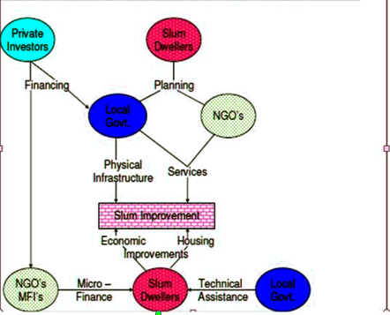
Source: World Urban Forum, 2006.
Conversely, in the bottom-up improvement process, the slum residents take the front line duty as individuals and families to improve the quality of their housing and better their economic situation, as illustrated in the diagram above. The NGO’s and local government also provide them with technical guidance to improve their housing, (ibid).
Secondly, the local government is commonly referred to as city government, any independently governed and other substantial entities that exercise authority over given area. It ensures that slum dwellers have access to essential infrastructure and services. This includes: portable water, sewerage, street lighting, solid waste collection, public transportation, education, health care and fire services, (ibid). In the top-down slum improvement process, they principally provide infrastructure and basic services. On the other hand, in the bottom - up process, they play a very useful role in the provision of housing construction, inspection and advices as part of their building permit enforcement responsibility. The local governments are also responsible for project implementation, coordination of civil organization, legal monitoring and evaluation, provision and maintaince of social infrastructure and planning of municipalities, (UN-HABITAT, 2003). However, NGO’s play varied roles. Some focus on advocacy for specific policies or interest of particular groups. Others specialize on charitable works and the provision of services that are unavailable or short in supply. In the top- down level of the slum upgrading, they play the advocacy and service delivery role, advocate for the interest of slum dwellers during the upgrading, project planning and promote policies and investment that support slum improvement. In the bottom-up level, specialized NGO’s and micro-finance institution enhance slum improvement by offering micro-credit to slum dwellers for both housing improvement and enterprise development, (Painter, 2006).
In addition, private investors provide capital necessary to fuel slum improvement process. This is necessary for scaling up the improvement. In the top-down process, capital is required by the local governments to finance the construction of infrastructure services in the slums. On the other hand, at the bottom level of slum improvement, NGO’s and micro-finances institution require capital to expand their micro-lending to slum dwellers, though the private sector will weigh risks and returns before investment, (World Bank, 2005). The civil organization ensures community involvement, the development partners ensures international exposure, resource mobilization mechanisms and capacity building. The media is vital for advocacy and dissemination of information, (UN-HABITAT, 2003).

2.5 Problems constraining the development of slum upgrading schemes
Generally, review on slums and slums upgrading may not specifically touch on the challenges of slum upgrading programmes or related solutions but it reveals various underlying factors that do constrain the process. Slums upgrading is not an independent process but involves various interrelated factors and actors on slums livelihoods. In many circumstances, slums upgrading involves relocations of slum dwellers due to the challenge of finding enough land adjacent to upgrade the slum. As a result, the interdependence between the city and the slum is broken leading to serious socio-economic effects such as: interruption of the residents’ daily activities, long distances to work place or even unemployment. Sjoberg (1960) conceives slums as an inseparable part of the urban economy and a product of urban stratification. Similarly, Meier (2000) notes that slums fullfils important political, social, and economic functions in the city while Gallagher (1992), observes that many cities around the world depend on the informal sector. Hence, slum upgrading should avoid undue relocations to ensure continued interdependence for the benefit of slum dweller and the urban economy.
According to UN-Habitat (2001), effective slum upgrading requires active involvement of the target beneficiaries. This is necessary for the success of any slum improvement initiatives. Sanaft (2000) argues that community participation gives the residents a sense of belonging and ownership during project implementation. It also promote exchange of information, conflict resolution and supplement design and planning of community development. When slum improvement initiative ignores that, then the process is likely to face the problems in the implementation of the programmes, (ibid). According to Das (2008), governments in developing countries in an attempts to solve housing problem though various policies via state funded projects. This is made efficient through decentralization which many policies fail to address. Some of these policies lack local initiatives such as social, cultural and economic conditions. For instance, in Thailand, the Baan Mankongprogramme suffered due to poor policy and decentralization to account for all institutional frameworks required for the operation of such projects, (Boonyubancha, 2005).
The UN-Habitat (2001), describes social segregation as a major challenge to upgrading programmes. Most of the slum dwellers are excluded from exercising any control over material, financial, intellectual and other resources that are necessary in exercising any form of power and have minimal access to and control over very minimal resources. Similarly, Beall (2002) attributes social disparity to foreign policies which mainly destroy local economy. He also argues that marginalization worsens the situation or leverage hence the need to promote bargaining power. Godhart and van (2008), clearly observes that most slum upgrading programmes concentrated mostly on housing improvements at the expense of other slum livelihoods. This is a challenge calling for the need of comprehensive and integrated for slum upgrading intervention covering all components.
However, Amis and Kumar (2002) argue that successful slum upgrading need good political will for effective facilitation and implementation of the project. Diversified political interests amongst the residents, and those in leadership, has contributed in creating suspicion and mistrust amongst the residents thus slowing down decision making. Elmhist (1999) also relates slum improvement programmes to political survival strategies meant to manipulate the poor for selfish interests. Slum upgrading also faces environmental degradation due to unhealthy environmental hazards in slums. This is mainly attributed by poor drainage, uncollected garbage, flooding among other dangerous exhibitions in slums. Van Vliet, (2002), argues that such conditionsposses health risks. Moreover, competing interests among stakeholders really slow down the upgrading initiatives. These stakeholders have their own interests in the slum, most of which conflict therefore they are a major drawback to the programme, (Muraguri, 2011). According to Zoysa el al (1998), NGO’s may promote social activism thus constraining such initiates. In New Delhi, India, activism by NGO’s has been questioned, propagated for failing target groups. Land tenure is also a major challenge since such settlements many of them are estate on illegal land. This therefore hinders improvement of such area, (Muraguri, 2011). In addition, ignorance among slum dwellers, lack of knowledge and skills is also an underlying factor. Magdeburg research group on Mumbai slums (2009), emphasizes that effective slum upgrading must take into account the beneficiaries capacities to build and enhance interdependence, awareness and sustainability of the initiatives. NGO’s therefore should be in the fore from in championing the initiative.

2.6 Gaps within the Literature
Slums and informal settlements have been a menace since the industrial and urbanization era. It is surprising that even basing on history, the true cause of such settlements cannot be established. Some of the factors historian uses to explain the emergent do not apply in other countries. Ratification of strong policy and legal framework to address the challenge has been constrained. Most of the strategies developed haves addressed the issue on temporal basis as major issues leading to informal settlements are not properly addressed especially land tenure. A lot of controversy and conflicts has been witnessed while attempting to address slums and informal settlements especially other stakeholders who view it a way of doing away with them. Some of the activities have been viewed as the role of the state hence not addressed by the stakeholders even though they were in position to do so. Lack of proper communication channel also brought misinformation, mistrust, suspicion and also opposition of various slum upgrading initiatives. Most of the initiatives by the States have been focusing on the development of physical infrastructure not bearing in mind that other social and environmental issues also need to be addressed. In addition, lack of comprehensive institutional framework has made public involvement a problem especially in the design, planning and implementation of the programmes met to upgrade slums. In this light, most of the targeted beneficiaries have never realized the relevance of slum upgrading.

2.7 Theoretical framework

2.7.1 John Turner’s Theory
Turner advocated for bottom-up form of development including three interrelated view point namely: a benevolent view of communities, hostile view of bureaucratic procedures and favourable view of participatory and humanistic management, as against to scientific and coercive administration, (Korten, 1986). This was during his formative writing in the squatter settlements in Peru, between 1957-1965. Based on his observation, Turner argued that demolition of slums is not a solution but improving such environment. For instance if the government can get rid of the existing slum unsanitary human waste, inadequate or polluted water, litter and filth from muddy unlit lanes need not to worry about shanty dwelling . He also suggests that as the environment improves, most of the slum resident will gradually better their homes and living environments especially when security of tenure and access to credit is improved. In this case, land tenure was identified as important but not seen as essential pre-condition for successful slum upgrading schemes. This because informal settlements often show great organizational skills in the land management hence could be trusted in the maintaince of infrastructure. He also insisted that housing is best provided and managed by the residents themselves rather being administered by the central government. The neighbourhoods designed with the local groups work better since people are experts on their own situation and therefore should be given a freedom to build, (Turner, 1972).
In this context or framework, the state as well as the private professionals such as architects or engineers acts as enablers resulting in a shift of thinking that valorizes experience and local know-how over technocratic professionalized form of knowledge. Moreover, in his book, Freedom to Build: Dwellers Control of Housing Process, Turner sets out views which are valid up to date. There has been attempt in Europe to involve the residents in decision pertaining their built environment for example: the work of participatory architects of 1960s and 1970s in the Scandinavian co-housing movement, the community technical aid centres of United Kingdom, yet their full potential have not been realized, (ibid).

2.7.2 Community Action Plan Model
This model was developed by Hamdi and Goethert in 1997, which states that ‘Communities and their groups should take part in the initiation, planning, design, implementation and maintaince of the development schemes in their place of residents’. Desai (1995) explains that community participation is a platform in which local people are involved in the decision making process of issues that affect their living conditions. Grassroots development also demonstrates some aspect of community participation. Community involvement serves as a framework in which the affected residents air issues that affect them most, (ibid).
World Bank (1999-2001), affirms the input of local community is vital in the designing hence a sense of ownership and success of the project. Hamdi and Goethert (1997) insist that the involvement can be done in the following levels namely: indirect, consultative, shared control and full control. They argue that new form form of development requires new definitions of public role and development partners. Hence, shift from consultative plan, political decide and the people received to community empowerment, participation by the affected group and promoting sustainable technologies in the planning process. Planning team should therefore undertake direct observation by looking, listening and communication through appropriate channels to ensure that the responses of the community are fully covered, (ibid).
Payne (1989) also argues that, it is very difficult to find out what people actually want since local groups or CBOs and other representatives’ needs may not reflect that of the other members of the society. The project team has the duty to ensure that the needs of various groups are established through various tasks such as: identifying opportunities, setting project goal, identifying resources and constrains with community involvement, (ibid).
Effective community participation requires skills, knowledge and technical know-how. The right institutions and framework must be designed by the legal bodies to enhance effective participation, (Denter and Klok, 2000).
In addition, Rakodi and Schlyter (1981) suggest that active participation should be a long term process to achieve quantifiable outcome hence people will fully acknowledge the value of participation. This model therefore provides a clear direction on how effective local participation can be attained. The only aspect it fails to address is how political power structure and cultural factors influence participation, (ibid).

2.7.3 The Culture of Poverty Theory
This theory was coined by Oscar Lewis in his book: Five Families; Mexican Case Studies in the Culture of Poverty, published in 1959. Lewis (1966) defined the Culture of Poverty as a sub-culture which reflected both adaptation and reaction of the poor to their marginal position in a class-stratified highly personalized/ individual and capitalist society. The sub-culture developed out of underdevelopment and rural-urban migration leading to rapid growth, unemployment/ underemployment, dependency, marginality, feeling of helplessness, and powerlessness. He further states that, individuals living within the culture have little or no sense of history and therefore lacking knowledge to alleviate their conditions through collective actions instead of focusing on the trouble. Lewis insists that the imposition of poverty on a population was the structural cause of the development of the Culture of Poverty as evidenced in a place especially informal settlements, hence the attitude and behaviors developed within the culture of poverty get passed down to subsequent generations through socialization processes. Lewis (1959; 1966; 1968; 1970) expresses the sub-culture in terms of seventy interrelated social, economic and psychological traits summarized as follows: the inhabitants live in overcrowded and poor housing settlements with occasional temporal grouping or voluntary associations depending on the a sense of community as well as sense of territoriality found among the poor. The family units and culture of the poor through intensive analysis of specific families gave him a clear concept of interrelationship between personality and culture. In addition, personal relationship among the members is the most important social unit in the culture of poverty with children experiencing unstable and often violent family life. There is also high incidences of of husband abandoning wife and children hence the family tend to be mother centred, (Hossain, 2006).
Just as any other theory, critics points out several flaws within theory, For instance, it assumes that the culture itself is fixed and unchanging implying that once a population exist within the culture of poverty, no amount of intervention in terms of alleviation of poverty will change the cultural attitude and behavior held by members of the population hence any assistance to their welfare will not eliminate poverty. The theory shifts blame for poverty from social and economic condition to the poor themselves. Factors such as sub-standard housing, education lack of sufficient social services, job opportunities and persistent segregation and determination are considered as the initial conditions of poverty. It is also worth noting that, the theory has had tremendous impact on the US policy forming Public Policy towards the poor in the early to mid 1960s, influencing President Lyndon Johnson on war against poverty. The culture of poverty and culture of dependency have become the foundation for Anti-poverty legislation such as temporary assistance for needy families, (Townsend, 1979).
Numerous approaches have been advanced for social change that deals in slum upgrading. Different school and governments have applied them in addressing the issues of housing. The model in its view restores housing structures more attractive. Urbanization theories such as migration, industrialization and dependency theories gave an insight to the problems occurring in slums. This study focused on the people as as the main hence used participatory and stakeholders approaches since they have an impact on the sustainability if the project, (ibid).

2.7.4 The Theories of the Culture of Poverty and Marginality.
The combined ideologies portrayed slums as problematic den of violence and prostitution and the only way out was to demolish them and relocate the residents to public housing projects. The theories blamed the victims for their problems and viewed slum as a social problem. Marginality was considered as a material force as well as an ideological concept and description of social reality, (Perlman, 1976 &Arefi 2008). The theories reflect popular misconceptions, stereotypes and assumed weakness associated with poor communities. Migrants to the cities were portrayed maladapted and failure to be absorbed in formal employment and housing markets therefore not considering slums/squatter settlement as no part of the urban community hence associating them with violence, crime, prostitution and social break down. Conventional wisdom therefore suggests that only solution to these problems was relocating the squatter to decent housing, (ibid). The theories notes that slums were not considered as part of the rational scientific city discourse prevalent in urban planning circles of the time. There is therefore little room for the poor in the planning circle of the time. Policy measures aimed at the urban poor in the planning arena ranged from segregation to outright removal on the end. For instance, the removal of policy and grand example of modern rationality city was Haussann’s design of Paris. This design therefore left little room for the poor.

2.8Conceptual framework
From the above literature review, the past slum upgrading efforts shows that local participation is necessary and valuable. This is in consideration of the difficulty to create and implement a successful urbanization plan with solely a top-down approach hence the need to design a bottom-up approach in order to meet and priotize the specific needs of slum dwellers. In this approach, a premise is held that “Every stakeholder is a key beneficiary and their ideas are necessary for the success of the project, (Mikkelsea, 1995). In 1991, the United Nations Committee on Economic, Social and Cultural Rights (UNCECSR), stated “Government should adopt national housing strategy that reflect the entire genuine consultation with and participation by all of those affected, including the homeless, the inadequate house and their representatives”. Hence participatory approach is the best practice for improvement of slums. It therefore enables the affected people to influence resource allocation, the planning and implementation of policies and programmes at different level and degrees that comprising: identification, time planning, design and implementation, evaluation and post implementation of development hence enhancing sustainability of such projects, (Perten, 2011).
This study therefore, resolved to adopt the conceptual framework developed by the UN-HABITAT (2012), about Streets as Tools for City for Urban Transformation in Slums: A Street led Approach to City Slum Upgrading. This concept imply that slum upgrading consist of physical, social, economic, organization and environmental improvement undertaken cooperatively and locally among citizens, business and local authority. Public policy strategies include: installation and improvement of infrastructure such access roads, security lighting, water supply, sanitation, and drainage among others; flood prevention and rehabilitation community open spaces, promoting small scale business and supporting local economic development.
In this framework, it is believed that opening or establishment of one infrastructure opens roots for other development. For instance, the case of street development and security lighting triggers economic activities, attracting services and increased resident identity with their place of residence, promote mixed activities, use and interaction among residents enhancing public safety; and also there is increased accessibility and proximity to new locations. Therefore, through this strategy, much transformation can be realized, as shown in the figure 2.

Figure 2:A Conceptual Framework
Adapted from the UN-HABITAT about Streets as a tool for Urban Transformation in Slums: A Street led approach to City Slum Upgrading.Modified to suit this study.
Physical improvement
- Area base plan- mapping and survey
- Water supply,
- sanitation,
- street lighting,
- public space,
- drainage,
- power line,
- environmental rehabilitation

Development Programmes
- Social issues- housing, recreational centres, security.
- Economic- empowerment, training enterprenuership, access to loans
- Education – school, daycare,training institutions
- Health- hospitals, dispensaries, mobile clinics, health centres

Slum Upgrading
Slum Uprading
Policy Framework
- Land tenure
- Land reforms,
- financial institution reforms,
- regulation framework and low income housing,
- recognition of housing rights

Stakeholders Participation
- National government
- local and county government,
- NGO’s, CBO’s, FBO’s, Civil society,
- International Agencies and developers,
- Private partners
- slum dwellers

Sustainable Living and Development

Livelihood option outcomes
- Improved security
- Reduced level of poverty
- Improved interaction and cultural exchange
- Sense of ownership, ownership and unity
- permanent development
- increased levels of literacy
- easy movement and accessibility
- improved health of the community or locals
Enlightened community

Source: UN-HABITAT (2012).
CHAPTER THREE

3.0 AREA OF STUDY

3.1 Location and extent
Kibera slum is located in Langata area in Nairobi, approximately 5 kilometers, an altitude of 1°9’S,1°28’S.and 36°4’E, 37°.10 southwest of Nairobi City. Kibera as a whole is an informal settlement comprising of fourteen villages covering approximately 225 hectares of land. It is because -of its strategic location, it is easy to access to Nairobi industrial area and the Downtown making it highly competitive location for both the poor and non-poor, (Omenya andLubaale, 2012). It is bounded by the Nairobi River and the Nairobi Dam an artificial lake, to the south that provides drinking water to the residents of the city. On the west, it is majorly boardered by Ngong’ forest and Golf course to the east and settlement to the north, (ibid).The neighborhood is divided into a number of villages, namely: Kianda, Soweto East, Soweto west, Raila, Gatwekera, Kisumu Ndogo, Lindi, Laini Saba, Silanga, Makina, Olympic, Karanja, Kambimuru and Mashimoni,(Mutisya, 2011), Figure 3 . The full location and extend is depicted in figure 4.
Figure 3: Map of villages in Kibera Informal settlement.
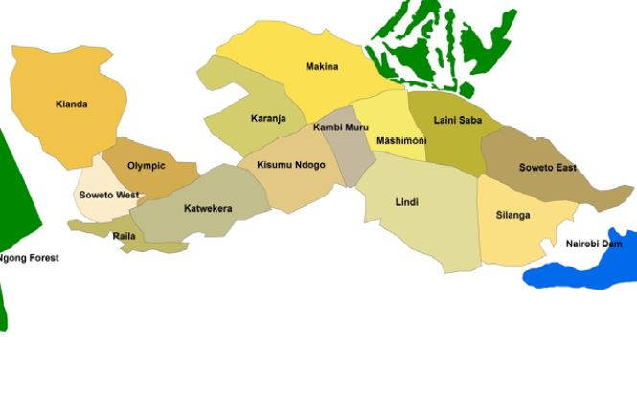
Source: Mutsya&Yarime, 2011

Figure 4: Location and Extent of Kibera.
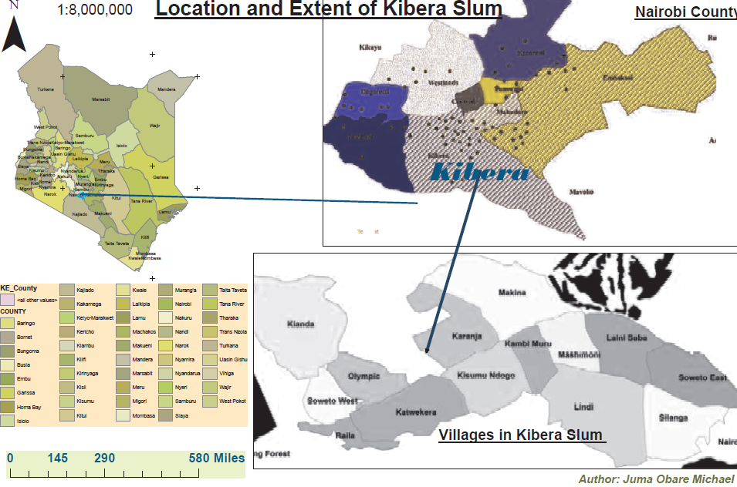
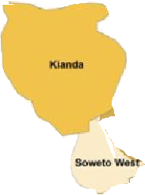
Study Areas
Source: Author 2015.

3.2Topography
Kibera is characterized by undulating hilly terrain with an elevation in a range of 1,460 m to 1,920 m. Lowest elevation occurs at the Athi River at the eastern boundary of the city and highest at the western rim of the city. It is unique because of its proximity to the Nairobi National Park with the area of 117 km² within its administrative area, extending along the western boundary and attracting a large number of international and domestic tourists annually. It also has an influence in the socio-economic activities of the residents, (Nairobi CIDP, 2014).

3.3 Drainage
The main drainage system depends on the terrain which follows the regional slope of volcanic rocks to the east. The subsidiary internal terrain slopes into the rift valley. The westwards extend from 4900feet (1493m above sea level) at the Athi River plains and 6000feet (1829m above sea level) in the region of Ngong’. Kibera is served by Nairobi River and Nairobi dam, which supply water to the residents of the city. These sources to some extend are polluted due to channeling of open sewers and industrial effluent directed towards them.It is also bordered by Ngong’ forest which is the water catchment for Nairobi River, (Saggerson, 1991). The terrain profile has an impact on the development of infrastructure especially access roads and other facilities.

3.4Climate
Rainfall
Kibera being part of Nairobi experiences two rainy seasons, but rainfall can be moderate. It picks up an average of 925 mm (36.4 in) of rainfall per year, or 77.1 mm (3 in) per month. The cloudiest part of the year is just after the first rainy season, when, until September, conditions are usually overcast with drizzle. It is situated close to the equator; the difference between the seasons is minimal. The seasons are referred to as the wet season and dry season. The driest weather is in July when an average of 19 mm (0.7 in) of rainfall (precipitation) occurs. The wettest weather is in April when an average of 206 mm (8.1 in) of rainfall (precipitation) occurs. The timing of sunrise and sunset varies little throughout the year for the same reason. It is important to note that during rainy seasons, accessibility to some places in the villages is a challenge due to muddy conditions, Figure 5.

Temperature
The average annual temperature in Nairobi, Kenya is very mild at 17.7 degrees Celsius (63.8 degrees Fahrenheit).The variation of mean monthly temperatures is 3.5 °C (6.3°F) which is an extremely low range. There is a range/ variation of mean diurnal temperatures of 11.7 °C (21 °F).The hottest month (March) is somewhat warm having an average temperature of 19º C (66.2 F).The coldest month (July) is very mild with an average temperature of 15.5ºC (59º F). Such conditions therefore require well established housing, health facilities to encounter disease incidences due to cold among others. Most of these infrastructures lack in Kibera due hence the need for upgrading, Figure 5.
Figure 5:The Rainfall and Temperature in Nairobi City.
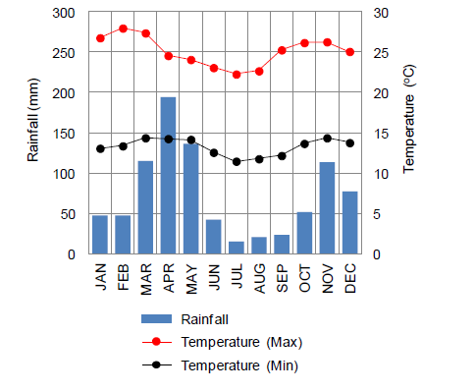
(Source: Nairobi CIDP, 2014).

3.5 Population distribution and profile
According to Kenya Population and Housing Census conducted in 2009, Nairobi City was approximately 3,138,000, accounting for 8.1% of the national population. The average population density excluding Nairobi National Park, which occupies 117km² or 16.8% of the city’s total area, is 5,429 per km², (Nairobi CIDP, 2014). The same report show Kibera was having a population of 178,284, with a density of 14,734 per km². The Kenya Bureau of Statistics (2013), further project this at an interval of three years namely: 2012, 2015 and 2017.
This is indicated in the table 1 and figure 6.
Table 1: The projected Population of Kibera,
YEAR | 2009 | 2012 | 2015 | 2017
KIBERA POPULATION | 178,284 | 199,812 | 223,940 | 241,623
Source KNBS, 2013.
Figure 6: Projected population of Kibera.

Source: Kenya Bureau of Statistics, 2013.
The approximate population in Kibera is not well known since the tally by different organizations is more figure than that presented by the Kenya Bureau of Statistics. According to the report by Umande Trust (2010), Kibera have an average population of more than 900,000. Similar report by the World Bank approximate population to One Million. There is therefore rise in the population. From the census report, the composition was mainly of young people below the 30 years. This implies that the infrastructure and the facilities available will not be enough to serve the population adequately. This is a challenge since in such areas; there is shortage of land for provision of social facilities such as health centres, schools, recreation among other infrastructure. The existing ones are of low standards hence the need for improvement of the facilities and establishment of new ones, (NCIDP, 2014). The figures 7 and 8showsthe population pyramid structures of Nairobi in the 2009 census and the changes in population per gender between 1999 and 2009 censusrepectively.
Figure 7: Population pyramid for Age Structure.
Age Structure of Nairobi County 2009
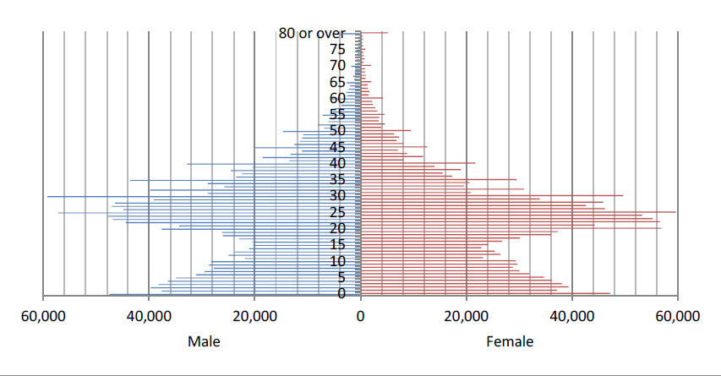
Source: Nairobi CIDP, 2014.

Figure 8: Changes in Population within a Decade
The Shift in Age Structure of Nairobi in a span of 10 years

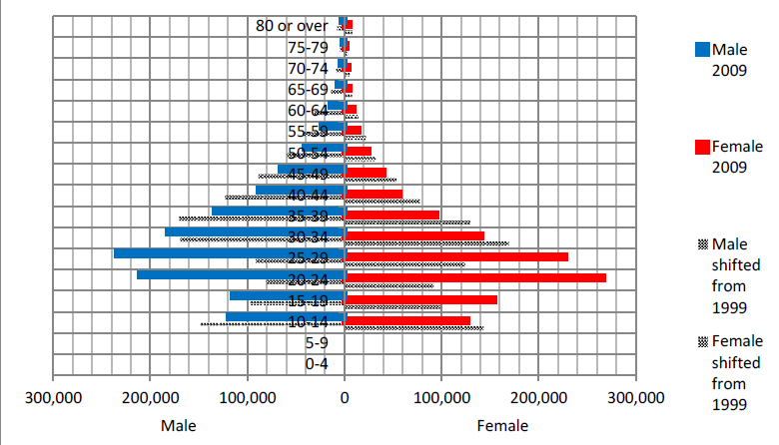
Source: Nairobi CIDP, 2014.

3.6 Socio-economic characteristics
Majority of the people in Kibera depend on employment for their sustenance. Many engage informal employment or casual labour to supplement the daily needs. Casual labour is mainly demanded by the construction, transport and the communication industry. Few engage in formal employment in the central business district and industrial sector. Poverty is therefore rampant. There is high rate of unemployment among the youth, substance abuse, risks of HIV/AIDS, insecurity and crime and lack of proper training institution. The nature and kind of activities they engage consist of low income hence unable to afford favourable living conditions especially housing. This result in the spread of slums hence the need to correct the trend,(ibid).

3.7 Education
Kibera have a number of educational facilities ranging from pre-school, primary education, literacy level, secondary schools and some tertiary institution. Most education centres in Kibera are classified as informal, but various initiatives have been underway to add schools. Some start as babycarecentres, which later develop into schools. Most are not regulated by the government. Some of the notable schools are Olympic Primary School, one of the leading government schools in the country, Kibera Primary School (also called Old Kibera), Facing the Future School (FaFu), as well as several church-owned and privately owned schools, (Njeru,2011). Notable Secondary schools include PCEA Silanga High School, owned by the Presbyterian Church of East Africa, Raila Educational centre, and Olympic secondary School among others. There is the vocational PCEA Emmanuel Technical Training Centre, offering self-employment skills to the residents.
The provision of basic education has therefore remained a challenge due to limited public schools as opposed to private. This is also influenced by the underdeveloped physical infrastructure in the existing schools. The existence of such feature therefore requires the intervention for improvement, (ibid).

3.8 Labour force
The National development (2002-2008), shows that employment opportunities for women are lower to that of men in both rural and urban areas. The major factors associated with this include: imbalances in training and access, retrogressive cultural practices which bar women from taking up positions in certain spheres of employment and lack of supportive legal framework. This is also rampant in slums. Kibera form the labour base for Nairobi downtown, with men employed in most of the formal employment. Women engage in small businesses that really earn little to supplement their needs. An improvement is therefore needed to empower such the residents that will help in poverty reduction.

3.9 Health
Health access is the ability of a person to receive and pay for the health care services, which is a function of availability of personnel and supply as well as ability to pay for those services, (NCDP, 2013). The residents of Kibera depend on health services from public hospitals that some can afford. This is mainly Kenyatta national hospital and other public healthcare within the proximity. sAccess to family planning issues is inadequate due to affordability and accessibility. It is in this light that rapid population growth rate is experienced in the area. There is therefore need to increase such services to control the looming situation of population growth, (ibid).

3.10 Land and Land use
Land ownership is contested to some people, the government owns all the land in Kibera, while for others especially the Nubi community, Kibera belongs to the Nubi. This is supported by their claim of ownership with documentation from the colonial government, (Omenya andLubaale, 2012). Like in any other informal settlement, the land use in Kibera is not designated. Most of the activities are mixed up. Most of the infrastructure is mixed up. This has been contributed due to lack of effective monitoring hence resulting in unplanned settlement. The land reserved for some land uses such as roads and railway have been encroached by human activities such as residential and commercial activities. There is therefore need for new planning with new slum improvement initiatives.

3.11 Infrastructure and Access
Infrastructure is the underlying foundation for development of an area. It is composed of road network, post and telecommunication, energy, financial institutions and educational facilities,(NCDP. 2013). Kibera is served by the following infrastructure:
Transport
Kibera is served by the Kenya-Uganda railway line that passes through the area from Mombasa. This facilitates movement of people to and from the city. Since development control issues are not much strict, the railway reserve encroached and residential shanties constructed close to the railway line. Fatal accidents have been witnessed claiming lives. Legal frameworks need to be strengthened to enhance controlled developments.The road networks to most of the villages are not well developed due to poor planning. This has hindered accessibility especially during emergencies such as fire outbreaks, (ibid).
Educational institutions
Being in Nairobi, the area is surrounded by high concentration of tertiary and university level institutions with science and technology. However, access to basic education is still a problem due high rate of poverty and inadequate facilities for vast population in the area. Civil organizations are striving to ensure that the young populations get basic education. Another constrain that hinder development of such infrastructure is the bureaucratic procedures for land in registration of public school has been a barrier to accessibility of education, (ibid).

Sanitation
Some villages in Kibera are heavily polluted by human refuse, garbage, soot, dust, and other wastes. The slum is contaminated with human and animal feces, due to the open sewage system and the frequent use of "flying toilets". The lack of sanitation combined with poor nutrition among residents’ accounts for many illnesses and diseases. The Umande Trust, a local NGO, is building communal toilets that generate methane gas (biogas) for local residents, (Umande Trust, 2007).

CHAPTER FOUR

4.0 RESEARCH DESIGN AND METHODOLOGY

4.1 INTRODUCTION
This chapter describes the types and sources of data, methods, and procedures that were used in data collection, the sample size, and frame, sampling procedures, analysis and presentation of data during the Kibera research project, Nairobi County to achieve the study which was: An evaluation on slum upgrading schemes in Nairobi. The field study was undertaken in Kibera slums where the upgrading initiative is taking place, specifically in Kianda, Laini Saba and Soweto West Villages.

4.2 RESEARCH DESIGN
This is a systematic plan to study a problem such as a socio-economic problem. It defines the study type such as descriptive, correlation, semi-experimental, experimental, review, and meta-analytic. If applicable, data collection methods and statistical analysis plan is included: (Robson, 1993). This study adopted a descriptive research design. Descriptive research design is an attempt to collect data from members of the public in order to determine the current status of that population with respect to one or more variables, (Mugenda and Mugenda, 2003). Qualitative and quantitative methods were used during data collection and analysis. Theseincluded: survey research, pre field work, and field work, review of relevant documents, data collection, analysis and interpretation.

4.3 Nature and Sources of Data

4.3.1 Nature of Data
These are forms of data applied during the study. They included demographic, socio – economic activities, environmental and other forms of spatial data.
The nature of data collected and analyzed sought to address the stated objectives of the study as provided in Table 2.

Table 2: Objectives and Nature of Data
S/No | Objective | Nature of Data (Variables)
1 | To analyze policy and legal framework for slum upgrading schemes in Kenya. | Relevance, strength, and weakness of the legal and policy framework for slum upgrading Kenya.
2 | To determine the infrastructural elements and facilities that needs upgrading in Kibera slums. | Social infrastructure: education, health, social services.  Economic infrastructure: electricity, roads, telecommunication, railways, water, sanitation and sewerage
3 | To examine the role of stakeholders in the Kibera slum upgrading scheme. | Government agencies, Private sectors, international agencies (UN-Habitat, SIDA, World Bank), Media, NGO’s, COB’s, The local residents.
4 | To examine problems constraining the development of Kibera slum upgrading scheme. | - Insecure tenure  - Conflicting interest  - Ignorance among the local dwellers  - Top- down approach  - Policy and legal framework
Source: Field survey, 2015.

4.3.2 Sources of Data
Primary Sources
Primary sources of data included households in Kibera, resource persons from relevant institutions including Government Agencies (Department of Slum Upgrading), Business Community, NGOs/CBOs, Private Sector, and County Administration.

Secondary sources
These are documented data sources and information on what other people have done. This data was collected from already existing information such as journals, publications, books, annual/quarterly reports, development plans, periodicals and existing spatial information like maps of the study area.

4.4 Methods and instruments of Data Collection
Various methods and instruments for data collection were used and these included the following:
Observation
Physical aspects that were relevant to the study were obtained through observation to verify
verbal claims by respondents. An observation guide as the instrument was used to capture such
elements. This was also used in verifying information or data collected using the questionnaires
hence observations as a method of data collection also served to increase the range of
relevance and reliability of data.
Interviews and Oral Interview guide
This method involved collection of data through face to face interaction with residents of the
Study area and relevant institutions such as the Ministry of devolution and planning, Department of Slum Upgrading, NGO’s such as Umande Trust, UNBOUND, Human Needs Project among others. Data collected using this method included: their role of in slum upgrading schemes, problems do constrain slum upgrading schemes and some of the infrastructural elements that need upgrading.
Questionnaires
This method involved collection of data through pre-determined questions based on the study
objectives. It was administered to households. A total of 70 household questionnaires were used during the field work. The household questionnaires were administered randomly since the settlements are crowed and unplanned. These were done in a bid to collect information as per the objectives of the study. A sample of this questionnaire is presented in the appendix section.
Focused Group Discussion (FGD)
FGD were very instrumental in getting information from various relevant agencies Information regarding operations and performance of slum upgrading schemes initiatives in Kibera was discussed at length. For instance, the Umande Trust elaborated several ways on how the engage the local community in their activities to transform their lives.

Photography
Photographs were used to capture information such as existing housing structures, the current elements are being upgraded and environmental degradation and solid waste management being undertaken. This method provided evidence of the slum upgrading schemes initiatives on the ground. Digital cameras were used to record real on-site images during the field study in order to be used during the report writing and data analysis.
Literature Review
Documents such as departmental reports especially from the department of Slum Upgrading, projects reports, books and referred publications were reviewed and relevant information regarding slum upgrading schemes gathered. This allowed for comparison between primary data collected and existing information.

4.5 Target Population
The study population consisted of households, relevant NGOs/CBOs, relevant government agencies, and local businesses. .

4.6 Sampling Techniques and Procedures
Simple random sampling
This involved random administering household questionnaires and interviewing the residence in the area as each individual had a chance or same probability due to homogeneity of the population. It was adopted since it best suited the pattern of settlement the pattern of settlement. This was also vital in reducing the level of biasness.
Snowball sampling
Snowball sampling (or chain sampling, chain-referral sampling, referral sampling is a non-probability sampling technique where existing study subjects recruit future subjects from among their acquaintances. Thus the sample group appears to grow like a rolling snowball. As the sample builds up, enough data is gathered to be useful for research. This sampling technique is often used in hidden populations which are difficult for researchers to access. This non-probability technique was applied when interviewing institutions and other stakeholders involved in the slum upgrading initiatives and their key function. After the interview, they showed us other organizations and groups they are collaborating with in the slum upgrading schemes or improvement process in Kibera. For instances, an interview with Mr, Nyamwaro, an officer from the Department of Slum Upgrading, he was able to show me some NGO’s such as: Umande Trust, MajinaUfanisi and Pamoja Trust.
Convenient Sampling
Convenient sampling is a non-probability sampling technique where subjects are selected because of their convenient accessibility and proximity to the researcher. The subjects are selected just because they are easiest to recruit for the study and the researcher did not consider selecting subjects that are representative of the entire population. It was preferred because it is fast, inexpensive, easy and the subjects are readily available.
Purposive Sampling
Purposive sampling represents a group of different non-probability sampling techniques. Also known as judgmental, selective, or subjective sampling, purposive sampling relies on the judgment of the researcher when it comes to selecting the units (e.g., people, cases/organizations, events, pieces of data) that are to be studied. Usually, the sample being investigated is quite small, especially when compared with probability sampling techniques.
The main goal of purposive sampling is to focus on particular characteristics of a population that are of interest, which will best enable you to answer your research questions. This method was employed in the identification of the various interest groups for instance; private developers, health centres, other relevant NGOs/CBOs.

4.7 Methods of Data Analysis
Microsoft Excel spreadsheet and statistical package for social scientist (SPSS) were used for the analysis. After obtaining the raw data set, it was sorted and coded. The open-ended questions were manually analyzed by grouping responses into similar themes and tallying them and frequencies determined using excel spreadsheet. The closed-ended were appropriately labeled and entered in the SPSS version 20

4.8 Limitations of the Study
Some of the residents of are hostile and unwilling to respond. Long distance to study area is a challenge a long side other factors such as traffic jam worsened it. The study had all respondents’ biasness as most of the respondents especially the institutions only gave the positive side of their story yet from observations, things were really different while some NGO’s provided a long bureaucratic procedure in order for them to respond, for instance Carolina for Kibera. The scheduling of the research during the holiday period was also inconvenient as some of the resident had travelled to their rural village for Christmass celebration. In some of the villages, especially Lainisaba, security of the research was an issues, strangers would not take photo without proper consultation.

CHAPTER FIVE

5.0 DATA ANALYSIS AND DISCUSSION

5.1 Policy and Legal framework for Slum Upgrading Schemes in Kenya.

5.1.1 Policy Framework
National Land Policy, 2009.
It explains informal settlements as occupation of land without formal recognition that do not comply with the physical and land use planning due to absence of security of tenure. Such settlements also host many Kenyans; hence present a challenge to land planning and development. Various interventions developed by this act to deal with the situations include: taking inventory of genuine squatters and people who inhabit informal settlement, determining whether the land is suitable for human settlements, establishment of appropriate mechanism for removal and resettlement, enhancing sustainability in handling subjects of land in informal settlements, establishment of measures to prevent to prevent slum development and appropriate of legal framework for eviction based on internationally acceptable guideline.
However, it is unfortunate that this policy has not achieved much due to poor implementation strategies especially to prevent the rise of more slums. The legal framework on informal settlements has not yet been in place due long bureaucratic procedures involved in the making draft bill into law as per reports from the Department of Slum Upgrading.
The National Vision 2030
This paper recognizes that there is a drastic change in demographic features and more than half of the nations will be living in urban areas. It aims to provide an adequate and decent housed nation in a suitable environment by 2020, with an initiative for high quality urban planning since most cities and towns are unplanned. It also notices the huge need for an effective capacity for regional and urban development planning for those living in slums and informal settlements. The short term flagship of the year 2019 was the development of the metropolitan and investment plans initiative with each county developing an integrated developing plan.
Apart from housing, other issues in slums that this policy paper addresses include: Equality and Poverty elimination, “to reduce the number of people living in absolute poverty to its tiniest proportion of the total population and equal opportunities in accessing public services and providing income generating activities as possible”. Others include increasing school enrollment for girls and children from nomadic communities and rural poor and slum communities, widening the coverage of essential healthcare, equitable distribution of water supply, sewerage and sanitation services. It is worth noting that some of these plans are currently being implemented in many informal settlements especially in Kibera slums.
The National Housing Policy, 2004
This policy gave the Government an opportunity to carry out land use planning and management and also establish banking facilities for low income housing. It advocates for provision of incentives for squatters who purchase land they occupy at lower rate for shelter development, waiving fees on survey, sub-division, and even change over. This is therefore can contribute improvement of informal settlements within the urban setting acquisition of land rights iseasened.
The National Urban Development Policy, 2011
This policy reorganized that Urban development composed of inadequate supply of quality goods and services with various land uses and management charged with corruption, controversy and conflict. It therefore seeked to create a framework for sustainable development of urban areas focusing on thematic areas especially governance and management of urban areas, urban finance, urban economy, national and county planning. Other issues that this policy addresses include: social infrastructure and services, urban housing, security and disaster risk management and marginalization of vulnerable groups. All these issues are some of the challenges slums and informal settlement face hence the call for upgrading is real.
The National Slum Upgrading and Prevention Policy.
This was initiated by the Ministry of Housing in 2012, (GoK, 2013). It aims at transforming slums and informal settlements into better dwelling for habitation by peoples from every background. This was to be implemented through multi-stakeholder collaboration since upgrading is a comprehensive, multidisciplinary and inter-disciplinary process.
Kenya Slum Upgrading Improvement Project (KISIP)
This is now a new initiative coined by the government of Kenya in partnership with the World Bank and Swedish International Development Agency (SIDA). It aims to focus on improving living conditions on the current informal settlement by improving infrastructure and strengthening of security of tenure.
The government is to support in planning for future urban growth in a manner that prevent emergence of new slums. This project is to run in 15 municipalities’ in five years from June 2011. It has four main components mainly strengthen of intervention and management of programmes, enhancing of security of tenure, improving infrastructure and service delivery and planning for growth of urban centres.
KENSUP Implementation strategies
The Kenya Slum Upgrading Programme(KENSUP) has been the sole body charged with improvement of livelihoods in urban slums since its formation. This has been influenced through a number of policy papers. Some of these include: The Communication Strategy of 2005, which had the objective to empower stakeholders and ensure their meaningful participation in the implementation of slum upgrading projects. The strategy was divided into three levels namely: national, city/town and at the settlement level in attempt to strengthen the nexus among the Central and Local Government institutions, Development partners as well as the beneficiary community. Secondly, the Communication Plan of 2006 was developed to easy the misunderstanding of KENSUP, by many stakeholders. These were based on historical background in attempts to improve the living conditions in slums. Lack of adequate information was considered as the major drawback to the activities of KENSUP, hence mistrust and suspicion among stakeholders. It is in collaboration with Sida that a comprehensive Communication Plan was launched and linked to Integrated Land and Urban Sector Programme (ILUSP) in order to address issues such as; gender, HIV/AIDS, human rights, and people with disability. This was meant to be line with the MDG Seven Target 11 which aim to improve the lives of 100million slum dwellers by the year 2020, 5.3million living in Kenya. This therefore enhanced participation in slum upgrading activities. Finally, the KENSUP Strategic Plan (2005-2020), Volume II. This addressed varied number issues such as policy and legal framework on slum upgrading, institutional framework, economic strategies for slum dwellers and infrastructural elements and facilities that need to developed of improved in slums. The plan identified security tenure as a major factor that has hindered the slum upgrading initiatives. It alarming that 10 years since the plan came into operation the land tenure is still unsolved.

5.1.2 Legal Framework
According to various experts charged with the upgrading of the conditions in slums and informal settlements, much has not been achieved due to existence gaps and weaknesses that exist within the legal framework. KENSUP implementation strategy Volume II, notes that slum and informal settlements operate outside the legal and policy framework. Therefore, there is need for recognition of KENSUP activities as well as mainstreaming the proposed activities within the Government of Kenya and local authorities and prioritization of activities. Generally, the country has been lacking a comprehensive and appropriate legal framework and guideline for informal settlements activities and slum upgrading. This is according to reports from the Department of Slum Upgrading. The long bureaucratic processes in the National Assembly followed for the bill to become a law has also contributed despite the agency to address the slum pandemic requires. Harmonization of programmesand activities of various stakeholders have been difficult especially coordination. Most upgrading initiatives have been operating through the guidance of various policies and laws on issues affecting slums such land, health, housing, security, water, among others which include:
The Constitution of Kenya
Article 21 states that; The Government or State has fundamental duty to observe, respect, protect, promote, and fulfill the fundamental rights and freedom of the citizen by taking appropriate legal action. This aim in protecting individualsirreguardless of the social and economic status in the society. This actually what affect slum residents since the suffer deprivation and marginalization. Article 43, calls for attainable standards in healthcare services, accessible and adequate housing, and reasonable standard of sanitation, clean and safe water in adequate quantities, social security, and education. All these are in insufficient in slum hence calls for slum upgrading.

Urban Areas and Cities Act, 2011
The Third schedule of this act provides for factors to be considered in the preparation of County Integrated Development Plans while Part V, article 36, provides the frameworks within which the integrated plan shall consider. These include: protection and enhancement of human rights especially right to housing and other basic services, provision of infrastructure, preparation of environmental plans and other strategic plans and evaluation of the socio-economic status of the residents. Kibera being in Nairobi is under the guidance of the NCIDP. It is worth noting that this act has considered numerous issues affecting the city, majorly the increased number of informal settlements/slums hence developing proper interventions. This act also requires that the county integrated plan to be made available to the members of the public at given points. This is what Nairobi County Government has not implemented hence most residents from various informal settlements are aware of or hear of it but do not understand what it contains.
County Government Act, 2012
This act provides that each County shall prepare a County Integrated Development Plan, which shall be a basis for all budgeting and spending public funds. The integrated plan shall address matters on physical, economic, social, environmental, and spatial planning. The Nairobi CIDP (2014) classifies Nairobi urban areas as unplanned, driven by the rapid population growth and poverty. The sprawling informal settlements hamper the spreading of the cities baseline for social services hence deteriorating of quality life. Informal settlements are categorized as an environmental issue accelerated by the rapid growth of population, increased demand for land and inappropriate land allocation hence pushing the poor to fragile areas where they are face various challenges such as inadequate housing and public services hence not vulnerable to environmental changes.
The Public Finance act of 2012
This act provides that the budgetary process for the County Governments for every financial year must begin with an integrated development planning process. This consist of both medium and long term plan which will in turn form the county budget estimates and establish financial and economic priorities for the county. This empowers the counties to borrow from other sources for the development programmes with the approval of the national government. Such funds can be used for upgrading of informal settlements within their jurisdictions.
The acts also have not achieved much due to unfavourable mode of implementation and have been considered ambiguous, hostile or contradictory. The Ministry of Land, Housing and Urban Development therefore established the Department of Slum Upgrading since duration of KENSUP elapsed to continue spearheading the programmes and activities that have been in operation.

5.2 Infrastructural elements and facilities under slum upgrading schemes.
According to Government of Kenya (2005-2020) KENSUP Strategy Paper, the population in urban centres hadincreased from 0.75Million in 1989 to 9.9Million in 1999. The 1989-1999 intercensal also reveals that the population in urban centres double from 3.88Million to 9.9Million, an increase of 155%. During the same period the number of urban centres grew from 139 to 194 an increase of 40%. It is worth noting that this rapid urbanization is a major contributory factor to the growth of informal settlement, (Government of Kenya, 2012). The influx of more population in urban centres resulted into the following issues: inadequate water supply, unemployment, environmental degradation, poverty, poor infrastructure and social amenities especially in informal settlements, (ibid).The KENSUP (2005-2020) Strategy Paper, reorganizes that infrastructure is acute in informal settlement; either they lack or the ones that are in place exhibit poor state and severe deficiencies are encountered. This paper classifies infrastructure into two namely: social and physical infrastructure. Social infrastructure include: schools, health centres, recreation facilities (social halls, playgrounds, community centres), vocational training centres and markets while physical infrastructure include: access roads and foot path, sewer systems, drainage, water and sanitation, electricity and street lighting. The report also points out that the present social infrastructure is overcrowded, under equipped leading to stress, high delinquency and high mortality rates. The poor states of physical infrastructure had retardate investment and income generating activities, (ibid).
From the field research and study, many residents identifies a number of issues they are facing, for instance; water supply, security, insecure tenure, solid waste, housing, accessibility, social services, educational facilities, unemployment, electricity, drainage, drug abuse and unequal distribution of resources. Table 3, highlites some of the problems.
Table 3: Some of the problems faced by residents of Kibera slums.
Problems | Reponses
 | N | Yes | No
Scarcity of water | 68 | 36 | 32
Insecurity | 68 | 27 | 11
Solid waste | 67 | 50 | 17
Insecure tenure | 67 | 27 | 40
Social services | 66 | 31 | 35
Education facilities | 67 | 41 | 26
Housing | 67 | 54 | 13
Source: Field data, 2015.
Water supply: 53% of the respondents showed that the accessibility to water is a problem in terms of cost and distance. Most of the existing water points are illegal connections and the pipes are also reinforced on degradated conditions such as polluted water and steams and open sewers making the water to be contaminated and unfit for human consumption due to leakages a proof by one of the resident and field observation. This is illustrated in Plates 1(a) and (b).
Plate 1(a) & (b): Unsanitary conditions where there is illegal Water pipes connections
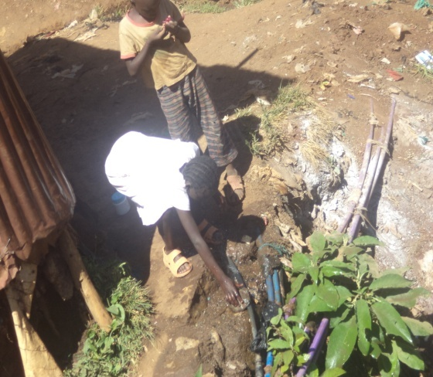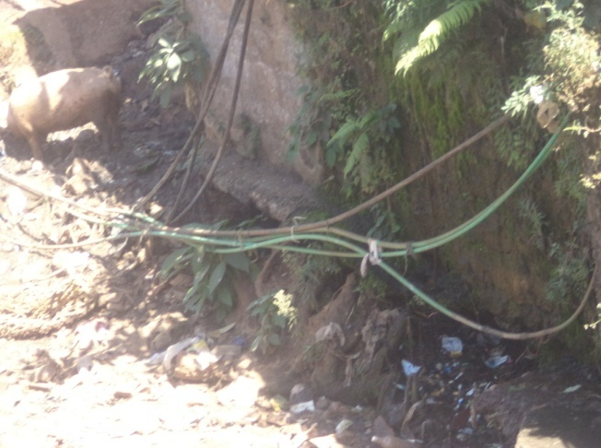
Source: Field survey, 2015.

Accessibility: From the field observation it was evident that accessibility is a major issue. Moving from one village to other especially those separated by a stream like the case of Soweto west and Raila villages is a challenge especially at night and during rainy seasons. The foot bridges are in poor state and people using it are highly vulnerable as shown in Plate 2(a) and (b).
Plate 2(a) & (b): The state of foot bridges connecting the Villages of Kibera.
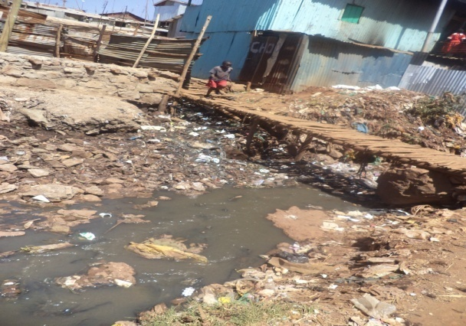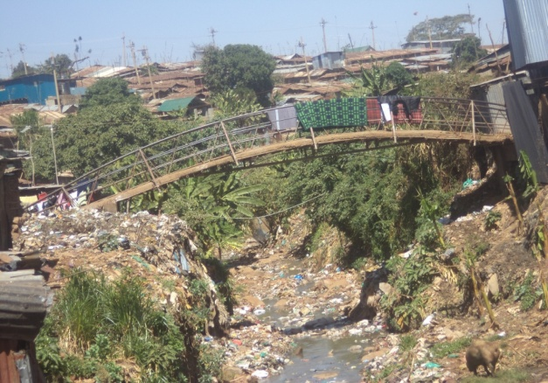
Source: Field survey, 2015.
Solid waste: 75% of the respondentsintervieved and field observation agree that solid waste is a challenge. This is due to uncollected waste for very long period, lack designated point for solid waste collect and ignorance from the residents for the need of clean water. Plate 3(a) and (b) is an evidence of how many streams have been polluted by solid waste.
Plate 3(a) & (b): The Menace of Solid water in some villages of Kibera
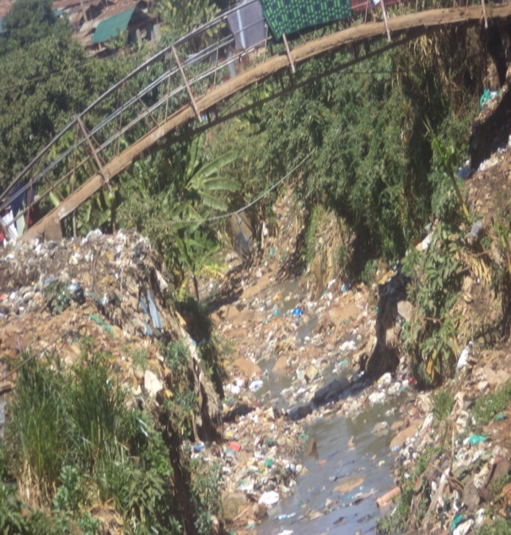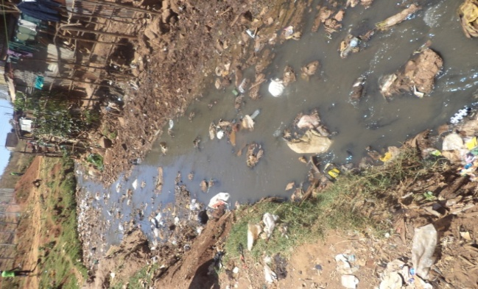
Source: Field survey, 2015.
Housing: This was the overriding theme during the study, especially in comparison to the number of people per household. 81% of the respondents alluded that housing was a major issue that should be addressed immediately. Most of the houses are in poor state as they are mud walled or earthened and also made from old materials. 50% of the respondents had more than three people per household and 81% of the respondents also stay single roomed shantis and houses. 17% of those who stay singled roomed in say that the space is enough for them while 83% argue that it is too small. 31% of those staying in double roomed house say that the space is enough for their households while 69% in the similar category are of the contrary opinion. Overally, 20% of the respondents agree that the space is enough for their households while 80% are of the contrary opinion. Majority of the respondents prefer if they can be provided with low cost houses that are a large, then the living conditions would be better. This is presented in the table below. This therefore conforms to what the UN-HABITAT describes as a slum household. The residents therefore, calls for developent of low cost housing, lowering of rent by land lords and structure owners, provision of secure tenure, employer to increase salaries and empowerment programmes.(Table 4, figure 9 and plate (a) and(b)).
Table 4: Household Composition.
Size of the House |  | Household size |  |  |  | Total
 |  | less than 3 people | 3-5 people | 6-8 people | Over 8 people
 | Single | 14 | 27 | 6 | 6 | 53
 | Double | 2 | 3 | 7 | 0 | 12
Total |  | 16 | 30 | 13 | 6 | 65

Source: Field data, 2015.

Figure9: Size of Households.

Source: Field data, 2015.
Plate 4(a) & (b): The Conditions of Shanties in Kibera.
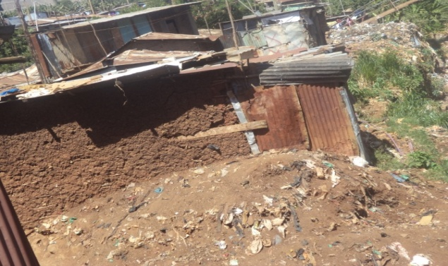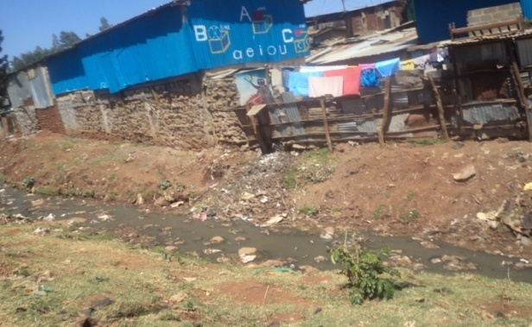
Source: Field survey, 2015.
Other issues had the following responses: insecurity 29%, Education facilities 61%, Social services 47% and Insecure tenure at 47%. Figure 11 is a graphical representation of some the challeges faced by residents of Kibera.

Figure 10: Problems faced by residents of Kibera.
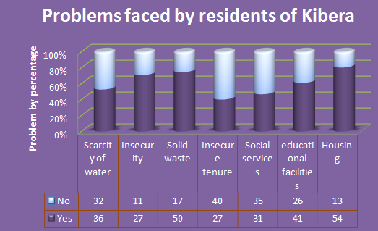
Source: Field data, 2015.
In examining some of the infrustructural elements and facilities that they would like to be improved, here are a number of reponses by percentage: Access roads 80%, Electricity 67%, Street lighting 73%, Water supply 74%, Sanitation 79%, Health facilities 71%, Education facilities 73%, Sewerage 79% and Housing at 91%. Security was also pointed by some residents as an issue that needs improvement by establishment of more Police posts. Table 5 and Figure12 shows some of the infrastructural elements that need ugrading.
Table 5: Infrastructural elements that need upgrading.

Infrastructure | Responses
 | N | Yes | No
Access roads | 66 | 53 | 13
Electricity | 66 | 44 | 22
Street lighting | 66 | 48 | 18
Water supply | 66 | 49 | 17
Sanitation | 66 | 52 | 14
Health facilities | 66 | 47 | 19
Education facilities | 66 | 48 | 18
Sewerage | 66 | 52 | 14
Housing | 66 | 60 | 6
Source: Field data, 2015.
Figure 11: Infrastructural elements that need Upgrading.
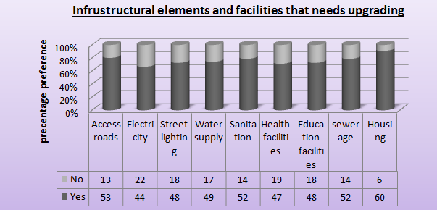
Source: Field data, 2015.
Apart from infrusttucture, other issues that emerged from the field study, that require immediate address include: identification and development of talents among children and youths, drug and substance abuse, gender based violence, unemployment, fair distibution of resources, and educational sponsorship for vulnerable groups. For instance. the case of unemployment and occupation, these are some the existing situation: 22% of the respondents were jobless, 27% were employed, 38% engaged in business especially informal subsistence and 13% were involved in others activities in an attempt to generate income. Unemployment is still an issue since more than half of the employed are temporary basis especially by the National Youth Service (NYS) in Table 6 and Figure 13.

Table 6: Occupation of respondents.
Occupation | Responses | Percentages
None | 15 | 22%
Employed | 18 | 27%
Business | 26 | 38%
Other | 8 | 13%
Total | 67 | 100%
Source: Field data, 2015.
Figure 12: Occupation of the Respondents.
Source: Field data, 2015.
During this field study, I found that many physical infrastructural elements were undergoing improvement in the various villages. Security and health issues were being addressed in all the villages. A Police post is being established in every village to enhance safety and foster developent and research. Community health clinics through the Beyond zero campaign initiative spearheaded by The First Lady Margret Kenyatta. This is to imrpove the primary health among children and pregnant mothers and reduce infant and maternal mortality in striving to attain sustainable development goals.Here are some of the development or improvement infrastructure in my area of study areas:
Kianda: There is housing project by the Ministry of Transport and Infrastructure under the Railway Corporation, with the aim of resettling the residents who had settled along the railway reserve. Plates 5 shows the housing apartments that are nearly ready for occupation by the selected residents.
Plate 5: Houses under construction by the Railway Corporation in Kianda,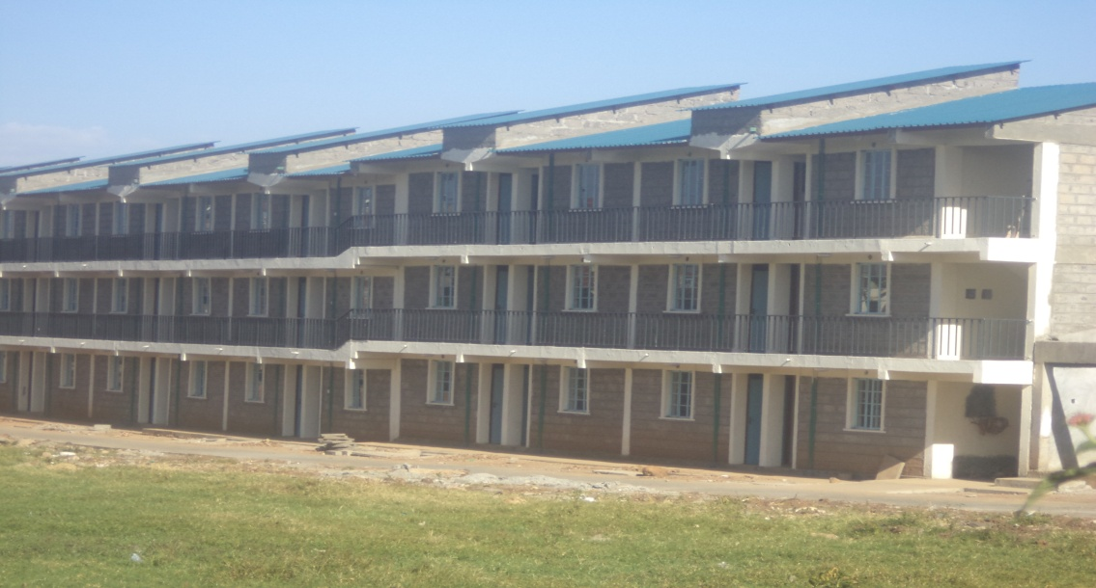
Source: Field survey, 2015.
Soweto west: Here there was installation of street lighting and public toilet, meant to improve public safety and sanitation. This is championed by the Ministry of Devolution and Planning incollaboration with the National Youth Service(NYS). Plate 6(a) and (b) shows of some the installed infrustructure.
Plate 6(a) & (b):Installation of Street lighting and sanitation facility.
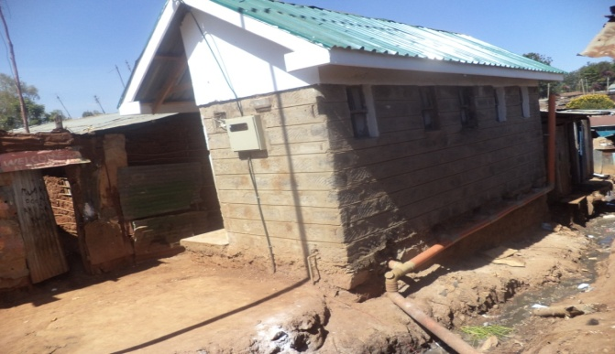
Source: Field survey, 2015.
Laini Saba: This area have attracted numerous improvement namely: Street lighting and Electricity connection funder by World Bank, Sanitation,drainage and Access roads spearheaded by the the Ministry of Devolution and Planning incollaboration with the National Youth Service(NYS), Plate 7(a) and (b).

Plate 7(a) & (b): Electricity installation and Access roads construction in Laini Saba village
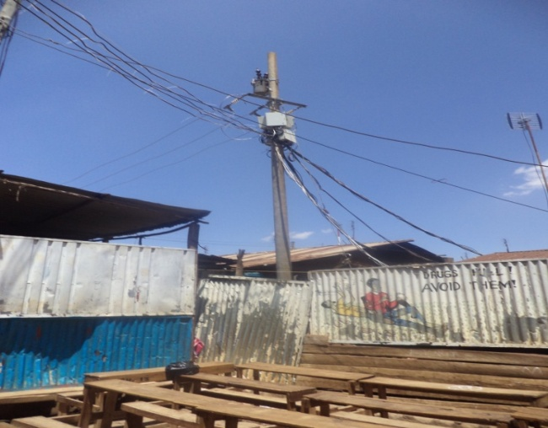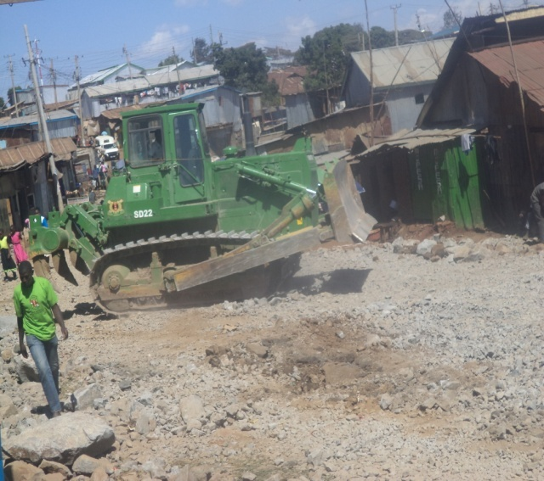
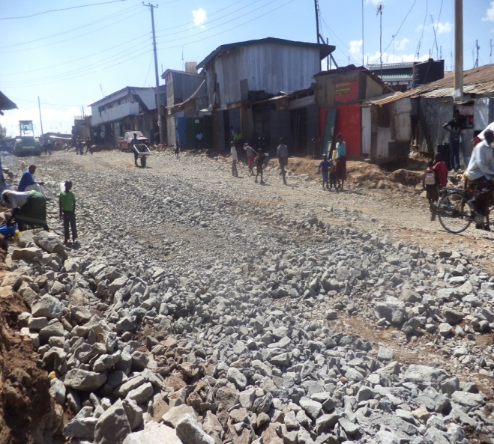
Source: Field survey, 2015.

5.3 The role of stakeholders in Kibera slum upgrading schemes
Slum upgrading like any other programme is a multidisciplinary, therefore requiring participation of various stakeholders to deal with physical, socio-economic issues and political issues in the area. According to some of the respondents, there are more than 1000 stakeholders but the impact of their operation is felt by a few residents or none at all. These stakeholders range from Government agencies: Ministry of Land, Housing and Urban Development, Ministry of Devolution and Planning, National Youth Service and Ministry of Health; to NGO’s, CBO’s /FBO’s and Media.Figure 14.
Figure 13: Some of the Stakeholders involved in Kibera Slum Upgrading.
Source: Field data, 2015,

5.3.1The National Government
Generally, the National Government is charged with the facilitative role, coordination of programmes and creating and ensuring an enabling environment for such programmes to run effectively. Apart from that function, it also plays numerous roles through various agencies for purpose of efficiency and effectiveness in the supervision and co-ordination of activities. First and foremost is the Ministry of Devolution and Planning, it cut across all ministries hence her involvement in the Kibera slum upgrading scheme. This ministry is working along with the National Youth Service and has developed an upgrading initiative. The initiative involve installation of infrastructures such as toilets, showers, construction of access roads, opening of drainage systems and construction of gabions to reduce soil erosion during rainy seasons. There is also clean up of streams and collection of solid waste. The key actors in this initiative include the NYS recruits and volunteers from the local community within the slums. The volunteers undergo two day training before being integrated in the full time project and also earn some cash per week. It is important to note that majority of the community have confidence in the project creating a sense of belonging and ownership a promising sustainable development. The youths have also been kept busy and an opportunity to interact with NYS recruits hence learning about discipline, hard work and teamwork. The rates of pollution and crime also have reduced.
Secondly, health facilities and services had been a great problem in Kibera. The Ministry of Health through the Beyond Zero initiative is working to improve primary healthcare. This initiative is being spearheaded by the First Lady Mrs. Margret Kenyatta, aimed to boost efforts to eliminate HIV infections amongst children and improve maternal survival rates by the end of the year 2015. This is aimed to achieve the sustainable development goal of improving infant and maternal mortality among the vulnerable communities in the developing world, and Kenya is not speared. At least each village in Kibera has a mobile clinic to serving the residents. This has been made possible by the support of the NYS recruits and the volunteers from the settlement especially in the construction of temporary infrustructures. Furthermore, the agency that has been the in forefront in slum upgrading is the Ministry of Land, Housing and Urban Development. It has played a critical role in the physical mapping and zoning of Kibera especially Soweto East village, where the housing project is ongoing. In order to actualize slum upgrading, the ministry has established the Department of Slum Upgrading to replace KENSUP (since its duration of operation was over). The programme was a collaborative initiative between the Government of Kenya, UN-Habitat, and other development partners. It aims to improve the lives of people living and working in slums and informal settlement in urban areas in Kenya. Its programmes include: community mobilization, preparation of strategic plans for informal settlements, shelter and infrastructure improvements, environmental and solid waste management and prevention of plorification of new slums among others. It also has an initiative to enable the local residents to save small amount that in the long run will enable them to acquire and own houses.
In addition, the Railway Corporation, through the Ministry of Transport and Infrastructure, and the World Bank, started a relocation project in 2012. This is meant create a 60m railway reserve by resettling those who had settled in the railway reserve. This project is in the process of achieving this, since first phase in Kianda is almost over. Some the residents are now in their temporary settlement waiting to be given their new permanent houses.

5.3.2Non-Governmental Organizations
Human Needs Project (HPN).
This programme was initiated by an American actress Connie Nielsen after a ten month working on a movie entitled: Lost in Africa. She was got struck by the conditions in Kibera, which resembled a prison namely: extreme overcrowding, scarcity of goods, violence and total absence preference and poverty. HPN aims to achieve a world where the present generation can access prosperity through local centralized centresby offering solid basic services, education, communication and credit. This is driven by the following core values: collaboration, transparency and accountability, sustainable services, economic empowerment and problem solving. The project offer the following services: clean water, sanitation, energy, green market (providing eco-friendly goods), IT service and free training, laundry and adult education. The organization also dedicated towards building a complete partnership with the local residents to find the best solution for unique challenges. This is through the following pillars namely: innovation, community engagement, and sustainability especially environment, finance and technical support. All these are driven by the premise that with access to right combination of services, anyone is motivated and can work better for their lives.
Global Alliance for Africa
This is a non-profit organization based in USA, that partner with non-profit agencies and sub-community groups in Sub-Saharan Africa. It aims to transform the lives of orphans, vulnerable children affected by the HIV/AIDS pandemic in Sub-Saharan Africa, by partnering with grassroots organization to design and implement economic development programmes that enable communities become self reliant. The organization runs the following programmes: microfinance, community library and therapeutic art. In Kibera, the NGO runs a community library in Kianda village, which library provides thousands children with education resources and consists mainly: general collection, children library and community social hall. This has kept most of the children busy hence reducing cases of early pregnancy among girls and drug abuse among male. The library also offers education programme, literacy, conservation practice relevant to achieve sustainability.Plate 8(a) and (b).
Plate 8(a) & (b): Community library in Kianda, managed by the Global Alliance for Africa.
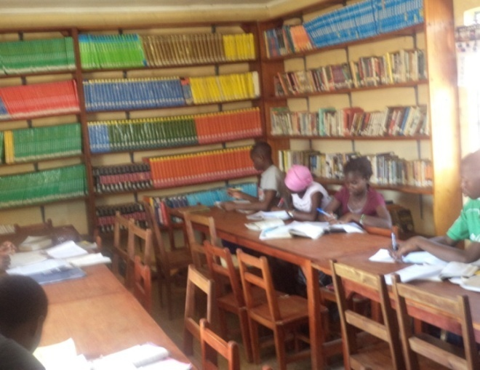
(Source: Field survey, 2015).

Carolina for Kibera
This organization aim to develop local leaders, catalyze positive change and alleviate poverty in Kibera. It is a collaborative programme advanced in health, education, ethnic cooperation, gender equality, economic empowerment and equips leaders with tools to strengthen community. Since healthcare in Kibera is a major challenge, in partnership with US Centre for Disease prevention and Control, it works to ensure that the residents have access high quality, comprehensive medical services and health education hence empower the residents with tools to keep their families healthy. In order to develop socially responsible leaders, they are promoting gender and ethnic understanding, educational scholarships for for bright and needy students and identification of talents through sports and talent shows. In addition, they offer economic empowerment through financial literacy, business skills, and entrepreneurship. They also have a slogan known as, “Taka niPato”,Trash is Cash, hence encouraging recycling and re-use of locally available material to generate income.
Unbound
This organization was initially known as Christian Foundation for Children and Aging (CFCA). It is an international non-profit organization, financed by the Jay Catholics in the full gospel to put the needs of the marginalized as a first priority. They build relationships of mutual respect and support to bridge cultural, religious and economic devices. It is guided by the following core values: theological base, integrity and accountability, dignity of persons and respectful relationship. It offers the following programmes: scholarship for education to children, nutrition and medication, food supply, housing and women empowerment mainly saving. The organization also have future plan for women towards development of an enterprising community and poverty alleviation.
Umande Trust
It is a right based agency which believes that modest resources can significantly improve access to water and sanitation services, if financial resources are strategically in support of community-led plans and actions. It has a mission is to partner choices in transforming water supply, sanitation and environmental services in partnership with communities in Kenyan urban slums. The organization aims in capacity building of the communities, foster sustainable management of resources, facilitate planning, building and maintenance of community services, conduct action based research and policy advocacy programme on issues related to water and sanitation and also promotes the introduction, development, and application of best practices for improved services. Umande operates in the nearly all informal settlements in Nairobi with many of her activities felt in Kibera slums. Most of their activities have been successful due to the support from the National government and Government agencies such NEMA and Nairobi Water and Sewerage Company and also acceptance by a larger percentage of the local residents.
Umande Trust has various programmes namely: Bio-centres innovations, Safi E-cookers, Kibera environmental initiatives among others. The bio-centres innovations combine the resources of the civil society, Umande Trust among other stakeholders. The organization have over 52 bio-centres with 22 of the found within Kibera slums. They serve as a multipurpose service points designed to improve access to descent and affordable sanitation, conversion of human waste into clean energy(bio gas), and fertilizer for urban greening and provide income generating activity and access to information to community based enterprises. Within the bio-centres there is library, an ICT centre where the computer literacy and big television screen where the community can watch news, for instance, the case of Ushirika Children Environmental Learning Centre, in Laini Saba. The vision for this project is to achieve a healthy, environmentally friendly re-invented toilets for universal usage yet scalable without the need for subsidy. It committed to affordable energy and specifically aims to contribute to to healthy urban sanitation. The organization also notes that the project have faced opposition from the public especially the bio gas generated from human waste as some view it as unclean and the problem of utilizing the by-products. See Plate 9(a), (b) and (c).
Plate 9(a), (b) & (c): Bio-centre, community library and toilets constructed The Umande Trust.
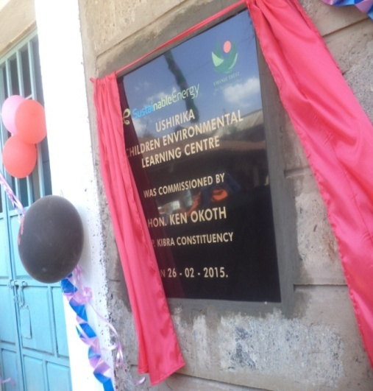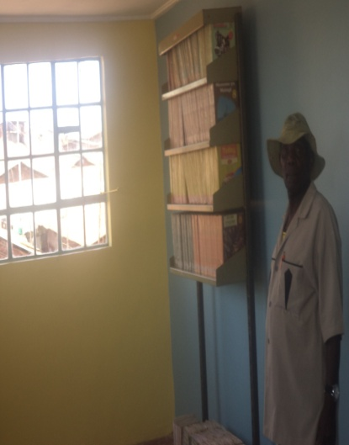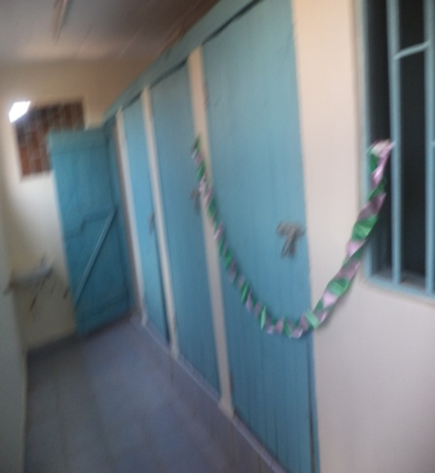
Source: Field survey, 2015.

The Safi E-cookers provides a thousand safe cookers to Kibera residents. The cookers use bio-ethanol (local brew, “chang’aa”) offering a safe, healthy, sustainable and affordable alternative energy to charcoal or firewood. This has been possible through the partnership between Umande Trust and Safi International. Another project spearheaded by the Umande Trust is Kibera Environmental Initiative meant to enlighten community members to actively participate in environmental improvement and local governance issues, ensuring that resources are also allocated for environmental improvement projects,(Plate (a), (b) and (c)).
Plate 10(a) & (b): Safi E-cooker and the tapping of Bio-gas and the cooking stoves installed by Umande Trust
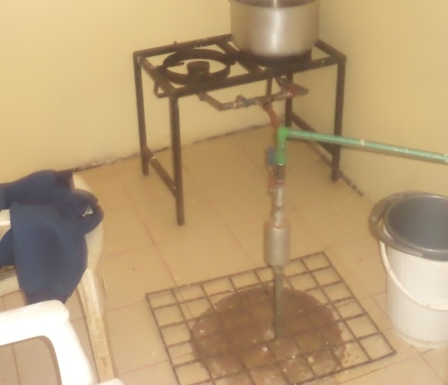 Source: Field survey, 2015.
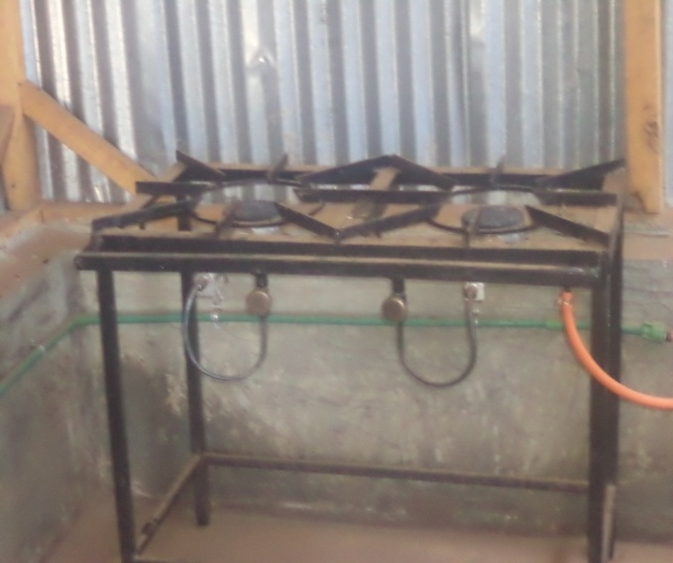
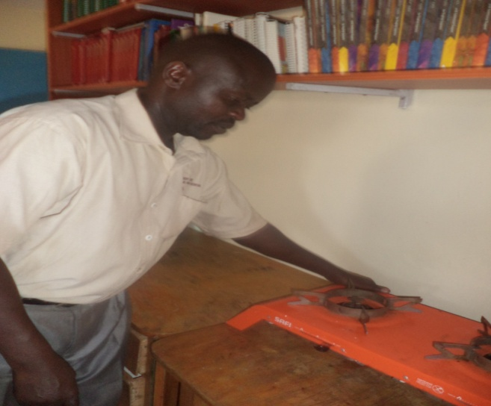
MajinaUfanisi (Water and Development)
This organization considers water as the main factor for the development of any society including urban slums or informal settlements. It has vision to provide water to all by being the leader in water and sanitation sector, influencing resilience, governance, knowledge management and promoting the best practice in environmental sanitation. This is guided by the following core values: Integrity, professionalism, equity and equal opportunity. They have the urban informal settlement upgrading initiative model meant to improve access to portable and affordable water, empowerment of communities with skills in management, productive and clean environment in informal settlements and climate change. In Kibera, the organization have supported a CBO, known as the Vision Sisters (Kianda) in establishment of water and sanitation facility and women rescue centre against gender based violence and other peace keeping initiatives within the settlement. This has improved accessibility to water, sanitation and increase awareness on social issues within the communities in Kibera.

5.3.3 Media
Communication and dissemination of information is important for the success of any programme as for the case of slum upgrading schemes. The media has been in the for front in ensuring that the local residents in Kibera have the right information about slum upgrading to prevent cases of mistrust, misconception, opposition and violence within the settlement among various stakeholders. The media house that has been in the forefront is Pamoja FM. This is a community radio station in Kibera slum, which was situated during the 2007/08 post election violence, to act as a calming influence on the residents of Kibera. For all these duration, it has remained true as the name suggests for advocacy and unity. It also has youth empowerment programme though education and information with the vision to create develop, apply, and transmit through thematic radio shows. This is for the purpose of knowledge, skills and understanding at various human development levels for equal, sustainable development, and peaceful co-existence among the local residents.

5.3.4 Community Based Organizations (CBO’s)
Most of the groups or organizations offer services that are similar and related to water and sanitation and garbage collection. They are mainly formed by like minded people not only for their mutual benefit but also to address some the issues affecting the society. The members work in shifts since they have other responsibilities or employ people to work on their behalf. From the field study I came the following CBO’s that are really transforming the face of Kibera. These include: Vision Sisters, Wise Ladies, UshirikawaMaendeleoyaMaisha and Nicofeli Youth Group. In common they provide water services at affordable rates and sanitation, that is, toilet and showers. Nicofeli Youth Group is also a bio- centre laid by the Umande Trust hence produce bio gas for domestic purpose especially cooking and also promotes the Safi E-cookers and also has a social hall for hire by other members of the community.
Vision Sisters emerges as an extra ordinary organization as it stretches further to address other social and economic issues overriding in the society. It aims at championing equal rights for girl child and women, fostering peace and development by integrating water, sanitation and gender violence interventions. They had an idea that due to poor basic services of water, sanitation and housing cases of conflict, violence and dehumanizing acts are rampant among the local people. They offer activities such as peace and reconciliation, welfare improvement project help of MajinaUfanisi. Within the organization there is a woman in crisis centre hence act as a women rescue centre offering: capacity literacy, empowerment in terms o health, income generation, awareness creation on general issues in the society.

5.4 Problems constraining the development of Kibera slum upgrading schemes.
The success of slum upgrading schemes depends on a lot of variables, especially how the Government harnesses and co-ordinates, the contribution of other players and creation of an enabling environment to pave way for the upgrading initiatives. This process therefore is not smooth since a lot of bottlenecks are encountered along. Many stakeholders identified a number of reasons constraining their operation. First and foremost, the Policy and Legal framework have been identified as a major drawback to the slum upgrading initiatives. The Department of Slum Upgrading admitted that there is no legal framework on slum upgrading and the draft bill that was prepared some time back is still awaiting approval by the National Assembly. This is due long procedure followed while initiating a bill into law; hence regulating the activities of various stakeholders has been an uphill for the Ministry of Housing. The Human Needs Project and the Young Generation Programme also had the same similar sentiments that legal factors were unfavourable in regards to their operation hence the National Government to hasten initiation of a more favourable legal framework.
Secondly, Communication is an important element for empowerment of stakeholders to purposely participate in the slum upgrading initiative to enhance sustainable outcome. It strengthens the relationship among stakeholders, for instance: the National Government, County Government, development partners, NGOs/CBOs, as well as target beneficiary. Communication also sensitize stakeholders on strategic interventions, proposed action plans, estimated cost, performance measures, monitoring and evaluation and community understanding of the programme and their participation. The Government of Kenya (2006) through KENSUP, identifies communication gap as a serious drawback to their operation and delayed implementation of programmes by key stakeholders. This has posed risks to the initiative volatility of the programme sites and misleading information by residents. For instance, previous attempts to upgrade slums by other partners created fear and mistrust to KENSUP initiatives, landlords and tenants. The work of other stakeholders is also hampered since they will not act to their optimal duty, (ibid).
Capacity building is vital for an initiative to be successful. Inadequate resources in such as personnel, materials and finances have derailed slum upgrading initiatives and other activities meant to improve living condition in informal settlements. Some NGOs such as Carolina for Kibera, African Health and Community Programme and Human Needs Project argue that they have been unable to serve the vast population of Kibera due to financial constrains. The Department of Slum Upgrading, applauded the same, that the budgetary allocation by the National Government is not adequate for them to execute their core function properly. It is in this light that some of their activities are not accomplished within the stipulated time frame.
However, the success of an upgrading initiative need support from both the government and the target beneficiaries. Failure by the Government to involve the target beneficiaries at all stages of the projects results in opposition of the projects by the local people since they lack knowledge on all the activities in place, for instance, some of the residents of Kibera in Gatwekeravillage, prevented the establishment of a police post in their area claiming they were safe and secure. Public education is therefore crucial to prevent a lot of myths about slum upgrading. Anotherchallenge is the rising of new slum while upgrading another hasmade the public not realize the true impact of slum upgrading in Kenya. Government of Kenya (2006) also states that issues such as: mistrust and suspicion, misinformation from groups of competing interest, lack of coordination, delay in dissemination of information and feedback mechanism among stakeholders have been drawback in attempt to improve slums.
Furthermore, transparency and accountability has been lacking in slum upgrading schemes. Democratic processes involved had been poor hence the community could not access the information regarding slum upgrading. Some the actors would therefore, act with impunity since they do not feel accountable to the community, (ibid). Finally, Land tenure systems especially in in Kibera have very complex. The Department of Slum Upgrading admits that many court cases filed by structure owners regarding tenure have hindered their activities especially in Soweto East, one of the villages in Kibera. Such cases take a very long time to solve and sometimes bring the slum upgrading initiatives to a standstill.
From the field study, the following were the views of the respondents about the ongoing slum rehabilitation, 87% of the respondents supported the upgrading initiative, saying that the living conditions had improved; crime rate had reduced since most of the youth are engaged in meaningful activities and even the solid waste menace had been well managed. 9% of the residents were against the move since it had denied them some of their sources of income especially garbage collection, while 4% of the respondents were unable to express whether they support or they are against. 73% of the respondents felt that the programme is effective since there was greater participation by the local residents and deployment of more resources for the programme. 12% saw it ineffective as it will not achieve much just as the previous ones while 15% had no idea (table 7 and figure 15(a) and (b)).
Table 7:Comments on the ongoing slum upgrading and its effectiveness.
Comments on slum upgrading | Responses |  | Effectiveness | Responses
Supporting | 59 |  | Effective | 50
Against | 3 |  | Ineffective | 8
Neutral | 6 |  | Neutral | 10
Source: Field data, 2015
Figure 14(a) and (b): Perception of Respondents about the ongoing Slum Upgrading.
Source: Field Data, 2015.

CHAPTER SIX

6.0 SUMMARY OF THE FINDINGS, CONCLUSION AND RECOMMENDATIONS.

6.1 Summary of the findings
Generally, the findings of the study reveal that slum upgrading is one of the best initiatives to improve slums settlements. A large percentage of Kibera residents support it and really believe that the initiative will not only transform their lives but the entire image of Kibera globally. Many positive impacts or benefits have been evident such as: improved security especially street lighting and police post, easy accessibility, improved living conditions in terms of water supply and sanitation, health services and above all creation of jobs for several youths that have been idle. However, some negative impacts have also been experienced such as: displacement of people without compensation especially on the road and railway reserves, deprivation of the only source of income for some youths, for instance garbage collection, and also relocation risky temporary places prone to accidents along the railway line. It is worth noting that the positive impact outweigh the negative impact by far, hence a viable scheme to be embraced. For the slum upgrading scheme to be effective or considered successful, public education should be in the forefront to prevent various incidences of misinformation and opposition of the initiatives from the beneficiary and other stakeholders hence reduced suspicion and mistrust as noted by KENSUP, as a major drawback to their goals and vision. The study determined that the existences of weakness and gaps within the policy and legal framework both at the National and County levels of Governments on slum upgrading has made the co-ordination of the general initiative a nightmare. Other stakeholders also claim that unfavourable government policies, lack of acceptance and appreciation of the activities by the local people have hindered their operation. Moreover, numerous infrastructural elements and facilities were dilapidated namely: Housing, sanitation, sewerage, accessibility, health and water services, hence the need for improvement. Controversial issues such as drug and substance abuse, unemployment, gender based violence, early pregnancies among teenagers and unequal opportunities and distribution of resources were also pointed out by the residents that need to be addressed through empowerment and affirmative action.

6.2 Conclusion
Slum upgrading scheme is an initiative that have transformed settlements not only as in Kibera and also in other parts of the World. The settlements have changed in terms of infrastructure especially lighting, roads, security, sanitation among other benefits. However, the initiative faces challenges such as: lack of comprehensive legal framework, communication breakdown among stakeholders, long court cases concerning security of tenure among other constrains. The National and County governments therefore need to hasten the enacting of laws on slum upgrading to enhance the proper co-ordination of the diverse operations by the different stakeholders. In addition, public education and involvement at every stage of the programme is important as this will create a sense of belonging, ownership and sustainability of the initiative hence sustainable living and development.

6.3 Recommendations

6.3.1 Short term Recommendations
- The major challenge to slum and informal settlements upgrading is the lack of general and comprehensive and appropriate legal framework and the guideline for such. The law makers should therefore hasten the approval of the slum upgrading draft bill into law. This will enhance mainstreaming of the activities of various stakeholders in terms co-ordination and supervision to ensure their activities are geared towards the general vision upgrading which is to improve the livelihoods of 5.3Million Kenyans living in the informal settlement by the year 2020.
- The National government should ensure that there is an enabling environment especially security and fair and just processes besides developing a framework to facilitate participation of all stakeholders.
- Long bureaucratic procedures in order to acquire the requirements for initiation of a project of an idea, has given room for some malpractices such as corruption. This has prevented the initiation of of better ideas that would fasten the upgrading process. These procedures need to be reviewed to ensure that matters of urgency are quickly addressed.
- There is need for harmonization of programmes by the various stakeholders to ensure that there is collection action towards the vision of slum upgrading.
- Public and private partnership should be adopted especially in the improvement of housing, health facilities, and education. Many respondents were for the idea of the development of low cost housing due to their low income. This can only be realized if the Government gives room for such partnerships.
- Some of the projects fail due inadequate finances. The relevant authorities therefore should remit those funds at the right time and carry post implementation activities. This will encourage accountability of resources. CBO’s facing the same situation, should develop project that will attract funding from other like minded partners and organizations hence join them in the realization of the their vision of transforming the lives in slum settlements.
- There is need for search of alternative technologies that are low costly to help in lowering of development cost and also realization of the project within set time frame without pressure.
- In ensuring effectiveness and efficiency in operation, the stakeholders should carry out capacity building initiatives to equip their staff with necessary resources and knowledge through training in workshops, seminars, trade fairs, shows and exhibitions. This will ensure that they are updated with the current emerging issues in their field of operation hence realizing their vision and come up with proper measures to counteract the emerging situation.
- There is need for public awareness to create an informed society through public campaigns, road show, appropriate media and various forums. This will encourage participation of various stakeholders and the general public in programmes and projects being initiated by the government and other institutions. This will help in avoiding opposition and lack of appreciation from local residents, hence giving them a sense of belonging and ownership leading to success and sustainability of the project.

6.3.2 Long term Recommendations
- The stakeholders should diversify in their operation to address other controversial issues other than those the ones within their mandate. Some of the issues that do occur since various stakeholders only focus on specific issues within their mandate.
- Communication and dissemination of information had been a major obstacle to the operation of several stakeholders in slum upgrading schemes, leading to misinformation. Therefore, mistrust, suspicion among stakeholders according to KENSUP Implementation strategy, “Communication Plan.” A well designed communication channel should be adopted to ensure that all the partners have the correct information about a given initiative or a concept. This will also enhance collective participation.
- There is need for community mobilization to form community based organizations to handle or mange some of the infrastructure and other environmental issues affecting them especially solid waste management, cleaning of rivers, streams and other drainage within the settlement. This will enlighten the residents on the need for clean and healthy environment conducive for habitation. The community also will be on the forefront in managing the resources in their surroundings.
- Comprehensive legal frameworks need to be in place, to enhance effective co-ordination and supervision of stakeholders. The national government should be on the fore front in ensuring that all the legal entities are to enhance effective operation and co-operation through national policy and institutional reforms, forums and implementation of initiatives. This will ensure that such initiatives are independent not politically influenced hence the government should only play the facilitative role. This will also develop strategies to prevent the rise of new slums and the expansion of the existence of ones. There is need for developing an integrated project comprehensive enough to address the all the issues affecting the informal settlements and how to deal with emerging issues.

6.4 Areas for further studies
- Socio-economic issues within the informal settlements and their implication on livelihoods.
- The state of solid waste management and livelihoods in slums.
- The implications of land tenure issues in informal settlements.

PLANNING MATRIX FOR INTEGRATED PLAN FOR SUSTAINABLE DEVELOPMENT OF KIBERA SLUM UPGRADING SCHEME.
Objectives | Planning Issues | Strategies | Activities | Timeframe |  |  |  | Actors
- To analyze policy and legal framework for slum upgrading schemes in Kenya. | - Lack of clear policy and legal framework on slum upgrading | - To hasten the enactment of the slum upgrading bill into law.  - To harmonize of policies related to slum upgrading for proper coordination purposes. | - Reducing the bureaucracies involved in the law making process.  - Review of the existing policies to ensure they are in line with the existing issues being addressed.  - Ensuring participation of the entire stakeholders. | Short term | Mid-term | Long term |  | National Government  County Government of Nairobi  NGOs/CBOs
 | - Ambiguity of some policies and laws. | - To develop simple and clear terms to common layman.  - To weigh what terms best fit the target group | - Review of the existing policies to ensure they are in line with the existing issues being addressed.  - Involvement of stakeholders in the law making proceedings.  - Carry out public campaign and education about the laws  and policies. |  |  |  |  | National Government  County Government of Nairobi  NGOs/CBOs
 | - Lack of appropriate communication channel | - To design good channel where all stakeholders can access the information with ease.  - To constant involve stakeholders about their initiatives | - Providing numerous communication channels either print or electronic hence actors have preferences  - Calling for forums such as workshops, seminars among others where actor can learn and share.  - Carry out public campaign and education about the laws  and policies. |  |  |  |  | National Government  County Government of Nairobi  NGOs/CBOs
 | - Poor planning and implementation | - To ensure that the resources required for implementation of such plans are available.  - To develop simple plans that will accrue much at a cheaper cost  - To ensure there is constant supervision and co-ordination of activities | - Lobbying all the stakeholders and technocrats necessary developments of the initiative.  - Sourcing the inputs needed at the right time for efficient flow of activities.  - Have adequate staff to carry out the activities effectively and efficiently. |  |  |  |  | National Government  County Government of Nairobi  NGOs/CBOs
- To determine the infrastructural elements and facilities that needs upgrading in Kibera slums | - Rapid population growth/ increase migration | - To increase the number and size of the facilities in order to accommodate people adequately  - To establish carrying capacity to control the overuse of that facility.  - To introduce a charge or an entry fees to anybody intending to use the facility | - Providing the inputs for construction and improvement of the existing facilities  - Have rules pertaining or other precautionary measures aout the utilization of a facility.  - Employing adequate and able staff to manage such resource  - Ensuring the users feel the need or importance of using a facility |  |  |  |  | County Government of Nairobi  NGOs/CBOs  FBOs
 | - Lack or poor state of infrastructure | - To refurbish the existing ones  - To establish new ones to meet the needs of the users  - To create numerous facilities thus ensuring there is preference in terms of use  - To create new designs for facilities with numerous uses | - Promoting public private partnerships  - Addressing security of tenure and other land related issues  - Provision of funds and other resources need for such developments  - Adopting alternative technologies which are cheaper to reduce the cost of such development |  |  |  |  | National Government  County Government of Nairobi  NGOs/CBOs
 | - Vandalism | - To provide security or staff to regulate the use  - To encourage community participation initiative | - Employing the necessary resources such as people, fencing or gating the facility  - create public awareness on the utilization of the resource |  |  |  |  | National Government  County Government of Nairobi  NGOs/CBOs  FBOs
- To examine the role of stakeholders in the Kibera slum upgrading scheme. | - Lack of involvement in the design, planning and implementation of project | - To develop a good communication channel  - To enact policies and laws that encourages involvement of stakeholders | - Allowing efficient dissemination of information  - Lay out the clear and correct procedures to follow in every initiative. |  |  |  |  | National Government  County Government of Nairobi
 | - Inadequate personnel and funds | • To promote  capacity  building at all  levels  • To mobilize  funds from  government and  donors  • To harness local  capacity and  opportunities to acquire funding | - Establishing  single  line funding at  both national and  county levels  - Running  workshops,  seminars and  and training session for personel  - Carrying out  public awareness  campaigns on financial management |  |  |  |  | National Government  County Government of Nairobi  NGOs/CBOs
 | - Lack of appreciation from the target group | - To make sure the target group are part of the programme  - To create awareness about their programmes | - Ensuring the they are actively involved in the initiative by ensuring their views are incorporated  - Organizing forum where the target group can express their ideas |  |  |  |  | National Government  County Government of Nairobi  NGOs/CBOs
- To examine problems constraining the development of Kibera slum upgrading  Scheme. | - Lack of transparency and accountability | - To enhance proper book keeping  - To ensure all stakeholder take full resposibilities of their action  - To carry out sensitization to ensure that every partner is aware of their role | - Do frequent audit to determine the accuracy of the financial records on quarterly basis  - Talk legal action against those embezzle the resource for the project  - Report cases of misconduct, misappropriation of funds and other malpractices  - Frequent public education and other exchange programmes |  |  |  |  | Local residents and public in general  National Government  County Government of Nairobi  NGOs/CBOs  FBOs
 | - Land tenure system | - To streamline formalities followed in acquiring land rights  - To eliminating any form of discrimination when acquiring land rights  - To hasten land proceeding in courts | - Enacting adequate policies and laws and ensure the correctly implemented  - Ensuring fair and equal opportunities for all  - Ensuring there is enough personnel to hand such issues in the court of laws |  |  |  |  | National Government  County Government of Nairobi

REFERENCES
Adebayo, K &Iweka, C. O. (2014). Sustainable Infrastructure Upgrade in Slums Settlement: the role of Architect. Lagos, Nigeria.
Alemoglu, D, Johnson, S & Robinson, J. A. (2001).The colonial Origin of Comparative Development: An Emperical Investigation.American Economic Review.
Amis, P & Kumar, S. (2002). Environment and Urbanization: Urban economic growth; infrastructure and Policy. India.
Arefi, M.(2008). Assets-bassed Approaches to Community-Development. Nairobi: UNHABITAT.
Awotona, A. (1989). The Perception of Housing Conditions in Nigeria by the urban poor. Habitat International.
Banerjec, Abhijit&Lakshmin. (2005). History, Institution and Economic Performance: The Legacy of Land Tenure system in India. American Economic Review.
Beal, J. (2002).Environment and Urbanization: Globalization and Social exclusion in cities; Framing the debate with lessons from Africa and Asia.Book House, Toronto.
Bryman, A. (2004). Social Research Methods. New York: Oxford University Press.
Das, A, K. (2008).Lofty Ideal, left dead: Empowerment through participatory slum upgrading in
Denters, B &Klok, P. J. (2010).Rebuilding Roomeback: Patterns of Citizens Participation in Governance.Urban Affairs Review.
Desai, V. (1995).CommunityParticipation and Slum Housing: A Study of Bombay. New Delhi, India. Sage Publication.
Easterly, William & Levine, R. (1997).Africa Growth Tragedy: Policies and Ethnic Divisions. Quarterly journal of Economics.Eastern Limited.
Edelmand, J &Andavarapu, D. (2013).Evolution of Slum Redevelopment Policy. University of Cincinnati, USA.
Elmhist, R. (1999). Political Geography: Space, identity, politics, and resource control in Indonesia. Trans-migration programme.
Frankfort, C. (2004). Research Methods in Social Sciences (5 ed.). University of Wisconsin: St.
Gallegher, R. (1992). The Rickshaws of Baughedet.The University Press.
Godhart, S & Vaughan.(2008). Research Review, the Mumbai BGN in relation to Upgrading Informal Settlements.Mumbai, India.
GoK (2005).Kenya Slum Upgrading Programme (KENSUP).Communication Strategy. Government Printers.
GoK (2005).Kenya Slum Upgrading Programme (KENSUP). The Strategic Plan (2005-2020). Government Printers
GoK (2006).Kenya Slum Upgrading Programme (KENSUP).A Communication Action Plan. Government Printers.
GoK.The County Government act, 2012.
GoK. The National Housing Policy, 2004
GoK.The National Land Policy, 2009.
GoK. The National Urban Development Policy, 2011
GoK.The National Vision 2030.
GoK.The Public Finance Management act, 2012.
GoK. Urban Areas and Cities act, 2011.
Government of Uganda (Ministry of Lands, Housing and Urban Development.(2008). The National Slum Upgrading Strategy and Action Plan.
Haber (eds.), Poverty in America (pp. 405-415). The University of Michigan
Hamdi , N &Goethert, R.(1997). Action Planning for Cities: A Guide to Community Practice. England, John Wiley Limited.
Hardoy, J, Mitlin, D &Satterthwaite. (2000). Environmental problems in an Urbanizing World: Finding solution for cities in Africa, Asia and Latin America. Earthscan, London.
Kenya National Bureau of Statistics (KNBS, 2010).The Kenya 2009 Population and Housing Census.
Kenya National Bureau of Statistics Report, 2013.
Kothari, C. R. (1985). Research Methodology: Methods and Techniques. New Delhi: Wiley
Lewis, O. (1959), Five Families: Mexican Case Studies in the Culture of Poverty, Basic
Lewis, O. (1961), The Children of Sanchez: Autobiography of Mexican Family,
Lewis, O. (1966), LA VIDA: A Puerto Rican Family-San Juan and New York, Vintage
Lewis, O. (1968), ‘The ‘culture of poverty’, in L. A. Ferman, J. L. Kornbluh and A.
Lewis, O. (1970), Anthropological Essays. Random House, New York.
line with the DCED Standard.
Magdeberg Research Group on Mumbai. (2009). Social Activism on Grassroots Organizations and NGO’s in the slums. Mumbai, India.
Malthaeu, H. (1997). Propenda slum upgrading Rio Grand de sul: From the provision of Infrastructure to strengthening the self management Capacity of the Poor. Mexico.
Malu, M. J. (2005). Participation in Upgrading Programmes: The Case of Mathare 4A slum upgrading programme in Nairobi, Kenya; A project submitted in the spatial fulfillment of the requirement for the Masters of Arts in Development Studies. University of Nairobi.
Martin’s Press.
McElroy, B & Mills, C. (2000).Managing Stakeholders.Grower Publishers.
Meir, J. E. (2002). On the Margin: The Emergence and Growth of Informal Settlement in the Greater Cape Town. South Africa.
Ministry of Devolution & Planning (2013): Nairobi County Developing Profile.
Ministry of Housing (Government of Kenya).(2013). National Slum Upgrading Policy and Prevention Policy.
Muaz, J. M. (2013). Practical Guidelines for Conducting: Summazing good Research Practice in
Mugenda, O.M and Mugenda, A.G (2003).Research Methods: Quantitative and Qualitative
Muraguri, L. (2011). Kenya Government initiatives in Slum Upgrading. Nairobi, Kenya.
Mutillah, W. (2003).Understanding Slums: Case Studies for the Global Report on Human Settlement; the case of Nairobi, Kenya.
Mutisya, E &Yamire, M.(2011). Understanding the Grassroots Dynamics of Slum in Nairobi: Dilemma of Kibera Informal Settlement. Tokyo, Japan.
Nairobi County Intergrated Development Plan (NCIDP), 2014.
Njeri, C. (2010). Slum Dwellers response to free education. University of Nairobi.
O’Meara, M-R. (2010). Innovative Approaches to Housing Policy and Production in Latin America: The Case of Sao Paulo, Brazil and Buenos Aires, Argentina.
Okpala, D. (1999). Urban Studies: Received Concept and Theories in African Urban Studies and Urban Management Strategies.
Payne, G. (1989). Low- income Housing in the Developing World: The Role of Site and Service and Settlement Upgrading. England, John Wiley Limited.
Perlman J.E. (1976). The Myth of Marginality: Urban Poverty and Politics in Rio de Janeiro. Berkly, C.A, University of California Press.
Perten, J. (2011). The Success and Shortcoming of Participatory slum upgrading in Villar.
Press, Ann Arbor.
Rakori, C, &Schlyter, A. (1981).Upgrading in Lusaka: Participation and Physical Changes. The National Swedish Institute for Building Research. Stockholm, Sweden.
Random House, New York.
Resources and Standard of Living, Penguin, London.
Robson, C. (1993). Real-World Research: A Resource for Social Scientists and Practitioner. Malden.
Sannaft.(2000). Community Participation Method in Design and Planning. Willey, New York.
Sasggerson, E. (1991). Geology of Nairobi area: Degree sheet 51.NEQUATER. Mines and Geology Department. English press, Nairobi- Kenya.
Shehayed, D &Sabry, S. (2008). Living in Informal Settlement Areas: Advantages and Disadvantages.ShiakhatBoulaq-Al Dakrour, Cairo, Egypt.
Shimangala, J.(2014). Biogas helping to clean up Nairobi Slums.Deuche well.
Sjoberg. (1996). The Pre-Industrial City: Past and Present. Free press, New York.
Syagga, P. M. (2011). Land Tenure in Slum Upgrading Project. Nairobi, IFRA.
Techniques.Nairobi: ACTS Press.
The Constitution of Kenya, 2010.
The National Development Plan (2002-2008): Effective Management for Suitable Economic Growth and Poverty Reduction.
Townsend, P. (1979), Poverty in the United Kingdom: A Survey of Household
Turner, J. (1972). Freedom to Build: Dweller control of the housing process. Macmillan, New York.
Umande Trust Kibera. (2007). The Right to Water and Sanitation in Kibera. Nairobi, Kenya.
UN-Habitat (2001). Cities in Globaling World: Global Report on Human Settlement. Earthscan, London.
UN-Habitat (2003).The Challenge of Slums: Global Report on Human Settlement. Earthscan, London.
UN-Habitat (2012).Streets as tools for urban transformation in slums: Streets led approach to city side slum upgrading.
United Nations (2000). The resolution adapted by the General Assembly: 55/2 the United Nations Millennium Declaration, New York.
United Nations Development Programme (UNDP). (2013). Human Development Report 2007/2008 fighting Climate Change. UNDP, New York.
Van Vliet, W. (2002).Environment and Urbanization: Cities in the globalizing World; from agencies of growth to agents of change.
World Bank & UNCHS (Habitat). (1999). Cities Alliance for Cities without Slums: Action Plan for moving Slum Upgrading to Scale.Washington DC & Nairobi, Kenya.
World Bank, Global Development Finance, 2005).
World Bank. (1999-2001). Upgrading Urban Communities for Practioners. Washington D.C.
Zhou, D. (2011). Redefining Indian Slum Policy.
Zoysa, Dc. (1999). Care seeking for illness in young infants in an Urban slums in India.

APPENDICES
KENYATTA UNIVERSITY
Department of Environmental Planning & Management
Bachelor of Environmental Planning and Management
I am JUMA OBARE MICHAEL, an undergraduate Student from the Department of Environmental Planning and Management in the School of Environmental studies, Kenyatta University. In order to fulfill the requirements of this degree programme, I am carrying out a research project study entitled: An evaluation slum upgrading schemes in Nairobi County: The Case of Kibera Slums.
Institutional Questionnaire.
The information and data provided will be confidential and is intended for academic purposes only Please answer these questions to the best of your knowledge. Write your responses in the space provided.
Name of the Interviewer ---------------------------------------------- Date of interview ------------------
Name of the institution ………………………………………………………………
Q1. What is your mandate and role in relation to slum upgrading?
………………………………………………………………………………………………………………………………………………………………………………………………………………………………………………………………………………………………………………………………………………………………………………………………………………………………………………………………………………………………………………………………………
Q2. What is the trend of slum/squatter dwellings in Kibera since independence?
…………………………………………………………………………………………........................................................................................................................................................
……………………………………………………………………………………………………………………………………………………….…………………………………….

Q3. a). Are there policy and legal framework that govern the slum upgrading activities in Kenya? i). Yes { } ii). No { }
b). Which are some of these regulation?
Policy | Strength | Weakness
c). How efficient and effective are these polices in spear heading slum upgrading activities?................................................................................................................................................................................................................................................................................................................................................................................................................................................................................................................................................................................................................................................................................................................................................................................
d). What do you recommend to ensure that the policies and the legal framework enhance the full realization of the slum upgrading activities in the country? ……………………………..
……………………………………………………………………………………………………………………………………………………………………………………………………………………………………………………………………………………………………………………………………………………………………………………………………………………………………………………………………………………………………………………………………
Q4. In your own opinion, what are some of the factors contributing to these trends of slums or informal settlement in Kibera?
...............................................................................................................................................................................................................................................................................................................................................................................................................................................................................................................................................................................................................................................................................................................................
Q5. Apart from housing, what are some of the infrastructural elements that need upgrading in slums, especially in Kibera slums?
Infrastructural elements | Tick appropriately
- Access roads
- electricity
- street lighting
- water supply
- sanitation
- health facilities
- education services
- sewerage
- housing
- any other
Q6. What is the role various stakeholders in ensuring that slum upgrading schemes in Kibera is realized?
- Relevant National agencies
……………………………………………………………………………………………………………………………………………………………………………………………………………………………………………………………………………………………………………………………………………………………………………………………………………………………………………………………………………………………
- County Governmant
………………………………………………………………………………………………………………………………………………………………………………………………………………………………………………………………………………………………………………………………………………………………………………………………

- Relevant NGO’S/CBO’s
………………………………………………………………………………………………………………………………………………………………………………………………………………………………………………………………………………………………………………………………………………………………………………………………
- International Agencies……………………………………………………………………..
………………………………………………………………………………………………………………………………………………………………………………………………………………………………………………………………………………………………………
- Local residents……………………………………………………………………………..
………………………………………………………………………………………………………………………………………………………………………………………………………………………………………………………………………………………………
- Any other (specitfy)……………………………………………………………………….
……………………………………………………………………………………………………………………………………………………………………………………………………………………………………………………………………………………………
Q7. a) What are some of the problems that do constrain slum upgrading activities in Kibera slum?………………………………………………………………………………………………………………………………………………………………………………………………………………………………………………………………………………………………………………………………………………………………………………………………………………………
b). What is the most appropriate way that can be in place to prevent such problems or restore the situation?…………………………………………………………………………………………………………………………………………………………………………………………………………………………………………………………………………………………………………………………………………………………………………………………………………………………………………………………………………………………………………………………

KENYATTA UNIVERSITY
Department of Environmental Planning & Management
Bachelor of Environmental Planning and Management
I am JUMA OBARE MICHAEL, an undergraduate Student from the Department of Environmental Planning and Management in the School of Environmental studies, Kenyatta University. In order to fulfill the requirements of this degree programme, I am carrying out a research project study entitled: An evaluation of slum upgrading schemes in Nairobi County: The Case of Kibera Slums.
The information and data provided will be confidential and is intended for academic purposes only. Please answer these questions to the best of your knowledge. Write your responses in the space provided.
Household Questionnaire.
Background information Name of the village…………………
- a). What is your gender?
- Male [ ] ii. Female [ ]
b). What is your marital status?
Marital status | Single | Married | Widower | Divorced
Tick appropriately

b). How long have you stayed in Kibera?
Duration | Less than 3 | Between 3-5 | Between 6-8 | Over 8
Tick appropriately

c). Why do you decide to stay in Kibera?...............................................................................
………………………………………………………………………………………………………………………………………………………………………………………………………………

c). How many people do you have in your household?
Duration | Less than 3 | Between 3-5 | Between 6-8 | Over 8
Tick appropriately

d). Education level?
Education level | None | Primary | Secondary | Tertiary
Tick appropriately

d). What is you occupation?
Occupation | None | Employment | Business | Any other (specify)
Tick appropriately

- a) What is the size of the house you are living in?
- Single room [ ]
- Double [ ]
- Any other [ ]
b). Is this space enough for your family?
- Yes [ ] ii. No [ ]
c). If No, what should be done to correct the situation?
………………………………………………………………………………………………………………………………………………………………………………………………………………………………………………………………………………………………………………………………………………………………………………………………………………………………

- What are some the problems you are facing in Kibera?
Problem | Tick appropriately
- Scarcity of water
- Insecurity
- Solid waste
- Insecure tenure
- social services
- education facilities
- housing
- Any other
- In your own opinion, what is the best way to address the above problems?
………………………………………………………………………………………………………………………………………………………………………………………………………………………………………………………………………………………………………………………………………………………………………………………………………………………………………………………………………………………………
- Comment on the ongoing slum upgrading initiatives in Kibera?
……………………………………………………………………………………………………………………………………………………………………………………………………………………………………………………………………………………………
- Which infrastructural elements do want to be upgraded in Kibera?
Infrastructural elements | Tick appropriately
- Access roads
- Electricity
- street lighting
- water supply
- sanitation
- health facilities
- education services
- sewerage
- housing
- any other

- How has ongoing slum upgrading initiatives in Kibera affected your Life?
………………………………………………………………………………………………………………………………………………………………………………………………………………………………………………………………………………………………………………………………………………………………………………………………………………………………………………………………………………………………
- a). In case of housing, which type of house would you prefer for your family?
………………………………………………………………………………………………………………………………………………………………………………………………………………
b). Give reasons
………………………………………………………………………………………………………………………………………………………………………………………………………………………………………………………………………………………………………………………………………………………………………………………………………………………………
- a).Do you think the slum upgrading initiative in Kibera is really effective?
- Yes { } ii. No { }
b). Give reasons ………………………………………………………….........................
………………………………………………………………………………………………………………………………………………………………………………………………………………………………………………………………………………………………
c). What measures should be put in place in order to actualize the slum upgrading initiative in Kibera?...............................................................................................................
………………………………………………………………………………………………………………………………………………………………………………………………………………………………………………………………………………………………………………………………………………………………………………………………
- What should the following stakeholders do to ensure effective realization of the slum upgrading in Kibera and other parts Kenya?
- National government
…………………………………………………………………………………………………………………………………………………………………………………………………………………………………………………………………………………………………………………………………………………….
- County government
……………………………………………………………………………………………………………………………………………………………………………………………………………………………………………………………..
- International agnencies (UN-Habitat and World Bank)
…………………………………………………………………………………………………………………………………………………………………………………………………………………………………………………………………………………………………………………………………………………….
- NGO’s
……………………………………………………………………………………………………………………………………………………………………………………………………………………………………………………………………………………………………………………………………………………
- Private sector/ investors
……………………………………………………………………………………………………………………………………………………………………………………………………………………………………………………………….
- Local residents
………………………………………………………………………………………………………………………………………………………………………………………………………………………………………………………………

